

Brazil’s submission of a Forest Reference Emission Level (FREL) for reducing emissions from deforestation in the

Amazonia biome for REDD+ results-based payments under the UNFCCC

Brasília, DF

September, 2014

1

Coordination:

Ministry of the Environment (MMA)

Ministry of Science, Technology and Innovation (MCTI)

Working Group of Technical Experts on REDD+:

Leticia Guimarães, Ministry of the Environment (MMA)

Alexandre Santos Avelino, Ministry of the Environment (MMA)

Monique Sacardo Ferreira, Ministry of the Environmen (MMA)

Thelma Krug, Ministry of Science, Technology and Innovation, National Institute for Space Research (MCTI/INPE)

Dalton de Morisson Valeriano, Ministry of Science, Technology and Innovation, National Institute for Space Research (MCTI/INPE)

Luis Eduardo Pinheiro Maurano, Ministry of Science, Technology and Innovation, National Institute for Space Research (MCTI/INPE)

Alberto Waingort Setzer, Ministry of Science, Technology and Innovation, National Institute for Space Research (MCTI/INPE)

Jean Pierre Henry Balbaud Ometto, Ministry of Science, Technology and Innovation, National Institute for Space Research (MCTI/INPE)

Niro Higuchi, Ministry of Science, Technology and Innovation, National Institute of Amazon Research (MCTI/INPA)

Philip Martin Fearnside, Ministry of Science, Technology and Innovation, National Institute of Amazon Research (MCTI/INPA)

Adriana dos Santos Siqueira Scolastrici, Foundation of Space Science, Applications and Technology (FUNCATE)

Ricardo Ribeiro Rodrigues, Luiz de Queiroz College of Agriculture (ESALQ), University of São Paulo (USP)

Edson Eyji Sano, Ministry of the Environment, Brazilian Institute of the Environment and Renewable Natural Resources (MMA/IBAMA)

Joberto Veloso de Freitas, Ministry of the Environment, Brazilian Forest Service (MMA/SFB)

Laerte Guimarães Ferreira Jr., Federal University of Goiás (UFG)

Rosana Clara Victória Higa, Ministry of the Agriculture, Livestock and Supply, Brazilian Enterprise for Agricultural Research (MAPA/EMBRAPA)

Heloisa Aparecida Belleza Ferreira, Ministry of the Agriculture, Livestock and Supply, Brazilian Enterprise for Agricultural Research (MAPA/EMBRAPA)

Heloísa Sinátora Miranda, University of Brasilia (UnB)

Mercedes Maria da Cunha Bustamante, Rede Clima

2
Table of Contents

Introduction 8

Area and activity covered by the FREL 8

a) Information that was used in constructing the FREL 12

b) Complete, transparent, consistent and accurate information used in the
construction of the FREL 26
b.1. Complete Information 26

b.2. Transparent Information 28
b.3. Consistent Information 41
b.4. Accurate Information 44

c) Pools, gases and activities included in the construction of the FREL 48
c.1. Activities included 48
c.2. Pools included 49
c.3. Gases included 53

d) Forest definition 54

References 57

Annexes 66

3
Figures

Figure 1: Distribution of the six biomes in the Brazilian territory 9

Figure 2: State boundaries and boundaries of the Amazonia biome 9

Figure 3: The relative contribution of the sectors Energy, Industrial Processes and

LULUCF to the total CO2 emissions at year 2000; and the relative contribution of the
Brazilian biomes to the total LULUCF emissions from Brazil 10

Figure 4: Aggregated deforestation (in yellow) until year 2012 in the Legal Amazonia

and the Amazonia, Cerrado and Pantanal biomes 13

Figure 5: Landsat coverage of the Brazilian Legal Amazonia area 19

Figure 6: Pictoral representation of Step 1. 20

Figure 7: Pictoral representation of Step 2. 21

Figure 8: Pictoral representation of Step 3 and Step 4. 22

Figure 9. Pictoral representation of Brazil's Forest Reference Emission Level 25

Figure 10. A sample of a window to download the information generated by PRODES.
29

Figure 11: RADAMBRASIL Vegetation map of the Amazonia biome with the distribution
of its 38 volumes. 30

Figure 12. Distribution of the RADAMBRASIL sample plots 31

Figure 13. Histogram and observed data (A) and histogram with carbon values in the
aboveground biomass (B) per CBH in Amazonia biome. 36

Figure 14. Representation of forest degradation in a portion of a Landsat image 49

Figure 15: Percent distribution of the main soil types in the Amazonia basin. 50

Figure 16: Brazil´s soil classification system 52

Figure 17. (A) Extension of burned pastures (2002 – 2008) in the Brazilian biomes; (B) CO2, CH4, N2O and CO emissions (in Mt CO2-eq) for the Amazonia biome in the same
period. 54

4
Tables

Table 1. Annual area deforested and associated mean gross CO2 emissions from
deforestation in the Amazonia biome from 1996 to 2010. 25

Table 2: Forest types considered in the Amazonia biome. 33

Table 3: Identification of the forest types sampled by RADAMBRASIL. 34

Table 4: Carbon densities (tC ha-1) in living biomass (aboveground and belowground,
including palms and vines; and litter mass) for the Amazonia biome, by forest type and

RADAMBRASIL volume, following the set of rules in Step 5 39

Table 5: Carbon density for the vegetation typologies in the Amazonia biome estimated
from the literature and references consulted 40

Table 6: Brazil´s forest monitoring systems for the Amazonia biome 48

Table 7. FRA 2010 vegetation typololgies included in this FREL 55

5
Boxes

Box 1: Forest and deforestation in the Amazonia biome 10

Box 2: Approaches to estimating deforestation in the Amazonia biome 14

Box 3: Choice of the Allometric Equation to Estimate Aboveground Biomass 17

Box 4: Emissions from gross deforestation as presented in the Second National GHG
Inventory and in the submission of Brazil´s FREL 42

Box 5: Carbon map uncertainties – analyzing the literature 47

Box 6: The rationale behind the non-inclusion of dead wood in Brazil´s FREL 52

Box 7: Estimates of CO2 and non-CO2 emissions of GHG 53

6
Annexes1

Annex I: Additional information 66

I. Amazonian Gross Deforestation Monitoring Project – PRODES 66
II. PPCDAm: Action Plan for the Prevention and Control of Deforestation in the
Legal Amazonia 71

Annex II: Examples to support this FREL submission 73

- Example of the calculation of adjusted deforestation increment and associated

CO2 emission for the year 2003 73

- Example of the calculation of the carbon density associated with a forest type………………………………………………………………………………….111

Annex III: The development of FRELs for other REDD+ activities in the Amazonia
biome 121

- Degradation in the Amazon biome: available historical data and forest
monitoring systems 121

Annex IV: The development of FRELs for other biomes…………………………....126

I. From subnational to national (all biomes) 126
II. Deforestation and degradation in the Cerrado biome 127
III. Enhancement of forest carbon stocks in the Atlantic Forest biome 129

- The additional information provided in the Annexes is meant to enhance clarity and transparency of this FREL and it is not meant for results based payments. Brazil recalls paragraph 2 of Decision 13/CP.19 on guidelines and procedures for the technical assessment of FREL submissions and paragraph 4 of the Annex of the same decision.

7
Introduction

Brazil welcomes the opportunity to submit a forest reference emission level (FREL) for a technical assessment in the context of results-based payments for reducing emissions from deforestation and forest degradation and the role of conservation, sustainable management of forests and enhancement of forest carbon stocks in developing countries (REDD+) under the United Nations Framework Convention on Climate Change (UNFCCC).

In February 2014, the Ministry of the Environment of Brazil (MMA) created a Working Group of Technical Experts on REDD+ through the Ministerial Ordinance No. 41. This Working Group, formed mainly by experts from renowned Brazilian federal institutions in the area of climate change and forests, provided inputs for the development of this submission of the Brazilian government to the United Nations Framework Convention on Climate Change (UNFCCC).

Brazil underlines that the submission of FRELs and/or forest reference levels (FRLs) and subsequent Technical Annexes to the Biennial Update Report (BUR) with results are voluntary and exclusively for the purpose of obtaining and receiving payments for REDD+ actions, pursuant to decisions 13/CP.19, paragraph 2, and 14/CP.19, paragraphs 7 and 8.

This submission, therefore, does not modify, revise or adjust in any way the nationally appropriate mitigation actions currently being undertaken by Brazil pursuant to the Bali Action Plan (FCCC/AWGLCA/2011/INF.1), neither prejudges any nationally determined contribution by Brazil in the context of the protocol, another legal instrument or an agreed outcome with legal force under the Convention currently being negotiated under the Ad Hoc Working Group on the Durban Platform for Enhanced Action.

Area and activity covered by the FREL

Brazil recalls paragraphs 11 and 10 of Decision 12/CP.17 (FCCC/CP/2011/9/Add.2) that respectively indicate that a subnational FREL may be developed as an interim measure, while transitioning to a national FREL; and that a step-wise approach to a national FREL may be useful, enabling Parties to improve the FREL by incorporating better data, improved methodologies and, where appropriate, additional pools.

Brazil proposes through this submission a subnational FREL for the Amazonia biome (refer to Figure 1) that comprises approximately 4,197,000 km2 and corresponds to 49.29 per cent of the national territory2 (refer to Figure 2).

- As presented in Figure 1, in addition to the Amazonia biome, the national territory has five other biomes: Cerrado (2,036,448 km2 – 23.92 per cent of the national territory), Mata Atlântica (1,110,182 km2

– 13.04 per cent of the national territory), Caatinga (844,453 km2 – 9.92 per cent of the national territory), Pampa (176,496 km2 – 2.07 per cent of the national territory), and Pantanal (150,355 km2 – 1.76 per cent of the national territory) (BRASIL, 2010, Volume 1, Table 3.85).

8
The national FREL to be submitted by Brazil in the future for each REDD+ activity selected will be calculated as the sum of the FRELs constructed for each of the six biomes in the national territory (refer to Figure 1).
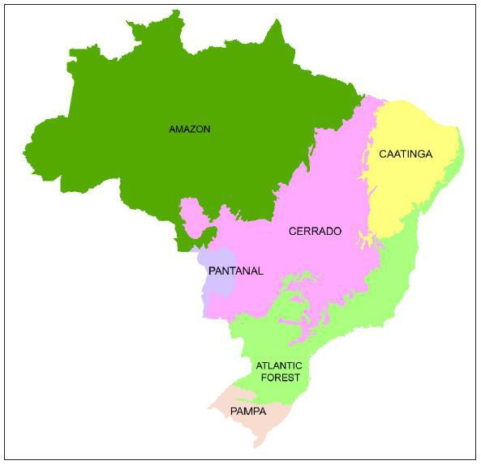

Figure 1: Distribution of the six biomes in the Brazilian
territory. Source: IBGE, 2011.

This will allow the country to assess and evaluate the effect of the implementation of policies and measures developed at the biome level (refer to Annex I, Part II, for details of the Action Plan to Prevent and Control Deforestation in the Legal Amazonia (PPCDAm); Annex IV, Part II, Box 4 for the Action Plan to Prevent and Control Deforestation and Forest Fires in the Cerrado (PPCerrado); and Annex IV, Part III for information on the Atlantic Forest.
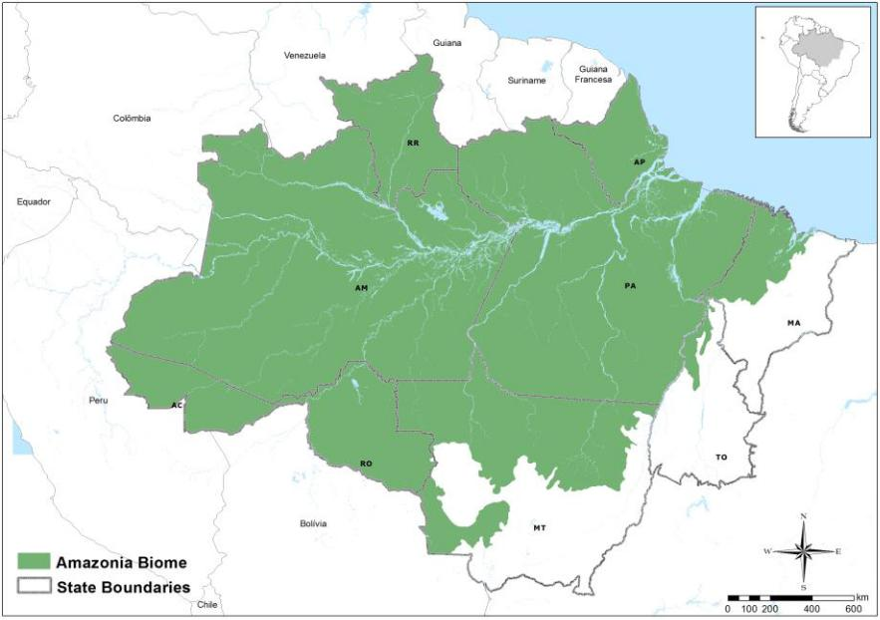

Figure 2: State boundaries and boundaries of the Amazonia biome. Source: MMA
(2014) based on IBGE (2010).

9
Considering the significant relative contribution of the net CO2 emissions from Land Use, Land-use Change and Forestry (LULUCF) to the total national net CO2 emissions; and the significant contribution of the Amazonia biome to the total CO2 emissions from LULUCF (refer to Figure 3), Brazil deemed appropriate to initially focus its actions in the forest sector through “reducing emissions from deforestation” in the Amazonia biome, as an interim measure, while transitioning to a national strategy that will include all biomes.
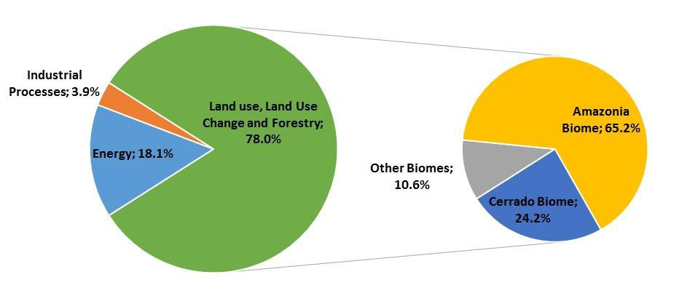

Figure 3: The relative contribution of the Energy, Industrial Processes and LULUCF sectors to the total CO2 emissions at year 20003 (excluding waste)4; and the relative contribution of the Brazilian biomes to the total LULUCF emissions (excluding liming) from Brazil. Source: BRASIL, 2010, Volume 1, Part 2, Chapter 2.

Regardless of the fact that this FREL submission for REDD+ results-based payments includes only CO2 emissions from gross deforestation in the Amazonia biome (see Box 1 below for details), preliminary information is provided in Annex IV, Part II, Box 4 for the Cerrado and in Annex IV, Part III for the Atlantic Forest, to indicate efforts already under development in Brazil to transition to a national FREL.

This submission includes emissions from the following carbon pools: above and below-ground biomass, and litter. The non-inclusion of the dead wood and the soil organic carbon pools (mineral and organic soils) are dealt with in section c.2.

Box 1: Forest and deforestation in the Amazonia biome

The National Institute for Space Research (INPE) through the Amazonian Gross Deforestation Monitoring Project (PRODES) annually assesses gross deforestation in “primary” forests in Legal Amazonia with a minimum mapping unit of 6.25 hectares

- The Guidelines for the preparation of national communications from Parties not included in Annex I to the Convention in the Annex of Decision 17/ CP.8 states that non-Annex I Parties shall estimate national GHG inventories for the year 1994 for the initial national communication or alternatively may provide data for the year 1990. For the second national communication, non-Annex I Parties shall estimate national GHG inventories for the year 2000 (UNFCCC, 2002).
- The relative contributions of CO2 emissions from waste to the total CO2 emissions in 2000 was less than

- per cent (0.006 per cent) and hence have been excluded from Figure 2. The relative contribution of CO2 emissions from liming to the total CO2 emissions from the LULUCF sector in 2000 was also less than 1 per cent (0.7 per cent) and hence also excluded from Figure 2.

10
(for details refer to Annex I, Part I, BOX 1). PRODES forest definition includes all vegetation types of Evergreen Forest Formations in the Legal Amazonia and forest facies of other formations such as Savanna and Steppe, which are generally classified as “Other Wooded Land” according to the Food and Agriculture Organization of the United Nations (FAO) classification system (see Section d of this submission for more information on the definition of forest adopted by Brazil). The presence of these facies in the Amazonia biome is not significant. However, when deforestation occurs in any of these facies, the associated emissions are calculated using their corresponding carbon density, provided in Tables 4 and 5.

At the beginning of PRODES in 1988, a map containing the boundary between Forest – Non-Forest was created based on existing vegetation maps and spectral characteristics of forest in Landsat satellite imagery. In 1987, all previously deforested areas were aggregated in a map (including deforestation in forest areas that in 1987 were secondary forests) and classified as deforestation. Thereafter, on a yearly basis, deforestation in the Amazonia biome has been assessed on the remaining annually updated Forest.

For the purposes of PRODES, the areas of Non-Forest are not monitored (regardless of being managed or unmanaged following the IPCC definition of managed land5 (IPCC, 2006). Deforestation occurring in Forest land (managed or unmanaged) is monitored and the associated CO2 emission calculated assuming instantaneous oxidation at the year deforestation occurs. Hence, the accumulated gross deforestation in the Brazilian Amazonia never decreases at each new assessment.

Another system developed and implemented by INPE and the Brazilian Enterprise for Agriculture (EMBRAPA) tracks the dynamics of land cover after deforestation, including to Secondary Forest. This system, referred to as TerraClass, maps the land use dynamics in areas that have been previously deforested in the Amazonia biome:

(http://www.inpe.br/cra/projetos_pesquisas/terraclass2010.php and http://www.inpe.br/noticias/noticia.php?Cod_Noticia=3302).

The CO2 removed from the atmosphere by Secondary Forest is not taken into account in the construction of this FREL due to the dynamics of Secondary Forest in Brazil. In Amazonia, approximately 20 per cent of the land deforested is abandoned to regrow (Secondary Forest), thus accumulating carbon. However, this Secondary Forest may eventually be cut again (thus losing all the carbon accumulated) to be converted to cropland or grassland, and normally remains in the new land-use category for a few years before abandonment. In this case, the gains and losses of carbon in Secondary Forests balance out, justifying why Brazil opted to report emissions from gross deforestation and not net deforestation.

The Brazilian deforestation time series from PRODES relate only to deforestation in primary forests that may or may not have been impacted by human activities or natural events but has not shown a clear cut pattern in the satellite imagery. Hence, areas previously logged, whenever identified in the satellite imagery as clear cut, are

- Managed land is land where human interventions and practices have been applied to perform production, ecological or social functions. (IPCC, 2006)

11
included as deforestation in PRODES.

Areas under selective logging activities are monitored under another project developed by INPE (DETEX – Detection and Mapping of Selective Logging Activities Project) that is presently undergoing new developments to discriminate impact levels and, if feasible, between authorized and non-authorized logging. Data for DETEX are already available since 2008 but are still aggregated in a single class.

Deforestation of other than primary forest is reported in the National GHG Inventory of Brazil. However, given Brazil´s national circumstances (one of the largest primary tropical forests in the world) and considering the marginal contribution of emissions from conversion of these other types of forests to the total emission from deforestation in Amazonia (1.57 per cent – refer to Table 3.98 in the Second National GHG Inventory), these other forest types (planted forests – Rev; Secondary Forests, Sec) have not been included in Brazil´s FREL.

Section c in this submission (Pools, gases and activities included in the construction of the FREL) provides more detailed information regarding other pools and gases.

Annex III (Development of FRELs for other REDD+ activities in the Amazonia biome) provides some preliminary information regarding forest degradation and introduces some ongoing initiatives to estimate the associated emissions, so as not to exclude significant activities from consideration.

There is recognition of the need to continue to improve the estimates of emissions associated with REDD+ activities, pools and gases. However, the material in the Annexes to this submission is not meant for results-based payments.

Brazil followed the guidelines for submission of information on reference levels as contained in the Annex to Decision 12/CP.17 and structured this submission accordingly, i.e.:

- Information that was used in constructing a FREL;

- Complete, transparent, consistent, and accurate information, including methodological information used at the time of construction of FRELs;

- Pools and gases, and activities which have been included in FREL; and

- The definition of forest used in the construction of FREL.

Details are provided below.

a) Information that was used in constructing the FREL

The construction of the FREL for reducing emissions from deforestation in the Amazonia biome was based on INPE´s historical time series for gross deforestation in

12
the Legal Amazonia6 using Landsat-class satellite data on an annual, wall-to-wall basis since 1988.

The Legal Amazonia encompasses three different biomes: the entire Amazonia biome; 37 per cent of the Cerrado biome; and 40 per cent of the Pantanal biome. Figure 4 shows the aggregated deforestation up to 2012 in the Legal Amazonia, per biome (in yellow). Up to 2012, about 12 per cent of the total accumulated deforestation in the Legal Amazonia occurred in the Cerrado and Pantanal biomes, mainly in the early 1990´s.

For the construction of the FREL for the Amazonia biome, the areas from the Cerrado and Pantanal biomes in the Legal Amazonia have been excluded.
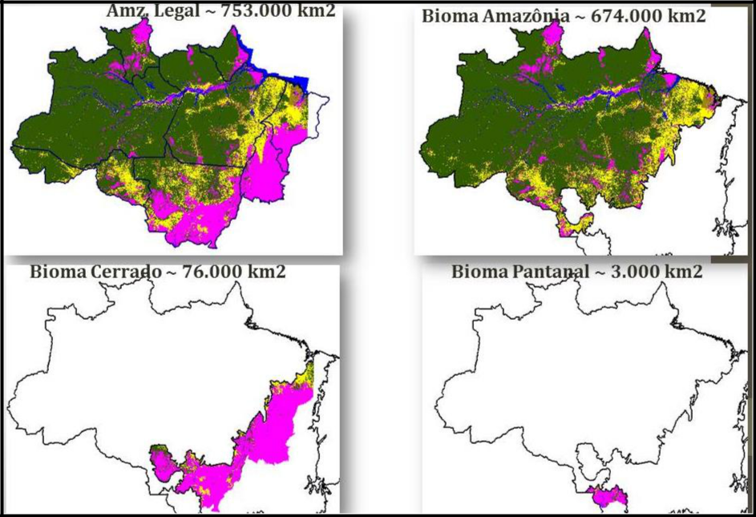

Figure 4: Aggregated deforestation (in yellow) up to year 2012 in the Legal Amazonia, and in the Amazonia, Cerrado and Pantanal biomes. Forest in green; Non-Forest in pink; water bodies in blue. Source: INPE (2014b).

The area of the deforestation polygon by forest type (in km2 or hectares) is the activity data necessary for the application of the first order approximation to estimate emissions7 as suggested in the IPCC Good Practice Guidance for Land Use, Land-use Change and Forestry (GPG LULUCF) (IPCC, 2003). These areas have been obtained from PRODES time series data (modified to consider only deforestation in the Amazonia biome) and the vegetation map from the Brazilian Institute for Geography and Statistics (IBGE). The fact that satellite data from optical systems (e.g., Landsat) are the basic source of information to identify new deforestation events every year, and

- The Legal Amazonia is an area of approximately 5,217,423 km² (521,742,300 ha) that covers the totality of the following states: Acre, Amapá, Amazonas, Pará, Rondônia, Roraima and Tocantins; and part of the states of Mato Grosso and Maranhão.

- “In most first order approximations, the “activity data” are in terms of area of land use or land-use change. The generic guidance is to multiply the activity data by a carbon stock coefficient or “emission factor” to provide the source/or sink estimates.” (IPCC, 2003; section 3.1.4, page 3.15).

13
considering that the presence of clouds may impair the observation of deforestation events under clouds, requires the application of an approach to deal with the estimation of the areas of primary forest under clouds that may have been deforested so as not to underestimate the total deforestation at any year (refer to Box 2 for alternative approaches to estimate the area of gross deforestation in the Amazonia biome). This is in line with good practice as defined in GPG LULUCF (IPCC, 2003).

Box 2: Approaches to estimate the area of gross deforestation in the Amazonia biome

There are several approaches to estimate the area deforested and each may lead to different results. The total deforested area may be different if calculated as deforestation increment, or deforestation rate, or adjusted deforestation increment. To further clarify the above, the text that follows explains the different approaches and terminologies used throughout this submission.

- Deforestation Polygons (at year t): refer to new deforestation events identified from the analysis of remotely sensed data (satellite images) at year t as compared to the accumulated deforestation mapped up to year t-1. Each deforestation polygon is spatially identified (geocoded), has accurate shape and area representations, and has an associated date of detection (the date of the satellite image from which it was mapped). For each year, a map containing all deforestation polygons (deforestation map) is made available in shapefile format for PRODES (and hence, for the Amazonia biome, after exclusion of the areas associated with the Cerrado and Pantanal biomes) at (http://www.obt.inpe.br/prodesdigital/cadastro.php). This map does not include deforestation polygons under cloud covered areas. However, the deforestation map also renders spatially explicit distribution of the cloud covered areas.

- Deforestation Increment (at year t): refers to the sum of the areas of all observed deforestation polygons within a given geographical extent. This geographical extent may be defined as the boundaries of a satellite scene which has the same date as the deforestation polygons mapped on that scene; or the entire Amazonia biome, for which the deforestation increment is calculated as the sum of the individual deforestation increment calculated for each scene that covers the biome. The deforestation increment may underestimate the total area deforested (and associated emissions), since it does not account for the area of deforestation polygons under clouds.

- Adjusted Deforestation Increment (at year t): this adjustment is made to the deforestation increment at year t-1 (or years t-1 and t-2, etc., as applicable) to account for deforestation polygons in areas affected by cloud cover and that are observable at time t. It is calculated according with Equation 1:

Incadj(t ) = Inc(t ) − ∑ACC(t −Δ),(t ) | + ∑ | ACC(t −Δ),(t ) | + ∑ | ACC(t +Ω),(t ) | Equation 1
Incadj(t ) = Inc(t ) − ∑ACC(t −Δ),(t ) | + ∑ | Δ +1 | + ∑ | Ω +1 | Equation 1
Δ=1 | Δ=1 | Δ +1 | Ω−1 | Ω +1

14

where:

Incadj(t ) = adjusted deforestation increment at year t; km2 Inc(t ) = deforestation increment at year t; km2

ACC(t −Δ),(t ) = area of the deforestation polygons observed (cloud-free)

at

Δ

year t over cloud-covered areas at year t- Δ ; km2. Note that when
=1, A − equals the area of the deforestation polygons
CC(t 1),(t )

observed at year t over cloud-covered areas at year t-1 (but which were under cloud-free at year t-2); for Δ = 2 , ACC(t −2),(t ) equals the area of the deforestation polygons observed at year t over an area that was cloud-covered at both years t-1 and t-2.

ACC(t +Ω),(t ) | = area of the deforestation polygons observed at year t+ Ω

over cloud-covered areas at year t; km2. Note that when |  |  |  |  |  |  | Ω =1 | , the
term | A |  |  | provides the area of the deforestation polygons observed
term |  | CC(t +1),(t )
at year |  |  | t+1 over the area |  |  | that was cloud-covered at year t; when
Ω = 2 |  | , | the term |  | A | provides the area of the deforestation
 |  | , |  |  | CC(t +2),(t )
polygons observed at year t+2 over the area that was cloud-covered at years t and t+1.

Δ = number of years that a given area was persistently affected by
cloud cover prior to year t but was observed at year t; Δ =1, 2, ....

- = number of years until a given area affected by cloud cover at year t is observed in subsequent years (i.e., is free of clouds); Ω = 1,2, …

As an example, suppose that the area of the deforestation increment observed at year t, Inc(t ) , is 200 km2 and that 20 km2 of this occurred over primary

forest areas that were cloud covered at year t-1 (but are cloud-free at year t). Since these 20 km2 may accumulate the area of the deforestation polygons under clouds at year t-1 and the area of the deforestation polygons that occurred at year t, the deforestation increment may overestimate the total area deforested area (and associated emissions) at year t.

The adjusted deforestation increment Incadj(t ) at year t evenly distributes the

total area of the deforestation polygons observed at year t under the cloud-covered area at year t-1 (or before, if the same area was also cloud covered at year t-2, for instance) among years t-1 and t. Hence, the adjusted deforestation increment at year t is 190 km2 (200 – 20/2) and not 200 km2, assuming that there were no cloud-covered areas at year t (in which case the

15
 | ∑ | A
adjusted deforestation increment at year t would be adjusted by | ∑ | CC(t +Ω)( t )
 | ∑ | Ω +1
 | Ω=1 | Ω +1
where ACC(t +Ω),(t ) = area of the deforestation polygons observed at year t+ |  |  | Ω

over cloud-covered areas at year t; and Ω is the number of years that a given area affected by cloud cover at year t is observed (i.e., is free of clouds).

The rationale behind Equation 1 is to remove from the deforestation
increment the area to be distributed among the years (- ∑ ACC(t −Δ),(t ) |  |  |  |  |  | ) and then
 |  |  |  | Δ=1
 | ⎛ | ∑ | A | ⎞
add back the portion allocated to year t | ⎜ | ∑ | CC(t −Δ),(t ) | ⎟ | . The last term of the
add back the portion allocated to year t | ⎜ | ∑ | Δ +1 | ⎟
 | ⎝ | Δ=1 | Δ +1 | ⎠
equation refers to the area distributed from subsequent years (or year) over cloud covered areas at year t.

- Deforestation Rate (at year t): was introduced in PRODES to sequentially address the effect of cloud cover; and, if necessary, the effect of time lapse between consecutive images. The deforestation rate aims at reducing the potential under or over-estimation of the deforested area at year t. The presence of cloud-covered areas in an image at year t impairs the observation of deforestation polygons under clouds, and may lead to an underestimation of the area deforested; while the presence of clouds in previous years (e.g., at year t-1) may lead to an overestimation of the area deforested if all deforestation under clouds at year t-1 is attributed to year t.

This over or under-estimation may also occur if the dates of the satellite images used in subsequent years are not adjusted. To normalize for a one year period (365 days) the time lapse between the images used at years t and t+1, the rate considers a reference date of August 1st and projects the cloud corrected increment to that date, based on a model that assumes that the deforestation pace is constant during the dry season and zero during the wet season. Refer to Annex I, Part I for more information on PRODES methodology for calculating the deforestation rate.

As an example of cloud correction, suppose that the primary forest area in an image is 20,000 km2 and that 2,000 km2 of this occurred over primary forest areas that were cloud covered. Suppose also that the observed deforestation increment is 180 km2. As part of the calculation of the rate, it is assumed that the proportion of deforestation measured in the cloud-free forest area (18,000 km2) is the same as that in the area of forest under cloud (2,000 km2). Therefore the proportion 180/18,000 = 0.01 is applied to the 2,000 km2, generating an extra 20 km2 that is added to the observed deforestation increment. In this case, the cloud corrected increment is 200 km2.

IMPORTANT REMARKS:

- Note that at any one year, an estimate based on the adjusted deforestation increment may be higher or lower than the rate of gross deforestation.

- For the sake of verifiability, this submission introduces a slight change in the methodology used in PRODES to estimate the annual area deforested.

16
PRODES methodology to annualize observed deforestation and to take into account unobserved areas due to cloud cover is not directly verifiable unless all the estimates are adjusted backwards.

- The approach applied in this submission relies on a verifiable deforestation map and does not annualize the time lapse between consecutive scenes. It deals with the effect of cloud cover by equally distributing the area of the deforestation polygons observed at year t over cloud-covered areas at year t-1 (or to years where that area was persistently cloud covered) among years t and t-1.

- The use of the adjusted deforestation increment to estimate the area deforested and associated gross emissions is deemed to be more appropriate for REDD+, due to the verifiability.

Annex II, Part I, provides an example of the application of the adjusted deforestation increment approach to estimate the area deforested at year 2003, as presented in Table 1.

In addition to the area of the annual gross deforestation by forest type, another fundamental element to estimate the associated emission is the emission factor that, here, consists of the carbon density associated with each forest type considered in this submission, consistent with the Second National GHG Inventory (in tonnes of carbon per unit area, tC ha-1) (refer to Tables 4 and 5). Annex II, Part II provides a table with the description of the sub-classes included under each forest type contained in this FREL submission. The forest types addressed in this submission are in line with those in Fearnside (2004) presented on Table 2 (Forest Types in the Brazilian Amazonia).

The carbon density per unit area was estimated using an allometric equation developed by Higuchi et al., (1998) from the National Institute for Amazonia Research (INPA), to estimate the aboveground fresh mass8 of trees from distinct forest types9 in the Amazonia biome as well as data from the scientific literature, as necessary (refer to Box 3 and section b.2).

Box 3: Choice of the Allometric Equation to Estimate Aboveground Biomass

Four statistical models (linear, non-linear and two logarithmic) selected from thirty-four models in Santos (1996) were tested with data from 315 trees destructively sampled to estimate the aboveground fresh biomass of trees in areas near Manaus, Amazonas State, in the Amazonia biome (central Amazonia). This area is characterized by typical dense “terra firme” moist forest in plateaus dominated by yellow oxisols.

In addition to the weight of each tree, other measurements such as the diameter at breast height, the total height, the merchantable height, height and diameter of the canopy were also collected. The choice of the best statistical model was made on the basis of the largest coefficient of determination, smaller standard error of the estimate,

- Hereinafter referred simply as aboveground fresh biomass.

- These forest types, or vegetation classes, totaled 22 and were derived from the Vegetation Map of Brazil (1:5,000,000), available at: ftp://ftp.ibge.gov.br/Cartas_e_Mapas/Mapas_Murais/, last accessed on May 5th, 2014.

17
and best distribution of residuals (Santos, 1996).

For any model, the difference between the observed and estimated biomass was consistently below 5 per cent. In addition, the logarithm model using a single independent variable (diameter at breast height - DBH) produced results as consistent as and as precise as those with two variables (DBH and height) (Higuchi, 1998).

Silva (2007) also demonstrated that the total fresh weight (above and below-ground biomass) of primary forest can be estimated using simple entry (DBH) and double entry (DBH and height) models and stressed that the height added little to the accuracy of the estimate. The simple entry model presented percent coefficient of determination of 94 per cent and standard error of 3.9 per cent. For the double entry models, these values were 95 per cent and 3.7 per cent, respectively. It is recognized that the application of the allometric equation developed for a specific area of Amazonia may increase the uncertainties of the estimates when applied to other areas.

In this sense, the work by Nogueira et al. (2008) is relevant to be cited here. Nogueira et al. (2008) tested three allometric equations previously published and developed for dense forest in Central Amazonia (CA): Higuchi et al. (1998), Chambers et al. (2001) and Silva (2007). All three equations developed for CA tend to overestimate the biomass of the smaller trees in South Amazonia and underestimate the biomass of the larger trees. Despite this, the total biomass of the sampled trees estimated using the equations developed for CA was similar to those obtained in the field (-0,8%, -2,2% e 1,6% for the equations from Higuchi et al., 1998; Chambers et al., 2001 and Silva, 2007, respectively, due to the compensation of under and over-estimates for the small and larger trees. However, when the biomass per unit area is estimated using the equations developed for the CA, the estimates were 6.0 per cent larger for the equations from Higuchi et al. (1998); 8.3 per cent larger for Chambers et al. (2001); and 18.7 per cent for Silva (2007).

The input data for applying Higuchi et al. (1998) allometric equation have been collected during the RADAM (RADar in AMazonia) Project (later also referred to as RADAMBRASIL project or simply RADAMBRASIL)10. RADAMBRASIL collected georeferenced data from 2,292 sample plots11 in Amazonia (refer to Figure 11 for the spatial distribution of the sample plots), including circumference at breast height (CBH) and height of all trees above 100 cm. More details regarding the allometric equation are presented in section b.2.

The FREL proposed by Brazil in this submission uses the IPCC methodology as a basis for estimating changes in carbon stocks in forest land converted to other land-use categories as described in the GPG LULUCF (IPCC, 2003). For any land-use conversion occurring in a given year, GPG LULUCF considers both the carbon stocks in the biomass immediately before and immediately after the conversion.

Brazil assumes that the biomass immediately after the forest conversion is zero and does

- The RADAMBRASIL project was conducted between 1970 and 1985 and covered the entire Brazilian territory (with special focus in Amazonia) using airborne radar sensors. The results from RADAMBRASIL Project include, among others, texts, thematic maps (geology, geomorphology, pedology, vegetation, potential land use, and assessment of natural renewable resources), which are still broadly used as a reference for the ecological zoning of the Brazilian Amazonia.

- Also referred in this submission as sample units, consisting of a varied number of trees.

18
not consider any subsequent CO2 removal after deforestation (immediately after the conversion or thereafter). This assumption is made since Brazil has a consistent, credible, accurate, transparent, and verifiable time-series for gross deforestation for the Legal Amazonia (and hence, for the Amazonia biome), but has limited information on subsequent land-use after deforestation and its dynamics.

The text that follows provides detailed information about the construction of Brazil´s FREL.

The basic data for estimating annual gross emissions from deforestation in the Amazonia biome derives from the analysis of remotely sensed data from sensors of adequate spatial resolution (mostly Landsat-5, of spatial resolution up to 30 meters). Images from the Landsat satellite acquired annually over the entire Amazonia biome (refer to Figure 5), on as similar as possible dates are selected, processed and visually interpreted to identify new deforestation polygons since the previous assessment (for details regarding the selection, processing and analysis phases, refer to Annex I, Part I). This generates, for each image in the Amazonia biome a map with spatially explicit (georeferenced) deforestation polygons since the previous year.
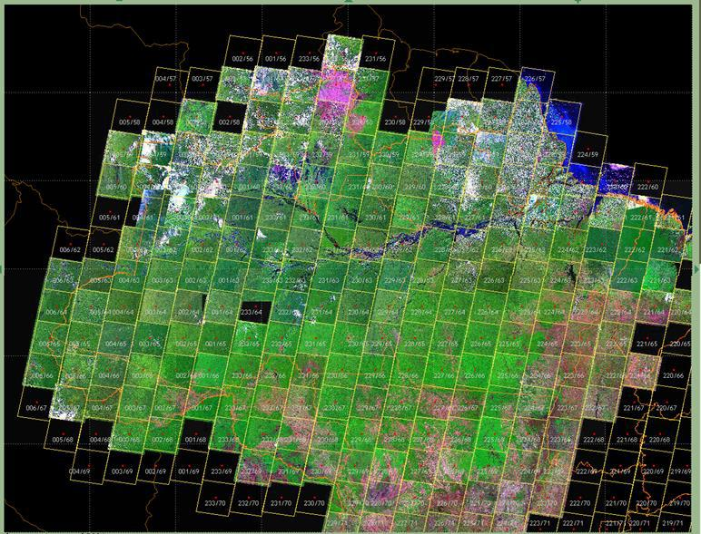

Figure 5: Landsat coverage of the Brazilian Legal Amazonia area. Source: PRODES, 2014

The next step in the process for estimating emissions from deforestation in the Amazonia biome consists of overlaying this deforestation map with the “carbon map” containing the carbon densities associated with distinct forest types in the Amazonia biome. Each deforestation polygon in a given image is associated with a RADAMBRASIL volume, a forest type and associated carbon density. Note that the same forest type may have a different carbon density depending on the RADAMBRASIL volume. This is due to variability in soil types, climatic conditions and flood regime for riparian vegetation in the Amazonia biome.

19
The carbon map is the same as the one used to estimate the emissions from forest conversion in the Second National GHG Inventory (details of the carbon map are provided in Section b.2).

Figures 6 to 8 present the sequence followed to estimate the total emission from deforestation for any year in the period from 1996 to 2010, used in the construction of the FREL.

Due to the fact the digital (georeferenced) information on the annual deforestation polygons only became annually available from 2001 onwards; that for the period 1998-2000 inclusive, only an aggregated digital map with the deforestation increments for years 1998, 1999 ad 2000 is available; and that no digital information is available individually for years 1996 and 1997, the steps and figures below seek to clarify how the estimate of the total CO2 emission was generated for each year in the period 1996 to 2010.

In order to simplify the presentation, Steps 1 to 4 assume that all the images used to identify the deforestation polygons were cloud free. Under this assumption, the adjusted deforestation increment is equal to the deforestation increment, and both are equal to the sum of the areas of the deforestation polygons mapped. In the presence of cloud cover, then the deforested areas are calculated following the adjusted deforestation increment approach described in Box 2.

Step 1: identification of the available maps with deforestation polygons, as follows: (i) map with the aggregated deforestation until 1997; aggregated deforestation polygons for 1998-2000; and individual maps with deforestation polygons for each year in the period 2001 to 2010 (inclusive).
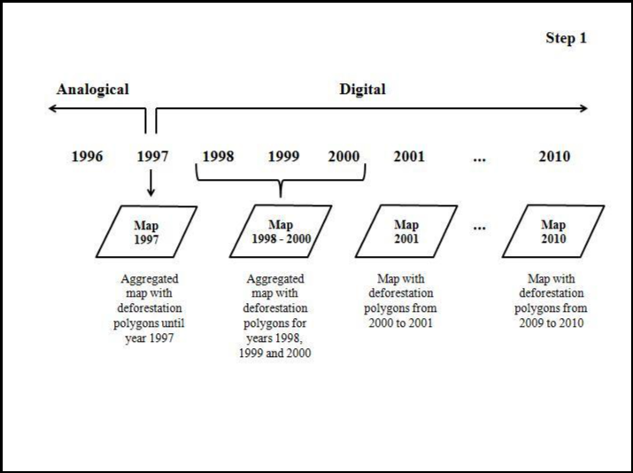

Figure 6: Pictoral representation of Step 1.

20

Step 2: integration of the map with the deforestation polygons (Step 1) with the carbon map in a Geographic Information System (GIS). For each year, a database containing each deforestation polygon and associated forest type (as well as RADAMBRASIL volume) is produced and is the basis for the estimation of the gross emissions from deforestation (in tonnes of carbon) which, multiplied by 44/12, provide the total emissions in tonnes of CO2.

For the period 1998-2000, the total CO2 emissions refer to those associated with the aggregated deforestation polygons for years 1998, 1999 and 2000 that, when divided by 3, provide the average annual CO2 emission.
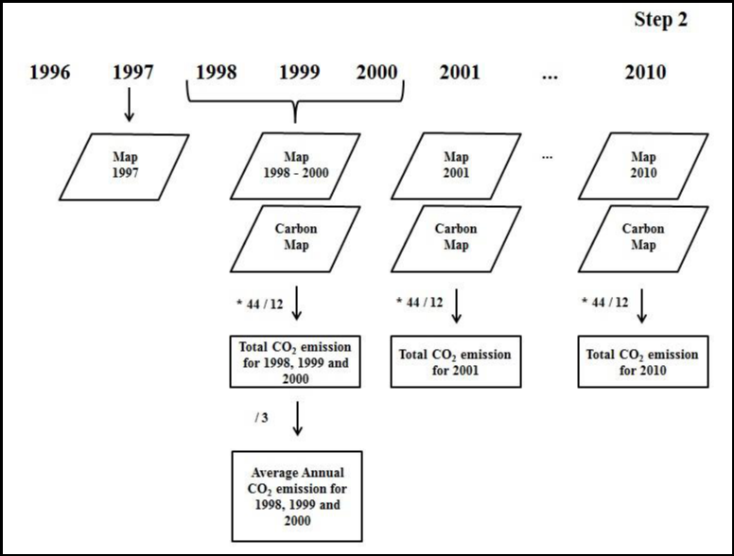

Figure 7: Pictoral representation of Step 2.

Step 3 indicates the estimated CO2 emissions for each year from 1998 (inclusive) until 2010; and Step 4 indicates the CO2 emissions for years 1996 and 1997.

21
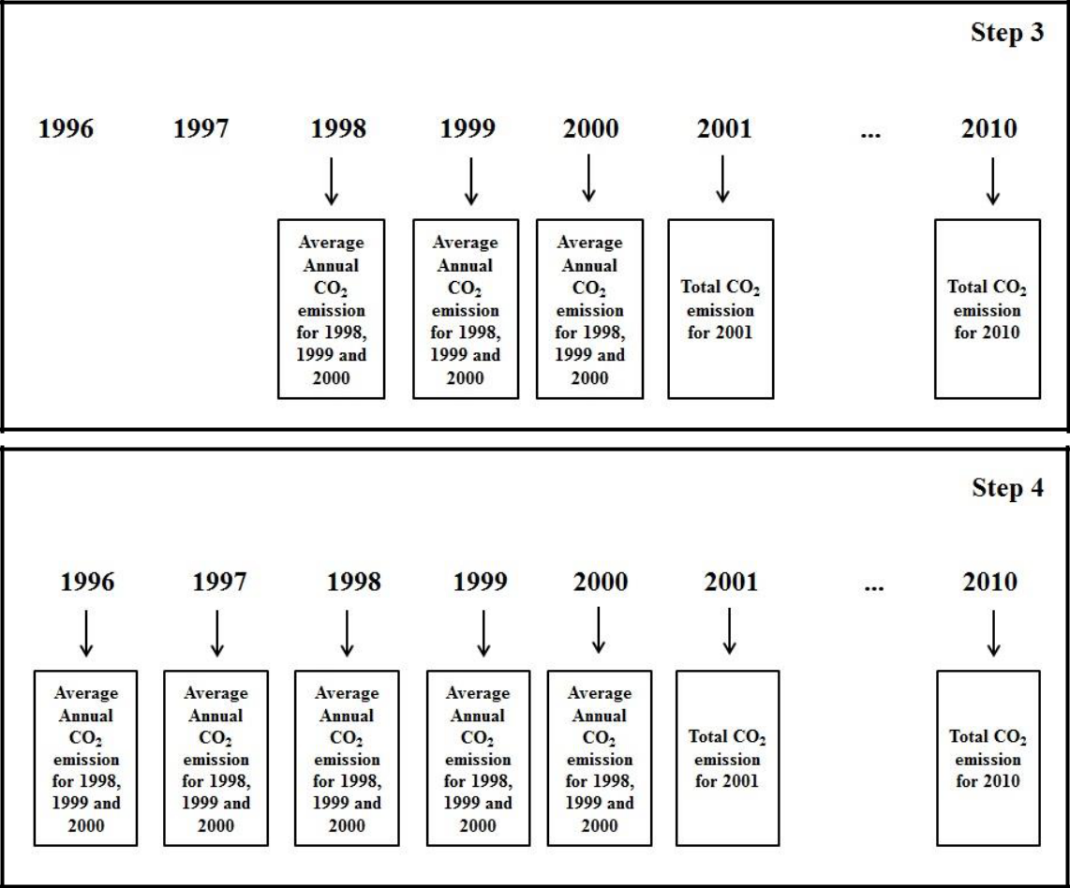

Figure 8: Pictoral representation of Step 3 and Step 4.

The next step is only applicable in case of the presence of cloud cover at year t.

Step 5: After the deforestation increment and associated emission have been estimated for year t, an analysis is made of the areas that were cloud covered in the previous year(s), for which information on deforestation is available at year t. The area of the observed deforestation polygons at year t that occur under the cloud covered area(s) at year t-1 is removed from the increment calculated for year t and evenly distributed (summed) to the increment calculated for year t-1 and year t.

As an example, suppose that the area of the deforestation polygons at year t that fall under a cloud-covered area at year t-1 is 100 km2. For the calculation of the adjusted deforestation increment for years t and t-1, these 100 km2 are subtracted from the increment calculated for year t and evenly distributed between years t and t-1 (i.e., 50 km2 is added to the observed increment for year t-1, and 50 km2 is added to the “reduced” increment for year t. In case the area observed at year t was cloud covered at years t-1 and t-2, then one third of the 100 km2 is evenly distributed (summed) to the increment calculated for years t, t-1, and t-2. Hence, the deforestation increment at year t can be reduced due to the distribution of some area to previous years, but may also increase due to the distribution of areas at year t+1 over cloud covered areas at year t. The areas and associated emissions indicated in Table 1 are the areas presented as adjusted deforestation increment and their associated emissions.

22
ESTIMATING EMISSIONS FROM DEFORESTATION POLYGONS

For each deforestation polygon i, the associated CO2 emission is estimated as the product of its area and the associated carbon density in the living biomass12 present in the forest type affected by deforestation (refer to Equation 2).

Equation 2:

GEi,j = Ai,j × EFj × 44/12 | Equation 2
where:
GEi, j = CO2 emission associated with deforestation polygon i under forest type j;
tCO2
Ai, j = area of deforestation polygon i under forest type j; ha
EFj = carbon stock in the living biomass of forest type j in deforestation polygon i
per unit area; tC ha-1
44/12 is used to convert tonnes of carbon to tonnes of CO2

For any year t, the total emission from gross deforestation, GEt , is estimated using

Equation 3:

 | N | p
GEt | = ∑∑ GEi, j |  | Equation 3
 | i=1 | j =1
where:
GEt | = total emission from gross deforestation at year t; tCO2
GEi, j = CO2 emission associated with deforestation polygon i under forest type j;
tCO2

N = number of new deforestation polygons in year t (from year t-1 and t); adimensional

p = number of forest types, adimensional

For any period P, the mean annual emission from gross deforestation, MGEp , is calculated as indicated in Equation 4:

- Living biomass, here, means above and below-ground biomass, including palms and vines, and litter
mass.

23
 | T | t
 | å | t
 |  | GE
MGE | = t =1
P | T

Equation 4

where:

MGEp = mean annual emission from gross deforestation in period p; tCO2 yr-1 GEt = total emission from gross deforestation at year t; tCO2
T = number of years in period p; adimensional.

BRAZIL´S FREL FROM GROSS DEFORESTATION IN THE AMAZONIA BIOME

The FREL proposed by Brazil is a dynamic mean of the CO2 emissions associated with gross deforestation since 1996, updated every five years, using the best available historical data and consistent with the most recent National GHG Inventory submitted by Brazil to the UNFCCC at the time of the construction of the FREL.

This base year was chosen by the Working Group of Technical Experts on REDD+ so as to leave out the high deforestation peak in 1995 and also to maintain consistency with other initiatives in Brazil, including the Action Plan to Prevent and Control Deforestation in the Legal Amazonia (see Annex I, Part I for details), the National Climate Change Policy13 and the Amazon Fund (www.amazonfund.gov.br).

The dynamic nature of Brazil´s FREL is meant to reflect the effects of policies and plans implemented in the Amazonia biome14, as well as improvements in data quality and availability.

Brazil’s FREL does not include assumptions on potential future changes to domestic policies.

In summary, for results based payments the following applies:

- For results obtained in the period from 2006 to 2010, inclusive, the FREL is equal to the mean annual CO2 emissions associated with gross deforestation (calculated as adjusted deforestation increment) from the period 1996 to 2005, inclusive (refer to Figure 9 and Table 1).

- For results obtained in the period from 2011 to 2015, inclusive, the FREL is equal to the mean annual CO2 emissions associated with gross deforestation (calculated as adjusted deforestation increment) from 1996 to 2010, inclusive (refer to Figure 9 and Table 1).

- For results obtained in the period from 2016 to 2020, the FREL is equal to the mean annual CO2 emissions associated with gross deforestation (calculated as adjusted deforestation increment) from 1996 to 2015, inclusive.

- For more information on the Presidential Decree no. 7390 of December 9, 2010 see: http://www.planalto.gov.br/ccivil_03/_Ato2007-2010/2010/Decreto/D7390.htm, last accessed on September 18th, 2014.

- For details regarding relevant policies and plans for the Amazonia biome, refer to Annex I, Part II.

24
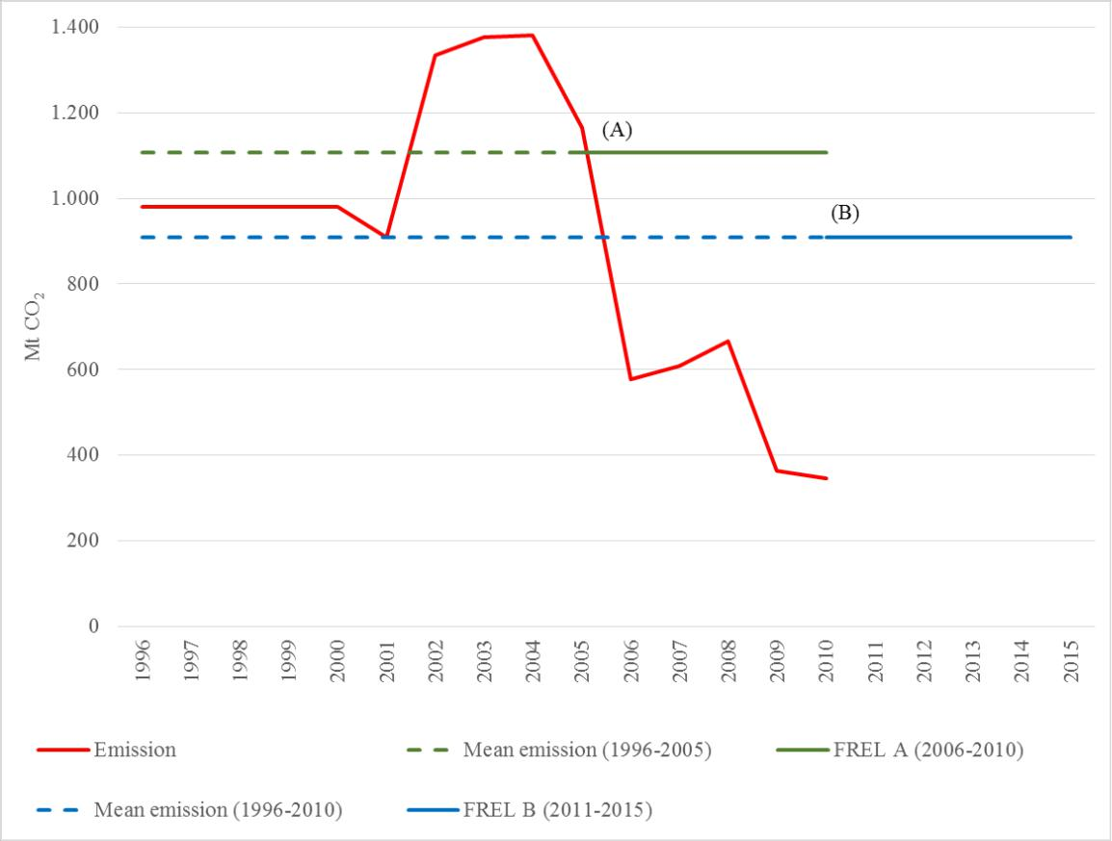

Figure 9. Pictoral representation of Brazil's FREL, where (A) refers to the mean annual CO2 emissions from the period 1996 to 2005 (1,106,027,616.63 tCO2); (B) refers to the mean annual CO2 emissions from the period 1996 to 2010 (907,959,466.33 tCO2).

Table 1. Adjusted deforestation increments and associated emissions (in tC and t CO2) from gross deforestation in the Amazonia biome, from 1996 to 2010.

 |  |  | ADJUSTED |  | EMISSIONS FROM |  | CO2 EMISSIONS
 | YEAR |  | DEFORESTATION |  | GROSS |  | FROM GROSS
 | YEAR |  | INCREMENT |  | DEFORESTATION |  | DEFORESTATION
 |  |  | (ha) |  | (tC) |  | (t CO2)
 | 1996 |  | 1,874,013.00 |  | 267,142,749.24 |  | 979,523,413.88
 | 1997 |  | 1,874,013.00 |  | 267,142,749.24 |  | 979,523,413.88
 | 1998 |  | 1,874,013.00 |  | 267,142,749.24 |  | 979,523,413.88
 | 1999 |  | 1,874,013.00 |  | 267,142,749.24 |  | 979,523,413.88
 | 2000 |  | 1,874,013.00 |  | 267,142,749.24 |  | 979,523,413.88
2001 |  | 1,949,331.35 |  | 247,899,310.88 |  | 908,964,139.89
2002 |  | 2,466,603.88 |  | 363,942,942.80 |  | 1,334,457,456.93
2003 |  | 2,558,846.30 |  | 375,060,876.74 |  | 1,375,223,214.70
2004 |  | 2,479,429.81 |  | 376,402,076.09 |  | 1,380,140,945.68
 |  |  |  |  |  | 25

2005 | 2,176,226.17 | 317,420,001.73 | 1,163,873,339.68
2006 | 1,033,634.15 | 157,117,398.10 | 576,097,126.38
2007 | 1,087,468.65 | 165,890,835.62 | 608,266,397.26
2008 | 1,233,037.68 | 181,637,813.29 | 666,005,315.39
2009 | 596,373.64 | 99,365,584.69 | 364,340,477.19
2010 | 583,147.53 | 93,929,048.84 | 344,406,512.43
1996 - 2005 |  |  | 1,106,027,616.63
1996 - 2010 |  |  | 907,959,466.33

The areas presented in Table 1 are the adjusted deforestation increments of gross deforestation estimated for the Amazonia biome. Note that those from PRODES correspond to the rate of gross deforestation estimated for the Legal Amazonia. The grey lines in Table 1 correspond to years for which data are only available in analogic format. For any year in the period from 1996 to 2010, gross CO2 emissions from deforestation have been calculated following Steps 1-4 in Figures 6 to 8, and Step 5.

REDD+ decisions under the UNFCCC value the constant improvement of data sets and information over time. It is not expected that countries will submit their information to the UNFCCC only when and if they have the most accurate data available for all significant pools. Brazil understands that the most important element before accuracy is to ascertain consistency and transparency of the data submitted.

Brazil is investing considerable human and financial resources to improve its historical data sets. INPE has a project to expand Digital PRODES to years before 2001 which will allow for the spatial analysis of deforestation and lead to more precise estimates for years before 2000. With the improved data, Brazil will submit a revised FREL to the UNFCCC.

- Complete, transparent, consistent and accurate information used in the construction of the FREL

b.1. Complete Information

Complete information, for the purposes of REDD+, means the provision of information that allows for the reconstruction of the FREL.

The following data and information were used in the construction of the FREL and are available for download at http://www.mma.gov.br/redd/index.php/en/forest-reference-emission-levels-frel/spatial-information:

- All the satellite images used to map the deforestation polygons in the Amazonia biome from 1996 to 2010.

- Accumulated deforestation polygons until 1997 (inclusive), presented in a map hereinafter referred to as the digital base map (see Annex I, Part I for more details).

26
- Accumulated deforestation polygons for years 1998, 1999 and 2000 mapped on the digital base map.

- Annual deforestation polygons for the period from 2001 to 2010, inclusive (annual maps).

IMPORTANT REMARK 1: All maps referred to in (2), (3) and (4) above are available in shapefile format ready to be imported into a Geographical Database for analysis. All satellite images referred to in (1) above are provided in full resolution in geotiff format. Any individual deforestation polygon can be verified against the corresponding satellite image.

IMPORTANT REMARK 2: The maps referred to in (2), (3) and (4) above are a subset of those produced by INPE for PRODES (for additional information see http://www.obt.inpe.br/prodes/index.php) and refer only to the Amazonia biome, the object of this submission. The information in (2) and (3) above are provided in a single file.

(5) The deforestation polygons by forest type attributes and RADAMBRASIL volume;

For each year, the deforestation polygons are associated with the corresponding forest type and RADAMBRASIL volume. These files are large and are thus presented here only for year 200315, the year that has been used to exemplify the calculation of the adjusted deforestation increment (refer to Box 2 and Annex II, Part I).

It is worth noting that for all since 2001, the stratification of the deforestation polygons by forest type attributes and RADAMBRASIL volume indicated that deforestation concentrates mostly in the so called “Arc of Deforestation” (a belt that crosses over RADAMBRASIL volumes 4, 5, 16, 20, 22 and 26 – refer to Figure 11), and marginally affects forest types in RADAMBRASIL volumes associated with higher carbon densities.

- The information that allows for the calculation of the adjusted deforestation increments for years 2001, 2002, 2003, 2004 and 2005 is available at: http://www.mma.gov.br/redd/index.php/en/forest-reference-emission-levels-frel/spatial-information . Annex II, Part I provides an example of the calculation of the adjusted deforestation increment for year 2003 (see “calculo_def_increment_emission_2003” thought the FTP. file available at: http://www.mma.gov.br/redd/index.php/en/forest-reference-emission-levels-frel/spatial-information).

- A map with the carbon densities of different forest types in the Amazonia biome (carbon map), consistent with that used in the Second National GHG Inventory, the latest submitted by Brazil to the UNFCCC at the time of construction of the FREL.

- For year 2003, a total of 402,176 deforestation polygons have been identified. For each deforestation polygon in the file, the following information is provided: the State of the Federation it belongs (uf); the RADAMBRASIL volume (vol); the associated forest type (veg) and the associated area (in ha).

27
- Samples of the relevant16 RADAMBRASIL data that have been used as input to the allometric equation by Higuchi et al. (1998). They are generated from the original RADAMBRASIL database, which is the basis for the construction of the carbon map. Consultation with the Working Group of Technical Experts on REDD+ led to the understanding that there may be cases of apparent inconsistencies in carbon densities within a forest type due to specific circumstances of the sample unit. This is part of the natural heterogeneity of the biomass density distribution in tropical vegetation.

b.2. Transparent Information

This section provides more detailed information regarding the items indicated in section b.1.

Regarding (1): Satellite Imagery

As previously indicated (section a), remotely sensed data is the major source of information used to map deforestation polygons every year. The availability of all satellite images used since 1988 allows for the verification and reproducibility of annual deforestation polygons over primary forest in the Amazonia biome as well as the cloud-covered areas.

Note that since the beginning of year 2003, INPE adopted an innovative policy to make satellite data publicly available online. The first step in this regard was to make available all the satellite images from the China-Brazil Earth Resources Satellite (CBERS 2 and CBERS 2B) through INPE’s website (http://www.dgi.inpe.br/CDSR/). Subsequently, data from the North American Landsat satellite and the Indian satellite Resourcesat 1 were also made available. With this policy INPE became the major distributor of remotely sensed data in the world.

Regarding (2), (3) and (4): Deforestation polygons

All deforestation polygons17 mapped for the Amazonia biome (i.e., aggregated until 2007; aggregated for years 1998, 1999 and 2000; and annual from 2001 until 2010) are available at http://www.mma.gov.br/redd/index.php/en/forest-reference-emission-levels-frel/spatial-information.

Note that this information is a subset of that made available since 2003 by INPE for PRODES at www.obt.inpe.br/prodes. At this site, for each satellite image (see (1) above), a vector map in shapefile format is generated and made available, along with all the previous deforestation polygons, the areas not deforested, the hydrology network and the area of non-forest. For PRODES, this information is provided for each State of the Federation and for the Legal Amazonia. Figure 10 shows the screen as viewed by the users when accessing INPE´s website to download images and data.

- The original RADAMBRASIL data for the volumes where deforestation occurs most frequently (CBH, forest type, RADAMBRASIL volume) are provided at: http://www.mma.gov.br/redd/index.php/en/forest-reference-emission-levels-frel/spatial-information, as RADAMBRASIL sample units data.

- The information for PRODES is also available for the Legal Amazonia are publicly available since 2003 at INPE´s website (www.obt.inpe.br/prodes).

28
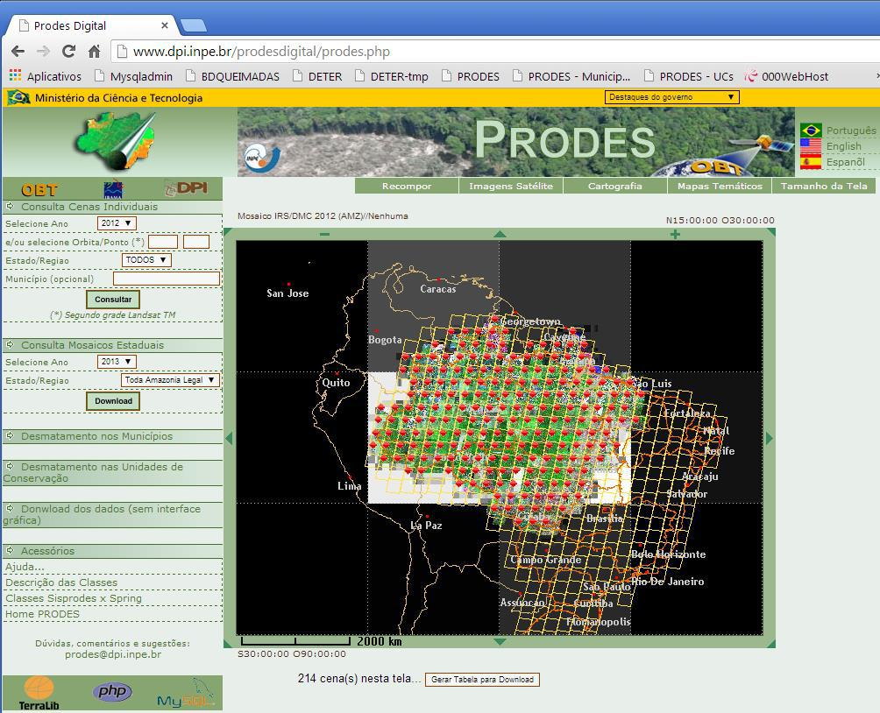

Figure 10. A sample of a window to download the information generated by PRODES. Source:
www.obt.inpe.br/prodes

Regarding (5): Deforestation polygons by forest type and RADAMBRASIL volume

In order to ensure transparency in the calculation of the annual adjusted deforestation increment and associated emission provided in Table 1, a file that associates each deforestation polygon with its forest type and corresponding RADAMBRASIL volume has been generated for each year since 2000. Since these files are large in size, the file for 2003, containing 402,176 deforestation polygons is made available at http://www.mma.gov.br/redd/index.php/en/forest-reference-emission-levels-frel/spatial-information, as tab “2003” in file “calculo_def_increment_emission_2003.xls”.

Regarding (6): Information for the calculation of the adjusted deforestation increment

The information to calculate the annual adjusted deforestation increment is provided in the website http://www.mma.gov.br/redd/index.php/en/forest-reference-emission-levels-frel/spatial-information for years 2001, 2002, 2003, 2004 and 2005 (shapefiles “SPAgregado2012_CO2AmazoniaCompleto_pol_split1”, “SPAgregado2012_CO2AmazoniaCompleto_pol_split2” and “SPAgregado2012_CO2AmazoniaCompleto_pol”).

29
It is important to note that the availability of data from similar spatial resolution sensors to Landsat is reducing the need for adjustments, as deforestation under cloud-covered areas is assessed using alternative satellite data.

Regarding (7): Carbon map

The map with the biomass density of living biomass (including palms and vines) and litter mass used to estimate the CO2 emissions from deforestation in Table 1 is the same as that used in the Second National GHG Inventory to estimate CO2 emissions from conversion of forest land to other land-use categories.

As already mentioned, the carbon map was constructed using an allometric equation by Higuchi et al. (1998) and data (diameter at breast height derived from the circumference at breast height) collected by RADAMBRASIL on trees in the sampled plots, as well as data from the literature, as necessary. The data collected by RADAMBRASIL were documented in 38 volumes distributed as shown in Figure 11 over the RADAMBRASIL vegetation map (refer to footnote 9). RADAMBRASIL data is provided for the relevant volumes at: http://www.mma.gov.br/redd/index.php/en/forest-reference-emission-levels-frel/spatial-information
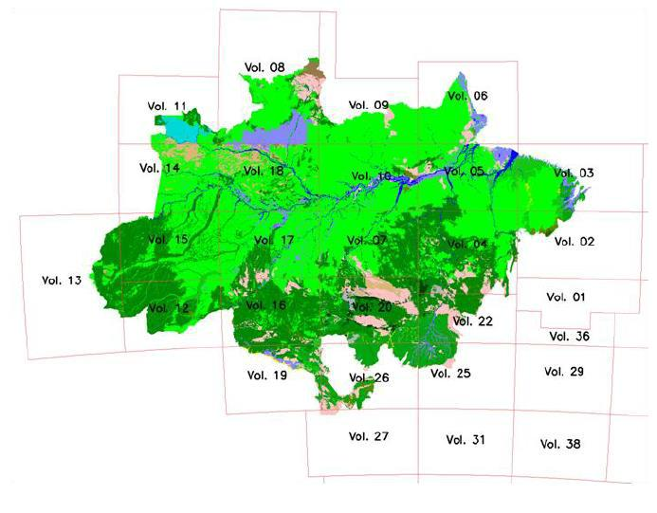

Figure 11: RADAMBRASIL Vegetation map of the Amazonia biome with the distribution of its 38
volumes. Source: BRASIL, 2010.

Regarding (8): RADAMBRASIL data

RADAMBRASIL collected a significant amount of data for each one of the 2,292 sample units. The relevant RADAMBRASIL data is provided for the sample units in the

30
relevant RADAMBRASIL volumes at site http://www.mma.gov.br/redd/index.php/en/forest-reference-emission-levels-frel/spatial-information, i.e., the volumes most affected by deforestation (volumes 4, 5, 16, 20, 22 and 26) and the information relevant for this submission, particularly CBH.

ADDITIONAL INFORMATION ON RADAMBRASIL DATA AND CONSTRUCTION OF THE CARBON MAP

All the RADAMBRASIL sample plots with relevant data for this submission consisted of transects of 20 meters by 500 meters (hence, 1 hectare). Figure 12 presents the distribution of the RADAMBRASIL sample plots in the biome Amazonia.

RADAMBRASIL collected data on trees with circumference at breast height above 100 cm in 2,292 sample plots. For the Second National GHG Inventory, some of these sample plots were eliminated if:

- after the lognormal fit, the number of trees per sample unit contained less than 15 or more than 210 trees (less than 1 per cent of the samples);

- the forests physiognomies were not found in the IBGE (Brazilian Institute for Geography and Statistics) charts; and

- no geographical information on the location of the sample unit was available.

The application of this set of rules led to the elimination of 582 sample plots from analysis (BRASIL, 2010).
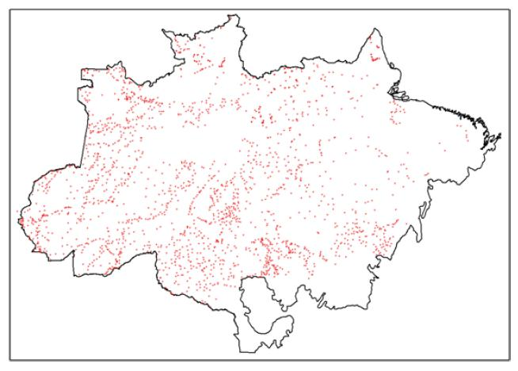

Figure 12. Distribution of the RADAMBRASIL sample plots. Source: BRASIL, 2010

31
The steps below are meant to facilitate the understanding regarding the construction of the carbon map:

- Reclassification of the forest types defined for the Amazonia biome, consistent with those contained in the Second National GHG Inventory.

- Identification of RADAMBRASIL sample units in the RADAMBRASIL vegetation map.

- Application of the allometric equation (Higuchi et al.,1998) to the data collected in the sample units for the specific forest type, to estimate the aboveground fresh mass from DBH (Equation 5).

- Conversion of aboveground fresh mass to dry mass and then to carbon in dry mass (Equation 6).

  - Inclusion of the carbon density of trees with CBH less than 100 cm (considering that RADAMBRASIL collected data only on trees with CBH larger than 100 cm) (Equation 7).

  - Inclusion of carbon of palms and vines (Equation 8).

  - Inclusion of carbon of belowground biomass and litter (Equation 9).

- Application of extrapolation rules to estimate the carbon density associated with the forest types in each RADAMBRASIL volume, noting that the same forest type in different volumes may have different values.

- Literature review to estimate the carbon density in forest types not sampled by
RADAMBRASIL.

Each of the above steps is now detailed.

Step 1: Reclassification of the forest types defined for the Amazonia biome, consistent with those of the Second National GHG Inventory.

The forest types in the Amazonia biome have been defined taking into account the availability of reliable data, either from RADAMBRASIL or from the literature to estimate their associated carbon density. As such, twenty two forest types18 were considered, consistent with the forest types in the Second National GHG Inventory of Greenhouse Gases submitted by Brazil to the UNFCCC. Table 2 provides the list of forest types considered.

- Also referred to in this document as forest types or forest physiognomies.

32
Table 2: Forest types19 considered in the Amazonia biome (see Table 7 in section C).

 | Description (IBGE Vegetation Typologies)
Aa |  | Alluvial Open Humid Forest
Ab |  | Lowland Open Humid Forest
As |  | Sub-montane Open Humid Forest
Cb |  | Lowland Deciduous Seasonal Forest
Cs |  | Sub-montane Deciduous Seasonal Forest
Da |  | Alluvial Dense Humid Forest
Db |  | Lowland Dense Humid Forest
Dm |  | Montane Dense Humid Forest
Ds |  | Sub-montane Dense Humid Forest
Fa |  | Alluvial Semi-deciduous Seasonal Forest
Fb |  | Lowland Semi-deciduous Seasonal Forest
Fm |  | Montane Semi-deciduous Seasonal Forest
Fs |  | Sub-montane Semi-deciduous Seasonal Forest
La |  | Forested Campinarana
Ld |  | Wooded Campinarana
Pa |  | Vegetation with fluvial influence and/or lake
Pf |  | Forest Vegetation Fluviomarine influenced
Pm |  | Pioneer influenced Marine influenced
Sa |  | Wooded Savannah
Sd |  | Forested Savannah
Ta |  | Wooded Steppe Savannah
Td |  | Forested Steppe Savannah

Step 2: Identification of RADAMBRASIL samples units in the RADAMBRASIL vegetation map.

The information collected by RADAMBRASIL on the sample units (refer to Figure 12) did not include the associated forest types. It did, however, include the coordinates of the sampled trees which, when plotted against the RADAMBRASIL vegetation map, led to the identification of the corresponding forest type (refer to Figure 11). Data from RADAMBRASIL sample plots were not available for all 22 forest types, as indicated in Table 3 (see http://www.mma.gov.br/redd/index.php/en/forest-reference-emission-levels-frel/spatial-information for more information on the vegetation subclasses contained in this map).

- Some forested facies present in major Vegetation Formations, such as Savanna and Steppe are also included as “Forests” in the PRODES map. These are generically classified as “Other wooded land” according to FAO classification system for National Forest Inventories. As an example, Dense Arboreous Savanna and Dense Arboreous Steppe are considered Forest in this map in the same way as the dominant Ombrophyllous Forest Formation. Therefore PRODES may map deforestation in areas classified as

FAO’s “Other Wooded Land” vegetation, but the occurrence of these is not significant, as the example provided in Annex II shows.

33

Table 3: Identification of the forest types sampled by RADAMBRASIL20.

 | Description (IBGE Vegetation Typologies) |  | Source
Aa |  | Aluvial Open Humid Forest | RADAMBRASIL
Ab |  | Lowland Open Humid Forest | RADAMBRASIL
As |  | Submontane Open Humid Forest | RADAMBRASIL
Cb |  | Lowland Deciduos Seasonal Forest
Cs |  | Submontane Deciduous Seasonal Forest
Da |  | Alluvial Dense Humid Forest | RADAMBRASIL
Db |  | Lowland Dense Humid Forest | RADAMBRASIL
Dm |  | Montane Dense Humid Forest | RADAMBRASIL
Ds |  | Submontane Dense Humid Forest | RADAMBRASIL
Fa |  | Alluvial Semi deciduous Seasonal Forest
Fb |  | Lowland Semi-deciduous Seasonal Forest
Fm |  | Montane Semi-deciduous Seasonal Forest
Fs |  | Submontane Semi deciduous Seasonal Forest
La |  | Forested Campinarana | RADAMBRASIL
Ld |  | Wooded Campinarana | RADAMBRASIL
Pa |  | Vegetation with fluvial influence and/or lake
Pf |  | Forest Vegetation Fluviomarine influenced
Pm |  | Pioneer influenced Marine
Sa |  | Wooded Savannah
Sd |  | Forested Savannah
Ta |  | Wooded Steppe Savannah
Td |  | Forested Steppe Savannah

Step 3: Application of the allometric equation (Higuchi et al.,1998), to the data collected in the sample units for the specific forest type, to estimate the aboveground fresh mass from DBH.

The allometric equation used in the construction of the carbon map (Higuchi et al., 1998)21 is applied according with the diameter at breast height (DBH)22 of the sampled trees, as indicated in Equation 523 below:

For DBH ≥ 20 cm

ln P = -0.151 + 2.170 × ln DBH Equation 5

where:

- Higuchi, N.; dos Santos, J.; Ribeiro, R.J.; Minette, L.; Biot, Y. (1998) Biomassa da Parte Aérea da Vegetação da Floresta Tropical Úmida de Terra-Firme da Amazônia Brasileira. Acta Amazonica 28(2):153-166.
- For the conversion of CBH to DBH, the CBH was divided by 3.1416.

- Higuchi (1998) provided two allometric equations: one for trees with DBH between 5cm and 20 cm; and another for trees with DBH larger than 20 cm. Since RADAMBRASIL only collected data on trees with DBH above 20 cm, only one of the equations is provided here (as Equation 5).

34
P = aboveground fresh biomass of a sampled tree; kg DBH = diameter at breast height of the sampled tree; cm

Step 4: Conversion of aboveground fresh mass to dry mass and then to carbon in dry mass

For each sampled tree, the associated carbon density in the aboveground dry biomass was calculated from the aboveground fresh biomass of the tree from Step 3, applying Equation 6:

C(CBH > 100 cm) = 0.2859 × P Equation 6

where:

P = aboveground fresh biomass of a sampled tree; kg

C(CBH > 100 cm) = carbon in the aboveground dry biomass of a tree with CBH>100cm; kg

Important remark: the value 0.2859 is applied to convert the aboveground fresh biomass to aboveground dry biomass; and from aboveground dry biomass to carbon. Silva (2007) also derived values for the average water content in aboveground fresh biomass (0.416 ± 2.8 per cent) and the average carbon fraction of dry matter (0.485±0.9 per cent) which are very similar to those used by Higuchi et al. (1994) after Lima et al. (2007), equal to 0.40 for the average water content in aboveground fresh biomass and 0.47 for the average carbon fraction of dry matter. The IPCC default values are 0.5 tonne dry matter/tonne fresh biomass (IPCC 2003); and 0.47 tonne carbon/tonne dry matter (IPCC 2006, Table 4.3), respectively.

The carbon densities of all trees in a sample unit (1 hectare) were summed up to provide an estimate of the total carbon stock in aboveground biomass for that sample, AC(CBH>100cm).

Step 4a: Inclusion of the carbon density of trees with CBH less than 100 cm (considering that RADAMBRASIL collected data only on trees with CBH larger than 100 cm).

Due to the fact that the RADAMBRASIL only sampled trees with circumference at breast height (CBH) above 100 cm (corresponding to diameter at breast height of 31.83 cm), an extrapolation factor was applied to the average carbon stock of each sampled unit to include the carbon density of trees with CBH smaller than 100 cm. This was based on the extrapolation of the histogram containing the range of CBH values observed in all sample units and the associated total number of trees (in intervals of 10 cm).

Figure 13 show the histograms used and the observed data (CBH and associated total number of trees), as well as the curves that best fit the observed data (shown in green).

35
The extrapolation factor was applied to the total carbon stock in each sample unit, AC(CBH > 100 cm), as indicated in Equation 7.

C(total) = 1.315698 × AC(CBH > 100 cm) Equation 7

where:

C(total) = total carbon stock of all trees in a sample unit; tC ha-1

AC(CBH > 100 cm) = total carbon stock in a sample unit from trees with CBH > 100 cm; tC ha-1

Important remark: the adequacy of this extrapolation was verified comparing data (biomass of trees in experimental areas in Amazonia) in a study by Higuchi (2004). In this study, the relationship between the aboveground biomass of all trees with DBH < 20 cm and those with DBH > 20 cm varied between 3 and 23 per cent, depending on the area. The average value was 10.1 per cent. On the other hand, applying the methodology presented here (developed by Meira Filho (2001), available in BRASIL, 2010) for DBH=20 cm (instead of CBH equals to 100 cm), the value 9.4 per cent is obtained, consistent with the value found by Higuchi (2004).
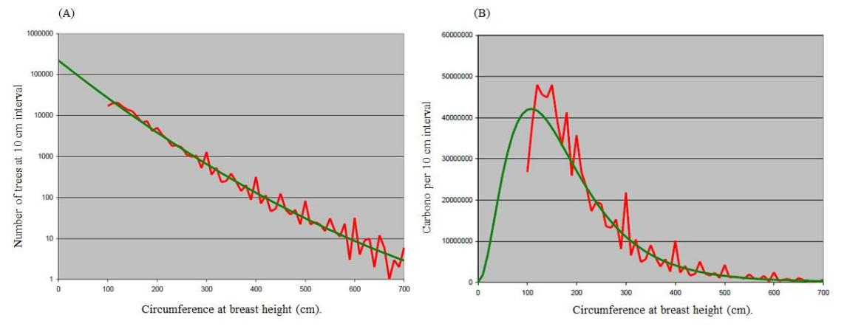

Figure 13. Histogram and observed data (A) and histogram with carbon values in the aboveground biomass (B) per CBH in Amazonia biome. Source: BRASIL, 2010, from BRASIL 2004 (developed by Meira Filho and Higuchi) Note: The red line represents observed data and the green line represents the best fit curve.

Step 4b. Inclusion of carbon of palms and vines.

In addition to the biomass from trees in the sampled units (regardless of their DBH value), the biomass from palms and vines, normally found in the Amazonia biome, have also been included. This inclusion was a response to the public consultation conducted for the First National GHG Inventory, part of the Initial National Communication of Brazil to the UNFCCC.

Silva (2007) has estimated that the biomass of palms and vines represent 2.31 and 1.77 per cent of the total aboveground biomass.

36
Hence, these values have been applied to C(total) in Equation 7 to obtain the total aboveground carbon in the sample as shown in Equation 8:

Caboveground = 1.3717 × AC(CBH > 100 cm) Equation 8

where:

Caboveground = the carbon stock in aboveground biomass in a sample unit (including carbon in all trees, palms and vines), tC ha-1

AC(CBH > 100 cm) = total carbon stock in a sample unit from trees with CBH > 100 cm; tC ha-1

Step 4c: Inclusion of carbon in belowground biomass and litter.

Silva (2007) estimated that the contribution of thick roots and litter to the fresh weight of living vegetation was 27.1 per cent (or 37.2 of the aboveground weight) and 3.0 per cent, respectively. The inclusion of carbon from these pools as indicated in Equation 9 provides an estimate of the total carbon stock in the sample unit:

Ctotal, SU = 1.9384 × AC(CBH > 100 cm) Equation 9

where:

Ctotal, SU = total carbon stock in living biomass (above and below-ground) for all trees, palms and vines in the sample unit; tC ha-1;

AC(CBH > 100 cm) = total carbon stock in a sample unit from trees with CBH > 100 cm; tC ha-1.

IMPORTANTE REMARK: Equation 9 already includes step 4a and step 4b. Hence, to generate the total carbon stock in living biomass and litter it is only necessary to apply Equations 4, 5 and 8. Annex II, Part II presents an example of the application of these equations to derive the carbon stock for one specific volume of RADAMBRASIL (volume 13) and a specific forest type (DS).

Step 5: Application of extrapolation rules to estimate the carbon density associated with the forest types in each RADAMBRASIL volume, noting that the same forest type in different volumes may have different values.

The application of Steps 3 and 4 (or equivalently, the application of Equations 5, 6 and 9 which integrates Equations 7 and 8) produces estimates of carbon density in living biomass (including trees with CBH < 100cm, palms and vines) and litter mass for the data collected by RADAMBRASIL. These sample estimates, gathered from different forest types in different locations, did not necessarily cover every vegetation type in each RADAMBRASIL volume (see Figure 12).

37
Hence, a set of rules was created to allow for the estimation of carbon densities for each vegetation type considered, as described below.

- Rule 1. For a given forest type in a specific RADAMBRASIL volume, if there were corresponding sample plots (where Steps 3, 4 and 7 are applied to each tree to estimate the associated carbon density), the carbon density for that forest type was calculated as the sum of the carbon density associated with each tree in the sample plot. For instance, suppose that volume v has 2 sample plots (sample plot 1, with 60 trees, and sample plot 2, with 100 trees) associated with forest type Aa. For sample plot 1, the sum of the carbon stock associated with each one of the 60 trees is calculated, say ASP1; for sample plot 2, the corresponding sum for the 100 trees was also calculated, say ASP2. The carbon density for forest type Aa in volume 1 was calculated as (ASP1+ ASP2)/2 (highlighted in green in Table 4).

- Rule 2. For a given forest type in a specific RADAMBRASIL volume, if there were no corresponding sample plots in that volume, then the carbon density for that forest type, for that volume, was calculated as the weighted average (by number of samples per sample plot) of the total carbon stock in each sample plot in the neighboring volume(s) (using a minimum of one and maximum of eight volumes).For instance, suppose that volume v has neighboring volumes v1, v2 and v3 with 2, 5 and 3 sample plots associated with forest type Aa. For each sample plot, the total carbon stock, say ASP1, ASP2 and ASP3, was calculated as in Rule 1 above. The carbon stock for forest type Aa in volume v, was then calculated as follows: (2* ASP1 + 5*ASP2 + 3* ASP3)/10 (highlighted in blue in Table 4).

- Rule 3. For a given forest type in a specific RADAMBRASIL volume, if there were no corresponding sample plots in that volume nor in the neighboring volumes, but there are samples plots in the neighbors to the neighboring volumes (second order neighbors), then the total carbon stock for that forest type in the specific volume is the average of the total carbon stock calculated from the second order neighbors. For instance, assume that there are no sample plots associated with forest type Aa in volume v and its neighboring volumes v1, v2 and v3, and that volumes v4, v5, v6 , v7 and v8 (second order neighbors) have 2, 4, 6, 3 and 5 sample plots associated with forest type Aa. Then, the carbon stock for forest type Aa in volume v was calculated applying Rule 2 to the second order neighbors (highlighted in pink in Table 4).

The example provided in Annex II applies rule 1 as described above.

38

Table 4: Carbon densities (tC ha-1) in living biomass (aboveground and belowground, including palms and vines; and litter mass) for the Amazonia biome, by forest type
and RADAMBRASIL volume, following the set of rules in Step 5. Note: Rule one: green, Rule 2: blue, Rule 3: pink. Source: BRASIL, 2010

 | RADAMBRASIL |  |  |  | Forest Fisionomy (tC/ ha)
 | Volume | Aa | Ab | As | Da | Db | Dm | Ds | La | Ld
 | 2 | 98.24 | 154.55 | 110.06 | 182.98 | 176.10 | 139.03 | 169.35 | 183.00
 | 3 | 98.24 | 154.55 | 129.28 | 137.85 | 161.01 | 139.03 | 275.37 | 183.00
 | 4 | 94.88 | 154.55 | 129.28 | 119.67 | 154.59 | 139.03 | 148.30 | 183.00
 | 5 | 108.33 | 154.55 | 146.82 | 213.85 | 185.15 | 109.69 | 230.13 | 183.00
 | 6 | 123.75 | 154.55 | 133.99 | 131.82 | 222.39 | 109.69 | 213.55 | 183.00
 | 7 | 159.51 | 160.29 | 180.66 | 142.58 | 153.42 | 139.03 | 175.71 | 262.99
 | 8 | 146.97 | 197.91 | 73.64 | 270.89 | 163.92 | 149.50 | 138.56 | 183.00 | 183.00
 | 9 | 127.61 | 213.37 | 112.13 | 262.68 | 157.38 | 109.69 | 184.64 | 262.99
 | 10 | 141.81 | 169.49 | 146.45 | 174.03 | 149.54 | 147.77 | 171.21 | 262.99 | 262.99
 | 11 | 154.71 | 197.91 | 158.20 | 166.72 | 168.13 | 83.74 | 144.81 | 114.31 | 114.31
 | 12 | 144.32 | 150.69 | 116.14 | 164.35 | 157.42 | 139.03 | 161.84 | 183.00
 | 13 | 144.76 | 144.62 | 139.24 | 168.64 | 153.25 | 104.05 | 121.02 | 160.43 | 160.43
 | 14 | 154.71 | 177.28 | 173.89 | 157.86 | 174.17 | 104.05 | 142.46 | 160.43 | 160.43
 | 15 | 172.81 | 164.36 | 156.03 | 171.77 | 154.38 | 104.05 | 155.40 | 228.80
 | 16 | 165.70 | 136.14 | 156.76 | 175.73 | 188.14 | 139.03 | 175.02 | 183.00
 | 17 | 136.09 | 159.17 | 157.15 | 175.64 | 165.53 | 104.05 | 159.63 | 228.80
 | 18 | 162.92 | 213.37 | 150.61 | 174.79 | 158.01 | 139.03 | 140.48 | 262.99 | 262.99
 | 19 | 150.22 | 147.92 | 135.72 | 170.56 | 159.40 | 139.03 | 154.78 | 183.00
 | 20 | 150.61 | 151.80 | 117.97 | 169.39 | 163.05 | 139.03 | 123.29 | 183.00 | 183.00
 | 22 | 148.74 | 154.55 | 97.40 | 137.67 | 153.42 | 139.03 | 145.55 | 183.00
 | 25 | 155.84 | 154.55 | 113.12 | 172.77 | 162.51 | 139.03 | 127.87 | 183.00
 | 26 | 165.70 | 136.14 | 130.49 | 175.73 | 188.14 | 139.03 | 153.93 | 183.00

39
Step 6: Literature review to estimate the carbon density in forest types not sampled by RADAMBRASIL

A literature review was conducted to fill in the gaps for which RADAMBRASIL had not estimated the associated carbon density. Table 5 presents the carbon density estimated from the literature and makes reference to the literature used.

The weighted average carbon density for the Amazonia biome is 151.6 tC ha-1. Eighty-four per cent of the carbon density of the forest types defined for the Amazonia biome was estimated using sample data from RADAMBRASIL. The remaining 16 per cent were derived from literature review.

Table 5: Carbon density for the vegetation typologies in the Amazonia biome estimated from the literature and references consulted24

 | Description (IBGE Vegetation Typologies) |  | tC ha-1 | Reference*
Cb |  | Lowland Deciduos Seasonal Forest | 116.27 | 1
Cs |  | Submontane Deciduous Seasonal Forest | 116.27 | 1
Fa |  | Alluvial Semi deciduous Seasonal Forest | 140.09 | 2
Fb |  | Lowland Semi-deciduous Seasonal Forest | 140.09 | 2
Fm |  | Montane Semi-deciduous Seasonal Forest | 140.09 | 2
Fs |  | Submontane Semi deciduous Seasonal Forest | 140.09 | 2
Pa |  | Vegetation with fluvial influence and/or lake | 105,64 | 2
Pf |  | Forest Vegetation Fluviomarine influenced | 98,16 | 2
Pm |  | Pioneer influenced Marine influenced | 94,48 | 2
Sa |  | Wooded Savannah | 47,1 | 3
Sd |  | Forested Savannah | 77,8 | 3
Ta |  | Wooded Steppe Savannah | 14,41 | 4
Td |  | Forested Steppe Savannah | 30,1 | 4

Note*:
- Britez, R.M. et al., 2006

- Barbosa, R.I. and Ferreira, C.A.C., 2004 Barbosa, R.I. and Fearnside, P.M., 1999

- Abdala, G. C. et al., 1998

Andrade, L. A.; Felfili, J. M.; Violati, L., 2002 Araújo. L. S., 2010

Araújo, L. S. et al., 2001
Barbosa, R. I. & Fearnside, P. M., 2005

Batalha, M.A., Mantovani, W & Mesquita Junior, 2001 Bustamante, M. M. da C. & Oliveira, E. L. de, 2008 Castro, E. A., 1996

Castro, E. A., & Kauffman, J. B., 1998 Costa, A. A. & Araújo, G. M., 2001 Delitti, W. B. C. & MEGURO, M., 2001 Delitti, W. B. C.. Pausas, J. & Burger, D. M. 2001 Delitti, W. B. C., Meguro, M. & Pausas, J. G., 2006 Durigan, G., 2004

- There was no single rule applied to estimate the carbon content presented in Table 5 (e.g., simple average of values in the literature). Some of these values refer to literature for the Cerrado biome but were deemed appropriate for the forest type considered (refer to footnote 15).

40
Fearnside, P. M. et al., 2009
Fernandes, A. H. B. M., 2008
Gomes, B. Z., Martines, F. R. & Tamashiro, J. Y., 2004
Grace, J. et al., 2006

Kauffman, J. B., Cummings & D. L. & Whard, D. E., 1994
Kunstchik, G., 2004
Meira Neto, J. A. A. & Saporeti-Junior, A. W., 2002
Martins, O. S., 2005
Ottmar, R. D. et al., 2001
Paiva, A. O. & Faria, G. E., 2007

Pinheiro, E. da S., Durigan, G. & Adami, M., 2009
Resende, D., Merlin, S. & Santos, M. T., 2001
Ronquim, C. C., 2007
Salis, S. M., 2004
Santos, J. R., 1988

Santos, J. R. et al., 2002
Schaefer, C. E. G. et al., 2008
Silva, F. C., 1990
Silva, R. P., 2007
Vale, A. T. do & Felfili, J. M., 2005
Valeriano, D. M. & Biterncourt-Pereira, M. D., 1988

- Fearnside, P.M. et al., 2009

Barbosa, R.I. and Fearnside, P.M., 2005 Graça, P.M.L.A., 1997 apud Fearnside, 2009

The information provided in this submission allows for the reconstruction of Brazil´s FREL. One should bear in mind that the exact value may not be necessarily reproduced due to rounding errors and the impressive amount of data being dealt with25. Annex II presents the example of the independent reconstruction for year 2003. With this explanation, Brazil considers the submission to be complete and transparent.

b.3. Consistent Information

Paragraph 8 in Decision 12/CP.17 requires that FRELs shall be established maintaining consistency with anthropogenic forest related greenhouse gas emissions by sources and removals by sinks as contained in the country’s National GHG Inventory.

Brazil applied the IPCC definition of consistency (IPCC, 2006)26, in the sense that the same methodologies and consistent data sets are used to estimate emissions from deforestation in the FREL construction and in the National GHG Inventory.

At the onset, Brazil clarifies that the estimation of emissions by sources and removals

- An independent reconstruction of the data in Table 1 for years 2003, 2004 and 2005 led to the following results: for year 2003: difference in area (0.168 per cent) and in CO2 emission (2.52 per cent); for year 2004: difference in area (0.93 per cent) and in CO2 emission (3.67 per cent); and for year 2005, difference in area (0.00 per cent) and in CO2 emission (2.42 per cent). The independent reproduction applied the values in Tables 4 and 5 as they are presented, while the original data was generated with more decimal places.

- Consistency means that an inventory should be internally consistent in all its elements over a period of years. An inventory is consistent if the same methodologies are used for the base year and all subsequent years and if consistent data sets are used to estimate emissions or removals from sources or sinks. An inventory using different methodologies for different years can be considered to be consistent if it has been estimated in a transparent manner taking into account the guidance in Volume 1 on good practice in time series consistency (IPCC Glossary, 2006).

41
by sinks in the Second National GHG Inventory followed the methodological guidance contained in the IPCC Good Practice Guidance for Land Use, Land-use Change and Forestry (IPCC, 2003).

Moreover, Brazil adopted approach 3 for land representation, meaning that all the land conversions and lands remaining in a same land-use category between inventories are spatially explicit. The basis for all activity data in the Second National GHG Inventory as well as the assessment of deforestation for the purposes of this submission rely on the use of remotely sensed data of same spatial resolution (Landsat-class, up to 30 meters).

Also, the same national institutions and team engaged in the development of the LUCF estimates for the First National GHG Inventory and LULUCF estimates for the Second National GHG Inventory has been in charge of the annual estimation of the rate of gross deforestation for PRODES, ensuring an even greater consistency between the estimates for the National GHG Inventory and those used for the generation of PRODES data, which are the basis for estimating the gross CO2 emissions from deforestation for the Amazonia biome reported here. Furthermore, the experts from the institutions responsible for the development of the National GHG Inventory and the PRODES data are also part of the Working Group of Technical Experts on REDD+ that supported the development of this FREL submission and its quality control.

It is to be noted that the reporting of LULUCF under Brazil’s Second National GHG Inventory covered the period 1994 to 2002 and incorporated some improvements relative to the Initial Inventory (1990-1994). The Second National GHG Inventory includes land-use transition areas and net CO2 emissions for each individual biome for the period 1994 to 2002. Hence, the figures provided in the Second National GHG Inventory27 for the area deforested in both managed and unmanaged forest land represent the area converted or maintained in the same land-use category for the 8-years interval between years 1994 and 2002.

In addition, the figures provided in the Second National GHG Inventory took into account both the emissions from the conversion to a new land-use category as well as removals from this new category. The Amazonia biome data presented in this submission refers only to gross emissions. The emissions associated with forest land converted to other land-use categories in the Second National GHG Inventory and those estimated for gross deforestation in this submission are based on the same carbon map introduced in section b.2 (Steps 1 to 6).

Box 4: Emissions from gross deforestation as presented in the Second National GHG Inventory and in the submission of Brazil´s FREL

Table 3.97 from the Second National GHG Inventory provides the following information for the Amazonia biome:

For the area of primary forest converted to other land uses:

- Total managed and unmanaged primary forest land (FM and FNM, respectively) converted to other land uses from 1994 to 2002, inclusive = 164,997.14 km2.

- The average annual primary forest land area converted to other land uses from 1994

- Table 3.97 (Land-use transition areas identified in the Amazon biome from 1994 to 2002); and Table

- 98 (Net CO2 emissions in the Amazon biome from 1994 to 2002).

42
to 2002, inclusive = 164,997.14/8 = 20,624.64 km2.

The corresponding data in this submission is as follows:

- Total area of primary forest deforested (adjusted deforestation increment) for all years from 1996 to 2002, inclusive = 137,860.00 km2.

- The average annual area deforested in this period is 137,860.00/7 = 19,694.29 km2.

Note that in the calculation of the average annual area converted to other land uses in the Second National GHG Inventory, the total area is divided by 8 (annual changes from 1994 to 2002: 1994-1995; 1995-1996; … 2001-2002); whereas for the calculation of the average in this submission, the total deforested area is divided by 7 (data for every year since 1996 until 2002).

IMPORTANT REMARK: the areas and associated emissions provided in the transition matrices in the Second National GHG Inventory (Table 3.97 and Table 3.98, respectively) have not been generated using the annual PRODES data. The analysis was carried out only for two years (1994) and (2002), and the area changes were not adjusted for the different dates and/or the presence of clouds (note that a reporting category has been introduced in the transition matrix, referred to as areas not observed due to cloud cover).

The difference between the average annual area deforested (adjusted deforestation increment) from the submission and the average annual area of forest land converted to other land-uses from the Second National GHG Inventory is 930.36 km2. This corresponds to a percent difference of 4.72 per cent relative to the average annual area deforested in the period 1996 to 2002 presented in this submission.

Regarding the emissions: The table below provides the CO2 emissions reported in the Second National GHG Inventory for the period 1994 and 2002 inclusive (Table 3.98) from conversion of Forest Land (FNM and FM) to Grassland (Ap), Cropland (Ac), Settlements (S), Reservoirs (R) and Others (O) which total 8,175,002,260.0 tCO2. Thus, the average annual emission is 1,021,875,828.5 tCO2 yr-1. The table below also provides the CO2 emissions for years 1996 to 2002 inclusive, estimated for this submission, which total 7,141,038,666.2 tCO2, providing an annual average emission of 1,020,148,380.9 tCO2 yr-1. The difference between the average annual emission from the National Communication and the submission is thus nearly zero.

43
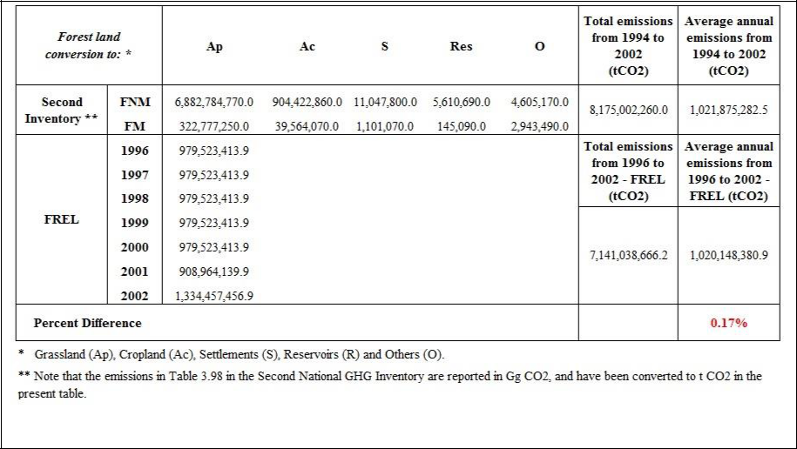

Hence, Brazil considers that the percent difference is indicative of results that are very similar despite the minor (but consistent) change in the methodology used for the purposes of the Second National GHG Inventory and the one applied to this submission. It is important to note that the source for the activity data and the emission factors are consistent, the first being based on the analysis of remotely sensed data and the second in the same carbon map used in the Second National GHG Inventory.

b.4. Accurate Information

b.4.1. Activity Data

The definition of deforestation adopted for PRODES and maintained in the FREL (i.e., clear cut), in conjunction with the annual wall-to-wall assessment of deforestation based on satellite imagery of high spatial resolution (up to 30 meters) allows deforestation polygons to be identified and mapped with very high accuracy. No ground truth is required for the Amazonia biome since there is an unequivocal identification of the clear cut patches in the Landsat imagery from one year to another. Only new polygons of deforestation are mapped each year on the aggregated deforestation map containing deforestation up to the previous year.

In addition, with the advent of new processing tools and greater availability of satellite data, the gaps of observation in the Landsat imagery due to the presence of clouds are being filled with data from other satellites with sensors of similar spatial resolution to Landsat (e.g., ResourceSat, DMC, CBERS). This ensures that the observation coverage of the Amazonia biome is as comprehensive as possible every year.

Note that all the land defined as forest, regardless of being managed or unmanaged according to the managed land definition in the GPG LULUCF (and with more clarity in the 2006 IPCC Guidelines) is included in the annual assessments. Hence, even if clear cut on unmanaged land is identified, it automatically becomes part of the managed forest land database, adding to the total area deforested. Regardless of the fate of the clear cut patches on unmanaged land (converted or not to other land-use categories), the

44
area and its associated emission are added to the total deforested area and the total CO2 emissions in the year that clear cut occurs.

Finally, the fact that PRODES is conducted by a consistent team of technicians every year and is subject to rigorous quality control and quality assurance by INPE´s researchers adds to the accuracy of the activity data, estimated by expert judgment to be around 5 per cent. Quality checks are carried out on a daily basis by INPE´s Coordinator of the Amazonia Program who checks the quality of the work, the consistency of the image classification among the different interpreters, and provides guidance to FUNCATE28´s coordinator, as necessary.

The classification focus only in the identification of the clear cut patches from the previous year and is analyzed and mapped on the screen (visual interpretation). The coordinator of PRODES at FUNCATE is a person knowledgeable in remote sensing (has a Doctorate degree from INPE) and is responsible for ensuring that the work is delivered to INPE with the quality expected in a timely manner. All data are properly archived, with copies maintained at both INPE and FUNCATE. The work by FUNCATE is conducted through a contract with INPE with clear Terms of Reference. Most importantly, since all data (images and annual maps) are publicly available since 2003, it allows the reconstruction of the deforestation increments by other stakeholders (usually NGOs, State Environmental Secretaries) and hence is verified by independent sources. Furthermore PRODES data are used as reference for many initiatives of global forest monitoring such as the ones conducted by the NASA/University of Maryland and the European Commission.

b.4.2. Emission Factors

The emission factors used in the construction of the FREL are the carbon densities in the living biomass (including palms and vines) and litter mass, as contained in the carbon map used by Brazil on its Second National GHG Inventory (refer to section b.1 and the carbon map for the Amazonia biome).

Brazil does not yet have a nationally wide forest inventory in place. Some states have already implemented their forest inventory following the National Forest Inventory (NFI) design developed jointly by the Brazilian Forest Service (SFB) and the FAO29 but data are not yet available at national level. There is an expectation that by 2017 all states will have implemented their forest inventories, consistent with the National Forest Inventory30.

RADAMBRASIL data used in the construction of the carbon map is the most comprehensive forest ground data available in Brazil up to now. It is difficult to assess

- The Foundation of Space Science, Applications and Technology (FUNCATE) was founded in 1982 with the objective of contributing to Brazil´s scientific and technological development. For more information see: http://www.funcate.org.br/
- For more information see: http://www.fao.org/forestry/17847/en/bra/, last accessed on April 4th, 2014.

- The Brazilian Forest Service (SFB) of the Ministry of the Environment of Brazil (MMA) is currently working in the development of the first National Forest Inventory of Brazil, an extensive forest plot network in a 20 x 20 km grid in some parts of the country, with finer-scale grids in vegetation transition areas and highly heterogeneous landscapes (http://ifn.florestal.gov.br/), estimated to be finalized only by the end of 2017. The work will include the development of allometric equations for different forest types, expanding the number of permanent plots and identifying and addressing information gaps. This will become a very important database in the near future (Ometto, 2014).

45
the uncertainty of the data collected by many different teams. The carbon map has been constructed using the RADAMBRASIL data as input data to the allometric equation by Higuchi et al. (1998) to relate aboveground fresh biomass with carbon densities developed using ground data collected in Central Amazonia. As mentioned in Box 3, the use of this allometric equation to estimate the aboveground fresh biomass in South Amazonia (SA) led to a difference of 6 per cent when contrasted with the biomass estimated from ground data collected in SA.

Regarding uncertainties associated with other variables in Higuchi et al (1998) equation, the following uncertainties estimated by Silva (2007) for the water and carbon content in fresh and dry biomass provide a first approximation to the uncertainties of these values as used by Higuchi et al (1998), .

- The average water content of 41.6 percent represents the weighted average of water in the following components from trees: (1) trunk (water content of 38.8 per cent and contribution to total biomass of 58.02 per cent); (2) thick branch (water content of 40.6 per cent and contribution to total biomass of 12.48 per cent); (3) thin branch (water content of 44.9 per cent and contribution to total biomass of 12.78 per cent); (4) leaves (water content of 59.7 per cent and contribution to total biomass of 2.69 per cent); (5) thick roots (water content of 48.9 per cent and contribution to total biomass of 3.06 per cent); (6) thin roots (water content of 44.5 per cent and contribution to total biomass of 11.59 per cent). The 95 per cent confidence interval for the average percent water content is 41.6 ± 2.8. The value used in Equation 6 (40.0 per cent is within this confidence interval).

- The average carbon content of 48.5 per cent represents the weighted average of the following components from trees (dry mass): (1) trunk (carbon content of 48.5 per cent and contribution to total dry biomass of 85.98 per cent); (2) thick roots (carbon content of 47.0 per cent and contribution to total biomass of 11.59 per cent); (6) thin roots (carbon content of 45.7 per cent and contribution to total biomass of 3.06 per cent). The 95 per cent confidence interval for the average percent carbon content is 48.5 ± 0.9.

- Regarding the uncertainties related to the biomass of palms and vines, Silva (2007) estimated that these are high (73.0 and 57.0 per cent, respectively). However, their contribution to the average total aboveground biomass is only 4.0 per cent, the largest contribution being from the trees themselves (94.0 per cent). Hence, the contribution of the biomass of palms and vines to the biomass uncertainty is low.

Other uncertainties associated with the carbon map may arise from other sources, including the following:

- data collection, sampling design;
- aggregated forest type;

- rules used to estimate the carbon density of the forest types per RADAMBRASIL volume.

It is difficult to associate uncertainties to most of these elements. RADAMBRASIL data, for instance, was collected under strenuous circumstances in the 70s, by different teams. Also, by that time the technologies that exist today were not available or accessible (GPS, for example).

46
The aggregation of the diverse forest types in Amazonia in forest classes may also generate uncertainties, but these are difficult to access without a proper Forest National Inventory. This is one area where improvements may be expected in the medium term.

A recent paper by Ometto et al., (2014) (refer to Box 5) addresses Amazon forest biomass density maps: tackling the uncertainty in carbon emission estimates and provides comparison with other biomass maps for Amazonia from the literature. It concludes stating that the methodology used to construct the carbon map, based on the RADAM data (1:1,000,000) “resulted in large differences in biomass with respect to the other maps, and large changes in biomass between adjacent surveyed areas and regions (corresponding to different RADAM volumes) with the carbon map.” And continues to say that “the large apparent disparities in biomass calculated for the carbon map were not propagated into CO2 emissions as the deforestation front in the analysis had not advanced to these areas.” Indeed, the analysis of the deforestation polygons (per volume and forest type) for years 2002 to 2005 have consistently shown that deforestation concentrates mainly in the so called “Arc of Deforestation”, corresponding to RADAM volumes 4, 5, 16, 20, 22 and 26 (refer to Figure 11). In addition, even within these volumes, the forest types affected by deforestation have been very consistent31.

Box 5: Carbon map uncertainties – analyzing the literature

Estimating the uncertainty associated with the carbon map is extremely complex. There are several carbon maps for the Amazonia biome published in the literature. Most of them constructed using satellite data, including the airborne LIDAR data and plot information. Some incorporate only aboveground biomass, whereas others include living biomass and others pools.

The accuracy of the map can be assessed in case adequate and representative ground datasets for calibration are available. This may exist in some areas in Amazonia but do not exist for the entire Amazonia biome. The literature on uncertainties tend to indicate that the largest uncertainties for REDD+ activities relate to the spatial distribution of biomass and to the spatial pattern of forest cover change, rather than to total globally o nationally summed carbon density.

Edward TA Mitchard, Sassan S Saatchi, Alessandro Baccini, Gregory P Asner, Scott J Goetz, Nancy L Harris and Sandra Brown. Uncertainty in the spatial distribution of tropical forest biomass: a comparison of pan-tropical maps (2013).

A more recent paper (Ometto et al., 2014) examines the influence of the use of different biomass maps on uncertainty in carbon emission calculations due to land cover change in recent years and in future scenarios. Five maps are compared (Saatchi et al. (2007; 2011); Nogueira et al. (2008); MCT (2010); and Baccini et al. (2012).

- In 2003, 2004, and 2005, the percentage of the deforestation increments falling in these volumes was 69 per cent, 70 percent, and 76 per cent, respectively. The forest types most affected by deforestation in RADAM volume 4, for instance, were As and Ds (99 per cent in 2003; 98.8 per cent in 2004 and 97 per cent in 2005). In volume 16, 90.6 per cent and 98 per cent of the increments fell under forest types Ab and As; and 96.9 per cent in Ab, As and Ds in 2003.

47
Some results indicate that the map used in the FREL (MCT (2010) and that from Nogueira et al. (2008) have similar spatial distribution of the biomass density classes.

The paper indicates that the methodology used in the Second National GHG Inventory, based on the RADAM data resulted in large differences in biomass with respect to the other maps, and large changes in biomass between adjacent surveyed areas and regions (corresponding to different RADAM data sheets) within the map.

Ometto, J.P.; Aguiar, A.P.; Assis, T.; Soler, L.; Valle, P.; Tejada, G.; Lapola, D.M.; Meir, P. Amazon forest biomass density maps: tackling the uncertainty in carbon emission estimates. Climatic Change (2014) 124:545-560. DOI 10.1007/s10584-014-1058-7

Work is underway to assess and reduce uncertainties and this process will contribute to the improvement of the data in future submissions.

c) Pools, gases and activities included in the construction of the FREL

c.1. Activities included

Brazil´s FREL includes only the activity “Reducing Emissions from Deforestation” in the Amazonia biome, using the PRODES data as a basis. In addition to the systematic assessment of deforestation in the Brazilian Amazonia, Brazil has developed other systems to track forest degradation and logging in forest management plans in the Amazonia biome (Table 6).

Table 6: Brazil´s forest monitoring systems for the Amazonia biome
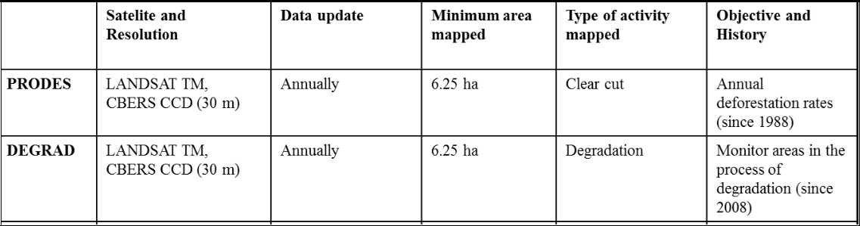

Brazil has, through INPE, implemented since 2008 a system to assess the areas affected by degradation in the Amazon biome, through the use of satellite imagery of the same spatial resolution as that used to assess deforestation increments (Landsat, up to 30 meters). This system, referred to as DEGRAD, provides detailed maps of areas under a degradation process (refer to Figure 14).

48
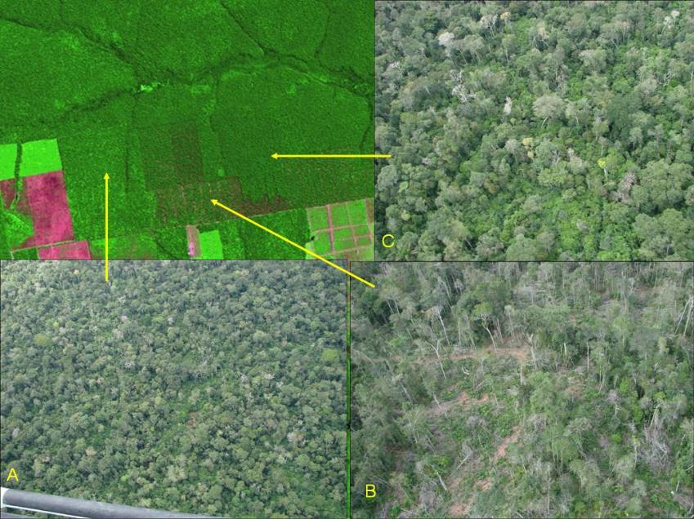

Figure 14. Representation of forest degradation in a portion of a Landsat image:

- degradation of moderate intensity, regeneration after logging patios still evident; B) degradation of high-intensity, large proportion of exposed soil; C) degradation of light intensity, evidence of openings for road access. Source. DEGRAD, INPE, 2014

These areas have not been subject to clear cut and hence have not been included in PRODES figures. Brazil provides some information regarding DEGRAD in Annex III.

The time series is still too short to allow a better understanding of the degradation process. It is expected that this understanding improves with time, as new data becomes available, allowing for the future submission of a FREL for degradation.

c.2. Pools included

The pools included in this FREL are those used in the construction of the carbon map, i.e, living biomass (above and below-ground) and litter.

Following the IPCC Good Practice Guidance for LULUCF (IPCC, 2003, Section 3.2.1.3, p. 338) consideration here will be carried out for the two types of soil carbon pools: (i) the organic fraction of mineral forest soils and (ii) organic soils.

In relation to the mineral forest soils, there are several publications in Brazil addressing changes in carbon stock in mineral soils from conversion of forest to pasture or agriculture in Amazonia. As already mentioned, Brazil does not have data on the dynamics of forest conversion for all years in the period considered in the construction of the FREL. However, there are two sources of information that were used as proxies to estimate the fate of the forest converted to other uses.

The first of these is the Second National GHG Inventory that has a spatially explicit database for the conversions of forest (managed and unmanaged) to other land-use categories from 1994 to 2002, per biome. The land cover/use for these two years was mapped using Landsat as the main source of data. The data in Tables 3.97 (Land-use

49
transition areas identified in the Amazon biome from 1994 to 2002 (hectares)) can provide an estimate of the forestland converted to grassland and cropland, the two major forest land conversions in Amazonia. Considering the total area of Forest Land converted to Grassland - Ap; Cropland – Ac; Settements – S; Wetlands - Res; and Other Land in Table 3.97, which totals 16,500,461 hectares, the area converted to Grassland and Cropland is 14,610,248 hectares and 1,846,220 hectares, corresponding to 88.5 per cent and 11.2 per cent, respectively.

The second source of information on transition of forest to other land use categories is TerraClass32, a more recent project carried out by INPE, which has estimated forest transitions for years 2008 and 2010. For these two years, 80.3 per cent and 80.0 per cent, respectively, have been converted to grassland (exposed soil grassland; clean grassland; dirty grassland; regeneration with pasture). Hence, the two sources consistently indicate that the major Forest Land conversion is to Grassland, including cattle ranching, abandoned grassland etc.

With this assumption in mind, a literature review was carried out to assess the impact of the conversion of native forest to pasture on the soil organic carbon pool. It is important to bear in mind that the literature review cited here is limited, and may not be representative of all situations that may occur in Amazonia. Brazil will intensify efforts to improve the understanding of the changes in carbon stock in the soil organic carbon pool, including by expanding the literature review and by stimulating new research. One of the issues that make the assessment of changes in the soil organic carbon pool relates to the timing of the changes, which may not occur immediately after the conversion. Normally the process may take years before a change can be detected.

A large area of the Amazonia biome (approximately 75 per cent) is covered by Latossolos (Oxisols) and Podzólicos (Ultisoils and Alfisols) (Cerri et al. (1999), following Jacomine and Camargo (1996)). The remainder falls into seven soil divisions (refer to Figure 15).
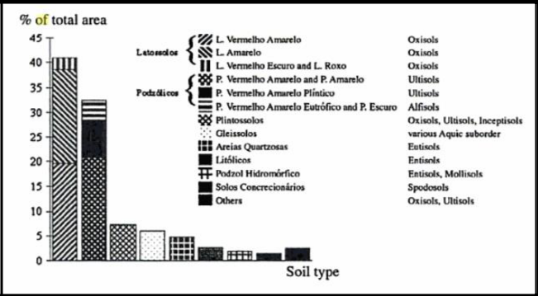

Figure 15: Percent distribution of the main soil types in the Amazonia basin. Source: Cerri et al., 1999.

- More information on TerraClass can be found in http://www.inpe.br/cra/projetos_pesquisas/terraclass2010.php

50
Regarding the changes in the soil organic carbon pool from conversion of forest to grassland (pasture), part of the literature indicates that there is a loss of carbon in the first years of conversion, generally followed by full recovery of the soil organic carbon. In some cases, an increase in soil carbon can occur, particularly in the superficial soil layer. A summary of some of the literature consulted in described below.

Fearnside and Barbosa (1998) showed that trends in soil carbon were strongly influenced by pasture management. Sites that were judged to have been under poor management generally lost soil carbon, whereas sites under ideal management gained carbon. Salimon et al. (2007) concluded that the soils under pasture present larger carbon stocks in the superficial soil layer where approximately 40 to 50 per cent of the carbon originated from grasses at depth 0 to 5 cm. In deeper layers, the contribution of the remaining carbon from the primary forest is larger, notably in those soils with greater clay content.

Cerri et al. (2006) carried out a literature review on this issue and concluded that approximately two thirds of the pasture in Amazonia exhibited an increase in carbon stock in soil relative to the native vegetation. It estimated equilibrium organic matter levels by running the models for a period of 10,000 years. Then, the models were run for 100 years under pasture. Century and Roth predicted that forest clearance and conversion to well managed pasture would cause an initial decline in soil carbon stocks, followed by a slow rise to levels exceeding those under native forest. The only exception to this pattern was found for the chronosequence called Suia-Missu, where the pasture is degraded rather than well managed like the other chronosequences.

Costa et al., (2009) concluded that there was no significant difference in the soil carbon stocks under vegetation, degraded pasture and productive pasture, at different land use time and different depth. The authors also conclude that after 28 years of use with well managed pasture, approximately 62 per cent of the soil organic carbon still derives from the original forest until 30 cm depth.

Fernandes et al. (2007) concluded that the incorporation of carbon by the pasture occurs gradually in increasing depth through time, and that the layer 0 – 10 cm apparently reached an equilibrium state after 10 years (around 9.8 tonnes per hectare). For the other layers, differences can still be observed in the stocks in areas of 10 and 20 years, this difference being largest at 40 cm depth. In the layer 0 – 20 cm the carbon stock in 10.8 tonnes per hectare in the soil with native vegetation; 15.1 and 17.3 tonnes per hectare for pastures of 10 and 20 years, respectively. These values represent an increase of 40 and 60 per cent in relation to the soil under native vegetation, respectively.

Trumbore et al. (1995) reported soil carbon losses in overgrazed pasture but soil carbon gains from fertilized pasture in the Amazon region. Neil et al. (1997) suggested that degraded pastures with little grass cover are less likely to accumulate soil carbon because inputs to soil organic carbon from pasture roots will be diminished, but that might not be true in more vigorous re-growth of secondary forest. Greater grazing intensity and soil damage from poor management would, in all likelihood, cause soil carbon losses.

Finally, Neill et al. (1997) when examining carbon and nitrogen stocks in seven chronosequences, each consisting of an intact forest and pastures of different ages created directly from cleared forest (7 forests, 18 pastures), along a 700-km transect in

51
the southwestern Amazon basis indicated that when site history was controlled by considering only pastures formed directly from cleared forest, carbon and nitrogen accumulation was the dominant trend in pasture soils.

In relation to organic soils, emissions from deforestation associated with organic soils (Organossolos) were not included in this submission since the presence of these types of soils in Brazil is not considered significant, as indicated in Figure 16. Furthermore these types of soil are not located in the areas most affected by deforestation (Arch of Deforestation).
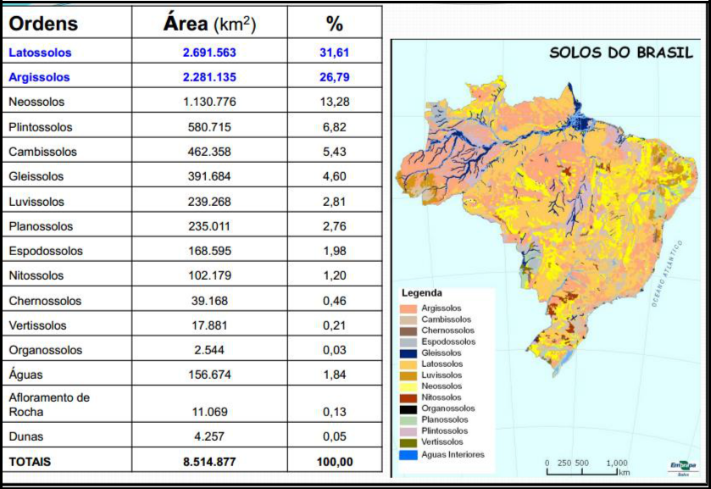

Figure 16: Brazil´s soil classification system Source: EMBRAPA, 2006

Ideally, more studies are needed to determine with more certainty how significant the changes in the soil organic carbon pool are following conversion of Forest Land. Considering the above information, the soil organic carbon pool has not been included in the construction of the FREL proposed by Brazil in this submission.

Box 6: The rationale behind the non-inclusion of dead wood in Brazil´s FREL

Regardless the occurrence of the deforestation activity, dead wood (necromass) will be present in forest land, due to normal mortality or increased due to disturbance events. Part of the carbon in the necromass will be incorporated in the soil organic carbon and the remaining will be emitted to the atmosphere through time.

It may take several decades for the carbon in the necromass to be fully emitted, slowly in the first years. Hence, emissions from the decomposing necromass follow an exponential model with small emissions in the first years, followed by decomposition emissions for some decades. This would be the expected natural process of emissions

52
from dead wood (standing and lying necromass constituted of coarse woody debris (trunks, stumps, branches, twigs), which the literature indicates to be of high error of estimation. In addition, one expects regeneration of the necromass from recruitment and increment (succession process initiated by pioneer species, followed by species of slow growth).

In the case of deforestation (defined here as clear cut), emissions from dead wood are instantaneous instead of spaced in time. So, when reducing emissions from deforestation, one is not avoiding emissions from dead wood (since this is a natural process) – the issue is related only to the time when the emissions are released to the atmosphere. Some types of disturbances can increase the amount of necromass (e.g., droughts, insect infestation) and related emissions, but this would have to be modeled under assumptions of future potential disturbances, an approach which Brazil is not following presently.

c.3. Gases included

This FREL only includes CO2 emissions. Non-CO2 emissions in the Amazonia biome are normally associated with the recurrent burning of tree residues left on the ground after the deforestation activity; or with wild fires, which are not very common.

Emissions resulting from the burning of tree residues and other organic matter present on the ground are directly related to the deforestation activity. Hence, the decrease of deforestation, per se, will lead to a decrease not only in CO2 emissions but also in non-CO2 emissions associated with fire (during the forest conversion and post-conversion).

The most common conversion of forest in Amazonia is to pasture for cattle ranching (IBGE, 2009). Pasture burning is the prevalent type of fire in Amazonia on an area basis. The majority (80 to 90 per cent) of the fire emissions derive from deforestation in Amazonia and Cerrado (Box 7).

Box 7: Estimates of CO2 and non-CO2 emissions of GHG

Bustamante et al. (2012) have provided estimates of CO2 and non-CO2 emissions of greenhouse gases (including CO2, CH4, N2O, CO, NOx) associated with deforestation, burning for pasture establishment, and pasture maintenance in the period from 2003 to 2008 (inclusive).

Figure 17 bellow shows the area of fire for pasture establishment and maintenance in all Brazilian biomes from 2003 to 2008 inclusive, and the associated CO2, CH4, N2O and CO emissions (in Mt CO2-eq) for the Amazonia biome.

53
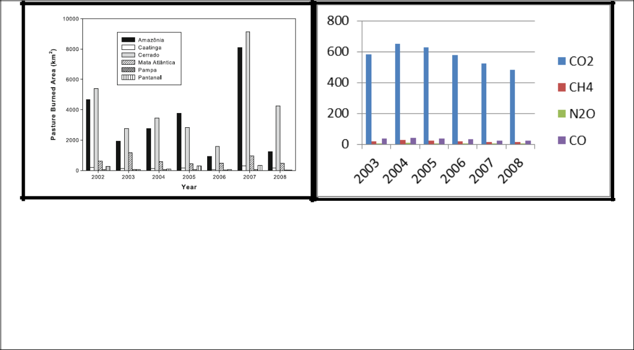

Figure 17. (A) Extension of burned pastures (2002 – 2008) in the Brazilian biomes; (B) CO2, CH4,
N2O and CO emissions (in Mt CO2-eq) for the Amazonia biome in the same period. Source:
Bustamante et al., 2012.

For the conversion of CH4, N2O and CO to CO2-eq, the global warming potential values used were 21, 310 and 2, respectively. Relative to the average CO2 emissions in the period, the average CH4; N2O and CO emissions represented 3.4 per cent; 1.0 per cent; and 5.9 per cent, respectively (IPCC, 2001).

Brazil decided not to include non-CO2 gases in the construction of its FREL as a mean to be conservative. However, it may reconsider this decision when improved data becomes available.

d) Forest definition

Brazil is a country of continental dimensions and with a large diversity of forest types. The forest definition broadly applicable in Brazil is that reported to the FAO for the Global Forest Resources Assessments (FRA), reproduced below:

“Forest is defined as land spanning more than 0.5 hectare with trees higher than 5 meters and a canopy cover of more than 10 percent, or trees able to reach these thresholds in situ. Land not classified as “Forest”, spanning more than 0.5 hectare; with trees higher than 5 meters and a canopy cover of 5-10 percent, or trees able to reach these thresholds in situ; or with a combined cover of shrubs, bushes and trees above 10 percent are classified as “Other Wooded Land”.

These two categories (Forest and Other Wooded Land) do not include land that is predominantly under agricultural or urban land use.

The classification of vegetation typologies into the categories of “Forest” and “Other Wooded Land” used by FAO was defined by Brazilian experts involved in the preparation of the FRA 2015.

It is to be noted that the number of vegetation typologies under “Forest” for the purposes of FRA is much larger than the aggregated forest types defined for the purposes of this submission (Table 7), the reason being the need to have a basis for estimating the carbon density in the forest types defined.

54
Table 7. FRA 2010 vegetation typologies included in this FREL (in grey).
 | Aa | Alluvial Open Humid Forest
 | Ab | Lowland Open Humid Forest
 | Am | Montane Open Humid Forest
 | As | Submontane Open Humid Forest
 | Ca | Alluvial Deciduous Seasonal Forest
 | Cb | Lowland Deciduous Seasonal Forest
 | Cm | Montane Deciduous Seasonal Forest
 | Cs | Submontane Deciduous Seasonal Forest
 | Da | Alluvial Dense Humid Forest
 | Db | Lowland Dense Humid Forest
 | Dl | High montane Dense Humid Forest
 | Dm | Montane Dense Humid Forest
 | Ds | Submontane Dense Humid Forest
 | Ea | Tree Steppe
 | EM | Transition Steppe / Mixed Humid Forest
 | EM | Transition Steppe / Seasonal Forest
 | Fa | Alluvial Semi deciduous Seasonal Forest
 | Fb | Lowland Semi deciduous Seasonal Forest
 | Fm | Montane Semi deciduous Seasonal Forest
 | Fs | Submontane Semi deciduous Seasonal Forest
 | La | Wooded Campinarana
 | Ld | Forested Campinarana
 | LO | Transition Campinarana / Humid Forest
 | M | Mixed Humid Forest:
 | Ma | Alluvial Mixed Humid Forest
 | Ml | Montane Mixed High Humid Forest
 | Mm | Montane Mixed Humid Forest
 | Ms | Submontane Mixed High Humid Forest
 | NM | Transition Seasonal Forest / Mixed Humid Forest
 | NP | Transition Seasonal Forest / Pioneer Formations
 | OM | Transition Humid Forest / Mixed Humid Forest
 | ON | Transition Humid Forest / Seasonal Humid Forest
 | Pa | Vegetation Fluvial and / or Lacustrine Influenced
 | Pfm | Forest Vegetation Fluviomarine influenced
 | Pma | Forest Vegetation Marine Influenced
 | Sa | Wooded Savannah
 | Sd | Forested Savannah
 | SM | Transition Savannah / Mixed Humid Forest
 | SN | Transition Savannah / Seasonal Forest
 | SO | Transition Savannah / Humid Forest
 | SP | Transition Savannah / Pioneer Formations (Restinga)
 | ST | Transition Savannah / Steppe Savannah
 | STN | Transition Savannah / Steppe Savannah / Seasonal Forest
 | Ta | Ta - Wooded Steppe Savannah
 | Td | Forested Steppe Savannah
 | TN | Transition Steppe Savannah / Seasonal Forest
 |  | Forest Plantations
 |  | Secondary Vegetation in Forestry areas

55
For the Amazonia biome, the historical time-series available for deforestation has been constructed assuming a clear cut pattern (exposed soil) and does not follow strictly the definition used for the FRA. However, the boundaries of forest/non-forest were based on the definition applied in the FRA report.

Hence, deforestation for the Amazonia biome is not associated with thresholds, but simply with canopy cover equals to zero. Any situation in which forest falls below the thresholds of the FAO definition but still does not have canopy cover equals to zero is characterized as forest degradation and treated as such under the DEGRAD.

Since the basis for the estimation of the carbon densities in the different forest types was the RADAMBRASIL sample plots and vegetation map, it would not be logical to disaggregate the estimates to accommodate a larger set of forest types.

56
References

ABDALA, G. C.; CALDAS, L. S.; HARIDASAN, M.; EITEN, G., 1998. Above and belowground organic matter and root:shoot ratio in Cerrado in Central Brazil. Brazilian Journal of Ecology, v.2, p.11-23.

ANDRADE, L. A.; FELFILI, J. M.; VIOLATI, L., 2002. Fitossociologia de uma área de Cerrado denso na RECOR-IBGE, Brasília, DF. Acta Botanica Brasílica, V.16, n.2, p.255-240.

ARAÚJO, L.S., SANTOS, J.R., KEIL, M., LACRUZ, M.S.P., KRAMER, J.C.M., 2001. Razão entre bandas do SIR-C/ X SAR para estimativa de biomassa em áreas de contato floresta e cerrado. In: X Simpósio Brasileiro de Sensoriamento Remoto - 21-26 abril, 2001, Foz de Iguaçu, Paraná. X Simpósio Brasileiro de Sensoriamento Remoto, Instituto Nacional de Pesquisas Espaciais (INPE).

ASNER, G.P., KELLER, M., PEREIRA, R., ZWEEDE, J., SILVA, J.N.M., 2004. Canopy damage and recovery after selective logging in Amazonia: field and satellite studies. Ecological Applications 14, 280–298.

BARBOSA, R. I. & FERREIRA, C. A. C., 2004. Biomassa acima do solo de um ecossistema de “campina” em Roraima, norte da Amazônia Brasileira. Acta Amazonica, v. 34(4):577-586.

BARBOSA, R.I.; FEARNSIDE, P.M., 1999. Incêndios na Amazônia brasileira: estimativa da emissão de gases do efeito estufa pela queima de diferentes ecossistemas de Roraima na passagem do Evento El Niño (1997/98). Acta Amazonica 29 (4): 513-534.

BATALHA, M.A.; MANTOVANI, W; MESQUITA JÚNIOR, H.N. Vegetation structure in Cerrado physiognomies in South-Eastern Brazil. Brazilian Journal of Biology, v.61, n.3, p 475-483, 2001

BRASIL, 1975. Ministério das Minas e Energia. Departamento Nacional de Produção Mineral. Projeto RADAMBRASIL.

BRASIL, 2004. Comunicação Nacional Inicial do Brasil à Convenção-Quadro das Nações Unidas sobre Mudança do Clima – Brasília: Ministério da Ciência e Tecnologia, Coordenação Geral de Mudanças Globais de Clima, 2004. Available at: http://unfccc.int/resource/docs/natc/brazilnc1e.pdf, last accessed on May 30th, 2014.

BRASIL, 2009. Lei Nº 12.187, de 29 de dezembro 2009. Institui a Política Nacional sobre Mudança do Clima - PNMC e dá outras providências. Available at: http://www.planalto.gov.br/ccivil_03/_ato2007-2010/2009/lei/l12187.htm, last accessed on March 24th, 2014.

BRASIL, 2010. Segunda Comunicação Nacional do Brasil À Convenção-Quadro das Nações Unidas sobre Mudança do Clima. – Brasília: Ministério da Ciência e Tecnologia, Coordenação Geral de Mudanças Globais de Clima, 2010. 2.v. CDU 551.583(81). Available at: http://www.mct.gov.br/upd_blob/0213/213909.pdf, last

57
accessed on March 24th, 2014.

BRASIL, 2014. Estratégia Nacional de REDD+ do Brasil (2014-2020). In press.

BRITEZ, R. M.; BORGO, M.; TIEPOLO, G. FERRETI, A.; CALMON, M. HIGA, R., 2006. Estoque e incremento de carbono em florestas e povoamentos de espécies arbóreas com ênfase na Floresta Atlântica do Sul do Brasil. Dados eletrônicos. Colombo - PR: Embrapa Florestas (CD ROM).

BUSTAMANTE, M. M. da C. & OLIVEIRA, E. L. de, 2008. Impacto das Atividades Agrícolas, Florestais e Pecuárias nos Recursos Naturais. In: Savanas: desafios e estratégias para o equilíbrio entre sociedade, agronegócio e recursos naturais, Capítulo 18. Embrapa, Editores Técnicos, Planaltina, GO, p. 647-669.

BUSTAMANTE, M.M.C.; NOBRE, C.A.; SMERALDI, R.; AGUIAR, A.P.D.; BARIONI, L.G.; FERREIRA, L.G.; LONGO, K.; MAY, P.; PINTO, A.S.; OMETTO, J.P.H.B. (2012) Estimating greenhouse gas emissions from cattle raising in Brazil. Climatic Change 115:559-577. DOI 10.1007/s 10584-012-0443-3.

CARVALHO, J.L.N.; AVANZI, J.C.; SILVA, M.L.N.; DE MELLO, C.R.; CERRI, C.E.P. (2010) Potencial de sequestro de carbono em diferentes biomas do Brasil (in English, Potential of soil carbono sequestration in diferent biomes of Brazil). Literature Review. Ver. Bras. Ciênc. Solo, volume 34, número 2. Available from <http://www.scielo.br/scielo.php?script=sci_arttext&pid=S0100-06832010000200001&lng=en&nrm=iso>. ISSN 0100-0683. http://dx.doi.org/10.1590/S0100-06832010000200001

CASTRO, E. A. & KAUFFMAN, J. B., 1998. Ecosystem structure in the Brazilian Cerrado: a vegetation gradiente of aboveground biomass, root mass and consumption by fire. Journal of Tropical Ecology, v.14, p.263-283.

CASTRO, E. A., 1996. Biomass, nutrient pool and response to fire in the Brazilian cerrado. Masters Dissertation , Oregon State University.

CERRI, C., BERNOUX, M., ARROWAYS, D., FEIGL, B. J., PICCOLO, M.C., 2000. Carbon stocks in soils of the Brazilian Amazon. In: LAL, R., KIMBLE, J.M.,

CERRI, C.E.P.; CERRI, C.C.; BERNOUX, M.; VOLKOFF, B. & RONDÓN, M.A. Potential of soil carbon sequestration in the Amazonian Tropical Rainforest. In: LAL,

CERRI, C.C.; BERNOUX, M.; ETCHEVERS, J. & CERRI, C.E.P. Carbon sequestration in soils of Latin America. New York, Haworth, 2006. p. 245-266.

CHAMBERS, J., ASNER, G., MORTON, D., ANDERSON, L., SAATCHI, S., ESPIRITO SANTO, F., PALACE, M., SOUZAJR, C. 2007. Regional ecosystem structure and function: ecological insights from remote sensing of tropical forests. Trends in Ecology & Evolution 22:8, 414-423 Online publication date: 1-Aug-2007.

58
CHAMBERS, J.Q., SANTOS, J., RIBEIRO, R.J., HIGUCHI, N., 2001. Tree damage, allometric relationship, and above-ground net primary production in central Amazon forest. Forest Ecology and Management 152, 73-84.

COSTA, A.A.; ARAUJO, G. M., 2001. Comparação da vegetação arbórea de Cerradão e de Cerrado na Reserva do Panga, Uberlândia, Minas Gerais. Acta Botânica Brasílica, v.15, n.1, p. 63-72.

COSTA, O.V.; CANTARUTTI, R.B.; FONTES, L.E.F.; DA COSTA, L.M.; NACIF, P.G.S.; FARIA, J.C. (2009) Estoque de Carbono do Solo sob Pastagem em Área de Tabuleiro Costeiro no Sul da Bahia. Part of a doctorate thesis by the first author in Soils and Plant Nutrition, Universidade Federal de Viçosa.(in English, Soil Carbon Stock under Pasture in Coastal Area at the South of Bahia).

DELITTI, W.B.C., PAUSAS, J. & BURGER, D.M. 2001. Belowground biomass seasonal variation in two Neotropical savannahs (Brazilian Cerrados) with different fire histories. Annals of Forest Science 7:713-722.

DELITTI, W.B.C.; MEGURO, M. & PAUSAS, J. G., 2006. Biomass and mineralmass estimates in a “cerrado” ecosystem. Revista Brasil. Bot., V.29, n.4, p.531-540, out.-dez. 2006.

DELITTI, W.B.C.; MEGURO, M., 1984. Biomassa e mineralomassa do campo cerrado de Mogi-Guaçu, SP. Ciência e Cultura 6:612.

DURIGAN, G., 2004. Estimativas de estoque de carbono na vegetação natural do Estado de São Paulo. Centro de Gestão e Estudos Estratégicos – CGEE, Prospecção Tecnológica, Mudança do Clima, Estudo 4- Oportunidades de Negócios em segmentos produtivos nacionais.

EMBRAPA, 2006. Sistema Brasileiro de Classificação dos Solos. 2a Ed. Brasilia, DF. 2006. Disponível em: http://www.agrolink.com.br/downloads/sistema-brasileiro-de-classificacao-dos-solos2006.pdf e http://clic.cses.vt.edu/IUSS1.4/Anjos_L_H-Evolution-Brazilian-Soil-Classification-System.pdf

FEARNSIDE, P. M. 2000 Global warming and tropical land-use change: greenhouse gas emissions from biomass burning, decomposition and soils in forest conversion, shifting cultivation and secondary vegetation Clim. Change 46 115–58

FEARNSIDE, P.M. 2004. Biomassa das florestas amazônicas brasileiras. Anais do Seminário Emissão x Sequestro de CO2: uma nova oportunidade de negócios para o Brasil. Companhia Vale do Rio Doce, Rio de Janeiro.

FEARNSIDE, P. M., RIGHI, C.A., GRAÇA, P. M. L. A., KEIZER, E. W. H., CERRI, C., Nogueira, E.M., BARBOSA, R. I., 2009. Biomass and Greenhouse-Gas Emissions from Land-Use Change in Brazil‟s Amazonian “Arc of Deforestation”: The states of Mato Grosso and Rondônia. Forest Ecology and Management, v.258, p.1968 - 1978.

FEARNSIDE, P.M. AND R.I. BARBOSA. 1998. Soil carbon changes from conversion of forest to pasture in Brazilian Amazonia. Forest Ecology and Management 108(1-2):

59
147-166.

FERNANDES, A. H. B. M.; SALIS, S. M. de; FERNANDES, F. A.; CRISPIM, S. M. A., 2008. Estoques de Carbono do Estrato Arbóreo de Cerrados no Pantanal de Nhecolândia. Comunicado Técnico 68, Embrapa Pantanal, Corumbá, MS. ISSN 1981-7231.

FERNANDES, F.A.; CERRI, C.C.; FERNANDES, A.H.B.M. (2007) 13C and the Soil Organic Carbon Dynamics in Cultivated Pasture in the Pantanal Sul-Mato-Grossense. Boletim de Pesquisa e Desenvolvimento 74. EMBRAPA. ISSN 1981-7215.

FRA 2010. Global Forest Resource Assessment 2010. Food and Agriculture Organization of the United Nations. Available at: http://www.fao.org/forestry/fra/fra2010/en/ last accessed on May 23rd, 2014.

GOMES, B.Z.; MARTINES, F. R.; TAMASHIRO, J. Y., 2004. Estrutura do Cerradão e da transição entre Cerradão e floresta paludícola num fragmento da International Paper do Brasil Ltda., em Brotas, SP. Revista Brasileira de Botânica, v. 27, n. 2, p. 249-262.

GRACE, J.; SAN JOSÉ, J.; MEIR, P; MIRANDA, H. S.; MONTES, R. A., 2006. Productive and carbon fluxes of tropical savannas. Journal of Biogeography 33, 387-400.

HIGUCH, N.; SANTOS, J.M.; IMANAGA, M.; YOSHIDA, S. 1994. Aboveground Biomass Estimate for Amazonian Dense Tropical Moist Forests, Memoirs of the Faculty of Agriculture, Kagoshima, 30(39); 43-54.

HIGUCHI, N. DOS SANTOS, J., RIBEIRO, R.J., MINETTE, L., BIOT, Y. 1998. Aboveground biomass of the Brazilian Amazon rainforest. Acta Amazonica 28 (2), 153-166.

HIGUCHI, N., CHAMBERS, J. DOS SANTOS, J., RIBEIRO, R.J., PINTO, A.C.M., DA SILVA, R. P., 2004. Dinâmica e balanço do carbono da vegetação primária da Amazônia Central. Floresta 34 (3)

IBAMA, 2014. Projeto de Monitoramento do Desmatamento dos Biomas Brasileiros por Satélite – PMDBBS. Available at: http://siscom.ibama.gov.br/monitorabiomas/, last accessed on March 24th, 2014.

IBGE, 2011. Censo Demográfico 2010: Características gerais da população. Instituto Brasileiro de Geografia e Estatística. Available on: http://www.ibge.gov.br/home/estatistica/populacao/censo2010/default_resultados_unive rso.shm, last accessed on March 24th, 2014.

IBGE, 2012. Manual técnico da vegetação brasileira. 2a edição revisada e ampliada. Rio de Janeiro, 2012. ISSN 0103-9598. Available at: ftp://geoftp.ibge.gov.br/documentos/recursos_naturais/manuais_tecnicos/manual_tecnic o_vegetacao_brasileira.pdf, last accessed on April 4th, 2014.

INPE, 2013. Metodologia para o Cálculo da Taxa Anual de Desmatamento na Amazônia

60
Legal. PRODES: Available at:
http://www.obt.inpe.br/prodes/metodologia_TaxaProdes.pdf, last accessed on March

24th, 2014.

INPE, 2014a. DEGRAD: Mapeamento da Degradação Florestal na Amazônia Brasileira.
Avaliable on: http://www.obt.inpe.br/degrad/, last accessed on March 24th, 2014.

INPE, 2014b. PRODES: Monitoramento da Floresta Amazônica Brasileira por Satélite.

Available at: http://www.obt.inpe.br/prodes/index.php,last accessed on March 24th, 2014.

IPCC, 2001. Third Assessment Report: Climate Change 2001. Working Group I: The

Scientific Basis. Available at: http://www.grida.no/publications/other/ipcc_tar/, last accessed on May 30th, 2014.

IPCC, 2003. Good Practice Guidance for Land Use, Land Use Change and Forestry.
Edited by Jim Penman, Michael Gytarsky, Taka Hiraishi, Thelma Krug, Dina Kruger,
Riita Pipatti, Leandro Buendia, Kyoko Miwa, Todd Ngara, Kiyoto Tanabe and Fabian
Wagner. Avaliable at: http://www.ipcc-
nggip.iges.or.jp/public/gpglulucf/gpglulucf_contents.html, last accessed on March 24th,
2014.

IPCC, 2006. Guidelines for National Greenhouse Gas Inventories. Prepared by the National Greenhouse Gas Inventories Programme, Eggleston H.S., Buendia L., Miwa K., Ngara T. and Tanabe K. (eds). Published: IGES, Japan. Avaliable at: http://www.ipcc-nggip.iges.or.jp/public/2006gl/, last accessed on April 4th, 2014.

JACOMINE, P. K. T. and CAMARGO, M. N. 1996.Classificação pedológica nacional em vigor. P. 675 – 689. In. V. H. Alvarez, L. E. F. Fontes and M. P. F. Fontes (eds.), Solo nos Grandes Domínios Morfoclimáticos do Brasil e o Desenvolvimento Sustentado. SBCS-UFV, Viçosa, MG, Brazil.

KAUFFMAN, J. B.; CUMMINGS, D. L.& WHARD, D.E., 1994. Relationships of fire, biomass and nutrient dynamics along a vegetation gradient in the Brazilian Cerrado. Journal of Ecology, 82, 519-531.

KUNSTCHIK, G., 2004 Estimativa da biomassa vegetal lenhosa em Cerrado por meio de sensoriamento remoto óptico e de radar. Tese (doutorado) - Instituto de Biociências, USP.

LIMA, A.J.N.; TEIXEIRA, L.M.; CARNEIRO, V.M.C.; dos SANTOS, J.; HIGUCHI, N. Biomass stock and structural analysis of a secondary forest in Manaus (AM) region, ten years after clear cutting followed by fire. Acta Amaz. vol.37 no.1 Manaus 2007, ISSN 0044-5967.

MARTINS, O. S., 2005. Determinação do potencial de sequestro de carbono na recuperação de matas ciliares na região de São Carlos – SP. Tese (Doutorado) - Universidade Federal de São Carlos, São Carlos : UFSCar, 136 p.

MATRICARD, E.A.T.; SKOLE, D.L. PEDLOWSKI, M.A.; CHOMENTOWSKI, W.;

61
FERNANDES. L.C 2010 Assessment of tropical Forest degradation by selective logging and fire using Landsat imagery. Remote Sensing of Environmet 114. 1117-1129.

MEIRA NETO, J. A. A.; SAPORETI-JÚNIOR, A. W. Parâmetros fitossociológicos de um Cerrado no Parque Nacional da Serra do Cipó, MG. Revista Árvore, v. 26, p. 645-648, 2002.

MIRANDA, S. C. 2012. Variação espacial e temporal da biomassa vegetal em áreas de Cerrado. Tese de Doutorado em Ecologia. Programa de Pós Graduação em Ecologia, Universidade de Brasília. 142p.

MITCHARD, TA E., SAATCHI, S., BACCINI, A., ASNER, G. P., GOETZ, S. J., HARRIS, N. L., and BROWN, S. 2013. Uncertainty in the spatial distribution of tropical forest biomass: a comparison of pan-tropical maps. Carbon Balance and

Management, SpringerOpen Journal. Available at:
http://www.cbmjournal.com/content/8/1/10, last accessed on October 29th, 2014.

MMA, 2013. Plano de Ação para Prevenção e Controle do Desmatamento na Amazônia Legal (PPCDAm): 3ª fase (2012-2015) pelo uso sustentável e conservação de florestas.

- p. Available on: http://www.mma.gov.br/florestas/controle-e-preven%C3%A7%C3%A3o-do-desmatamento/plano-de-a%C3%A7%C3%A3o-para-amaz%C3%B4nia-ppcdam, last accessed on March 24th, 2014.

MONTEIRO, A., LINGNAU, C., SOUZA, C.M., 2007. Object-based classification to detection of selective logging in the Brazilian Amazon. Revista Brasileira de Cartografia 225 -234.

NEILL, C., MELILLO, J. M., STEUDLER, P. A., CERRI, C. C., MORAES, J. F. L., PICCOLO, M. C., AND BRITO, M. 1997. Soil carbon and nitrogen stocks following forest clearing for pasture in the southwestern Brazilian Amazon. Ecological Applications 7:1216–1225.

NOGUEIRA. E.M., FEARNSIDE, P.M., NELSON, B.W., BARBOSA, R.I., KEIZER, E.W.H., 2008. Estimates of forest biomass in the Brazilian Amazon: New allometric equations and adjustments to biomass from wood-volume inventories. Forest Ecology and Management 256, 1853-1867.

OMETTO, J. P., AGUIAR, A. P., ASSIS, T., SOLER, L., TEJADA, G. LAPOLA, D., MEIR, P. 2014. Amazon forest biomass density maps: tackling the uncertainty in carbon emissions estimates. Climatic Change, Springer Science. DOI 10.1007/s10584-014-1058-7.

OTTMAR, R. D.; VIHNANEK, R. E.; MIRANDA, H. S.; SATO, M. N.; ANDRADE, S. M. A., 2001. Stereo photo series for quantifying Cerrado fuels in Central Brazil. Washington: USDA: USAID; Brasília, DF: UnB, 2001. V. 1. il.

PAIVA, A.O.; FARIA, G.E.. Estoques de carbono do solo sob cerrado sensu stricto no Distrito Federal, Brasil. Revista Trópica-Ciências Agrárias e Biológicas, v.1, p. 60-65, 2007.

62

PINHEIRO, E. da S.; DURIGAN, G.; ADAMI, M., 2009. Imagens Landsat e QuickBird são capazes de gerar estimativas precisas de biomassa aérea de Cerrado? Marcos Adami Anais XIV Simpósio Brasileiro de Sensoriamento Remoto, Natal.

RESENDE, D.; MERLIN, S. & SANTOS, M.T., 2001. Sequestro de carbono: Uma experiência concreta. Instituto Ecológica. Palmas.

RONQUIM, C.C.. Dinâmica espaço temporal do carbono aprisionado na fitomassa dos agroecossistemas no nordeste do Estado de São Paulo. Campinas: Embrapa Monitoramento por Satélite, 2007. 52p. (Embrapa Monitoramento por Satélite. Documentos, 63).

SAATCHI, S. S. , HARRIS, N. L., BROWN, S., LEFSKY, M., MITCHARD, E. T. A., SALAS, W., ZUTTA, B. R., BUERMANN, W., LEWIS, S. L., HAGEN, S., PETROVA, S., WHITE, L., SILMAN, M., MOREL, A. 2011. Benchmark map of forest carbon stocks in tropical regions across three continents. Proc. Natl. Acad. Sci. U.S.A. 108, 9899.

SAATCHI, S. S., HOUGHTON, R. A., DOS SANTOS ALVAL, R.C., SOARES, A. J. V., YU, Y. (2007) Distribution of aboveground live biomass in the Amazon basin. Glob Chang Biol 13(4):816–837.

SALIMON, C. I.; WADT, P.G.S.; DE MELO, W. F. Dinâmica do Carbono na Conversão de Floresta para Pastagens em Argissolos da Formação Geológica Solimões, no Sudoeste da Amazônia. Revista de Biologia e Ciências da Terra, ISSN 1519-5228, Volume 7, Número 1, 2007. (in English, Carbon Dynamics of the Pasture-Forest Conversion in Siltisoils from Solimões Geologic Formation in Southwestern Amazon)

SALIS, S.M. Distribuição das espécies arbóreas e estimativa da biomassa aérea em savanas florestadas, pantanal da Nhacolândia, Estado do Mato Grosso, do Sul. Tese (Doutorado) - Universidade Estadual Júlio de Mesquita Filho, Rio Claro, 2004

SANTOS, J. 1996. Análise de modelos de regressão para estimar a fitomassa da floresta tropical úmida de terra firme da Amazonia brasileira. Tese de Doutorado, Universidade Federal de Viçosa, 121 p.

SANTOS, J. R., 1988. Biomassa aérea da vegetação de cerrado, estimativa e correlação com dados do sensor Thematic Mapper do satélite Landsat. PhD Thesis, Universidade Federal do Paraná, Brazil.

SANTOS, J.R., LACRUZ, M.S.P., ARAÚJO, L.S., KEIL, M., 2002. Savanna and tropical rainforest biomass estimation and spatialization using JERS-1 data. International Journal of Remote Sensing 23, 1217-1229.São José dos Campos, São Paulo, Brazil.

SCHAEFER, C. E. G. R.; AMARAL, E. F.; MENDONÇA, B. A. F. de; OLIVEIRA, H.; LANI, J. L.; COSTA, L. M. FERNADES FILHO, E. I., 2008. Soil and vegetation carbon stocks in Brazilian Western Amazonia: relationships and ecological implications for natural landscapes. Environ Monit Assess (2008) 140:279-289.

63

SHIMABUKURO et al. 2004. Deforestation detection in Brazilian Amazon region in a near real time using Terra MODIS daily data. Geoscience and Remote Sensing Symposium, 2004. IGARSS '04. Proceedings. 2004 IEEE International (Volume:5 ) 20-24 Sept. 2004, 10.1109/IGARSS.2004.1370436.

SILVA, F.C. Compartilhamento de nutrientes em diferentes componentes da biomassa aérea em espécies arbóreas de um cerrado. 1990. 80 f. Dissertação (Mestrado em Ecologia) Universidade de Brasília, Brasília, 1990.

SILVA, R. P. 2007. Alometria, estoque e dinâmica da biomassa de florestas primárias e secundárias na região de Manaus (AM). Tese de Doutorado. Universidade Federal do Amazonas (UFAM), Instituto Nacional de Pesquisas da Amazônia (INPA), Manaus. 152 p. CDD 19. ed. 634.95.

SOS/INPE, 2012. Atlas dos Remanescentes Florestais da Mata Atlântica: Período 2011-

2012. Relatório Técnico. Available on: http://www.sosma.org.br/wp-content/uploads/2013/06/atlas_2011-2012_relatorio_tecnico_2013final.pdf, last accessed on March 24th, 2014.

SOUZA, C.M., ROBERTS, D. A., COCHRANE, M. A., 2005. Combining spectral and spatial information to map canopy damage from selective logging and forest fires. Remote Sensing of Environment 98, 329–343.

STEWART, B.A. (Eds.), Global Climate Change and Tropical Ecosystems. Crc Press Inc, Boca Raton, pp. 33-50.

TRUMBORE, S.E., DAVIDSON, E.A., DE CAMARGO, P.B., NEPSTAD, D.C. AND MARTINELLI, L.A. (1995). Belowground cycling of carbon in forests and pastures of Eastern Amazonia. Global Biogeochemical Cycles 9: doi: 10.1029/95GB02148. issn:
0886-6236.

UNFCCC, 2002. Decision 17/ CP. 8. Guidelines for the preparation of national communications from Parties not included in Annex I to the Convention. FCCC/CP/2002/7/Add.2 ANNEX, p. 4-12. Available at: http://unfccc.int/resource/docs/cop8/07a02.pdf#page=2, last accessed on March 3rd, 2014.

UNFCCC, 2011. Annex. Guidelines for submissions of information on reference levels. In. Decision 12/ CP. 17. Guidance on systems for providing information on how safeguards are addressed and respected and modalities relating to forest reference emission levels and forest reference levels as referred to in decision 1/CP.16. FCCC/CP/2011/9/Add.2. p. 19. Available at: http://unfccc.int/resource/docs/2011/cop17/eng/09a02.pdf#page=16, last accessed on March 3rd, 2014.

UNFCCC, 2013. Decision 13/ CP.19. Guidelines and procedures for the technical assessment of submissions from Parties on proposed forest reference emission levels and/or forest reference levels. FCCC/CP/2013/10/Add.1. p. 34-38. Available at: http://unfccc.int/resource/docs/2013/cop19/eng/10a01.pdf, last accessed on March 3rd,

64
2014.

VALE, A. T. do & FELFILI, J. M., 2005. Dry biomass distribution in a cerrado sensu strict site in Central Brazil. R. Árvore, Viçosa-MG, v.29, n.5, p.661-669.

VALERIANO, D. M. & BITENCOURT-PEREIRA, M. D., 1988. Relationship between spectral reflectance and phytomass of the ground layer community of neotropical savanna (cerrado). Archives of the photogrammetric and remote sensing commission VII, 27 (B10), 649-657.

VERBRUGGEN, A., W. MOOMAW, J. NYBOER, 2011: Annex I: Glossary, Acronyms, Chemical Symbols and Prefixes. In IPCC Special Report on Renewable Energy Sources and Climate Change Mitigation [O. EDENHOFER, R. PICHS-MADRUGA, Y.

SOKONA, K. SEYBOTH, P. MATSCHOSS, S. KADNER, T. ZWICKEL, P. EICKEMEIER, G. HANSEN, S. SCHLOMER, C. VON STECHOW (eds)], Cambridge University Press, Cambridge, United Kingdom and New York, NY, USA. Available on http://www.ipcc.ch/pdf/special-reports/srren/SRREN_Annex_Glossary.pdf, last accessed on March 24th, 2014.

65

Annexes

Annex I: Additional information

- Amazonian Gross Deforestation Monitoring Project -

PRODES

PRODES is part of a larger program (Amazonia Program) developed at the National Institute for Space Research (INPE) that monitors gross deforestation in the Legal Amazonia33 since 1988. It uses satellite imagery to identify new deforestation polygons every year in areas of primary forest. Deforestation is associated with clear-cut activities, normally associated with the conversion of forest land to other land-use categories. Gross deforestation is assessed annually, on a wall-to-wall basis, encompassing the analysis of approximately 215 Landsat images, aided by additional Landsat class data (CBERS/CCD, REsourcSat/LISS3 and DMC) to reduce the incidence of cloud cover, with the minimum mapping area of 6.25 hectares.

BOX 1: PRODES minimum mapping area

PRODES was set in 1988 to map deforestation over hardcopy prints of Landsat images at the 1:250,000 scale. Consistent data for gross deforestation are available on an annual basis since 1988. Minimum mapping unit was defined as 1 mm2, which is equivalent to 6.25 ha in the surface. Since 2008, deforestation polygons with area larger than 1 ha and under are retrieved in a separate dataset and registered as PRODES deforestation as they coalesce to a size larger than 6.25 ha. The first three years of this dataset are inflated by past deforestations. However, for all years since 2011 the total area (in km2) of small deforestation polygons stabilizes at values around 500 km2 yr-1, (642 km2 in 2011, 390 km2 in 2012 and 479 km2 in 2013). The consistency of the PRODES time series is ensured by using the same deforestation definition, same minimum mapping area, similar satellite spatial resolution34, same Forest/Non-Forest vegetation boundaries, and same methodological approach to analyze the remotely sensed data at every new assessment.

Forest areas affected by forest degradation that do not have a clear-cut pattern in the satellite imagery are not included in PRODES. A separate project, named DEGRAD (refer to Annex III for more information), is carried out by INPE to address forest degradation. This ensures the consistency of the PRODES deforestation time series over time.

- The Legal Amazonia covers the totality of the following states: Acre (AC), Amapá (AP), Amazonas (AM), Pará (PA), Rondônia (RO), Roraima (RR) and Tocantins (TO), Mato Grosso (MT) and part of the state of Maranhão (MA), totalizing approximately 5.217.423 km² (521.742.300 ha).

- Spatial resolution is the pixel size of an image associated with the size of the surface area being assessed on the ground. In the case of the Landsat satellite, the spatial resolution is 30 meters.

66
At the start of PRODES, deforestation polygons were identified by visual interpretation on false color composites of Landsat imagery at the scale of 1:250,000 and mapped on overlays that contained the aggregated deforestation up to the previous year. Subsequently these deforestation polygons were manually digitized in a Geographic Information System (GIS) developed by INPE. This analogical approach to assess deforestation (Analog PRODES) was employed from 1988 until 2002.

Due to the increased computing capability built by INPE, it was possible to transition to digital annual assessments of deforestation (Digital PRODES) after 2000, which was preceded by a 1997 digital base map. Digital PRODES maintains full consistency with the Analog PRODES data. This includes consistency with the forest boundaries in Analog PRODES and the aggregated deforestation polygons. Despite the evolution to a digital assessment, the identification of the deforestation polygons continued to be carried out through visual interpretation in the screen and not through digital classification methods35. This ensured even greater consistency between the Analog and Digital PRODES.

Due to the large volume of analogic data when Digital PRODES started, INPE decided to map the deforestation polygons from years 1998 to 2000 on an aggregated deforestation map until 1997 (digital base map). Hence, the deforestation polygons for these years were lumped into a single digital database, with no discrimination of the specific year when deforestation occurred. From year 2000 onwards, the deforestation polygons have been annually assessed and included in the Digital PRODES database. The Digital PRODES allows for the visualization of the deforestation polygons every year, in a single file. Thus, the geographical expansion of deforestation, as well as its spatial pattern, can be assessed and monitored.

In summary, the digital database does not have individual deforestation information for years prior to 1997, inclusive; it has information for years 1998 to 2000 in an aggregated format; and information (deforestation polygons) for all years since 2000 on an annual basis.

Digital PRODES allowed INPE to make available through the web the deforestation maps in vector format, as well as all the satellite images used, thus ensuring full transparency to the public in general. Since 2003, INPE began to publish the annual deforestation rate in the web, together with all the satellite imagery used to generate the information, and the maps with the identification of deforestation polygons. Annually INPE provides for the download of approximately 215 Landsat satellite images of Landsat5/7/8 (or similar data as CBERS/CCD, REsourceSat/LISS3 and DMC). Each image is accompanied by the associated map containing all past deforestation.

INPE continuously improves its tools to better manage large-scale projects such as PRODES. Its latest development, the TerraAmazon, is a system that manages the entire workflow of PRODES, annually storing approximately 600 images (e.g., Landsat, CBERS, DMC, Resourcesat). It performs geo-referencing, pre-processing and enhancement of images for subsequent analysis in a multi-task, multi-processing environment. The database stores and manages approximately 4 million polygons.

- INPE has developed alternative methodologies to identify deforestation increments in satellite imagery (e.g., linear mixture model, Shimabukuro et al., (2004). However, the visual assessment demonstrated to be simpler and more efficient).

67
There are some steps that are followed until the deforestation increments are identified in the satellite imagery. These are now detailed:

Images selection
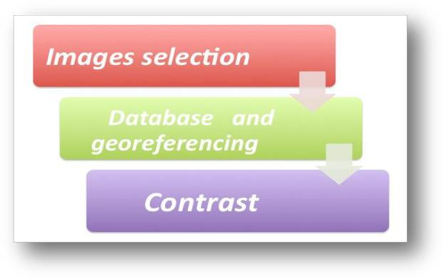

Figure a.1: Steps prior to identification of the deforested polygons.

The first step consists of selecting the images to be used. For this, a query is conducted

directly from INPE´s Image Generation Division (DGI) site (http://www.dgi.inpe.br/siteDgi_EN/index_EN.php) to identify (preferably) Landsat images (or similar) for the year of interest (usually corresponding to the months of July and August), with minimal cloud cover, better visibility and a suitable radiometric quality.

Satellite imagery available in the DGI are usually pre-processed for geometric correction and made available in UTM projection. Figure a.2 shows an image from Landsat 5 selected in the DGI library.
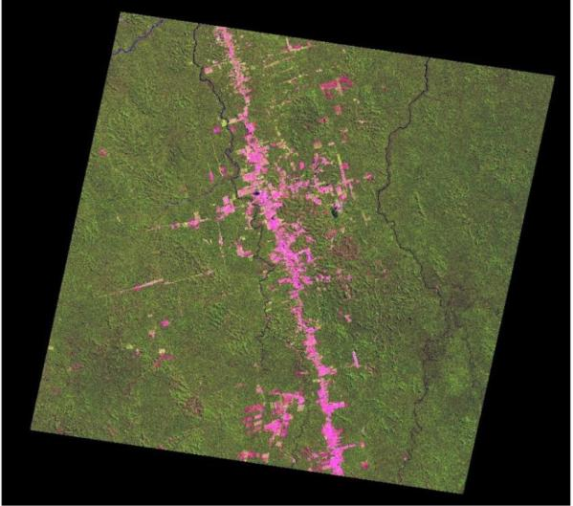

Figure a.2: Landsat 5 (pathrow 227/65) of 01/07/2002 - Color composite Red, Green, Blue for bands 5,4,3, respectively,available on the DGI catalog .

Database and georeferencing

68
The next step consists of image geo-referencing, which is carried out through visual collection of at least nine control points evenly distributed in coherent features (rivers, roads intersection) in the image to be geo-referenced. INPE uses as reference data the orthorectified Landsat mosaic for the year 2000, produced by Geocover NASA project (https:// zulu.ssc.nasa.gov / MrSID). The geo-referencing is carried out by linear matrix transformation of first or second order, depending on the image quality, with transformation parameters obtained by least-square method applied to the set of control points.
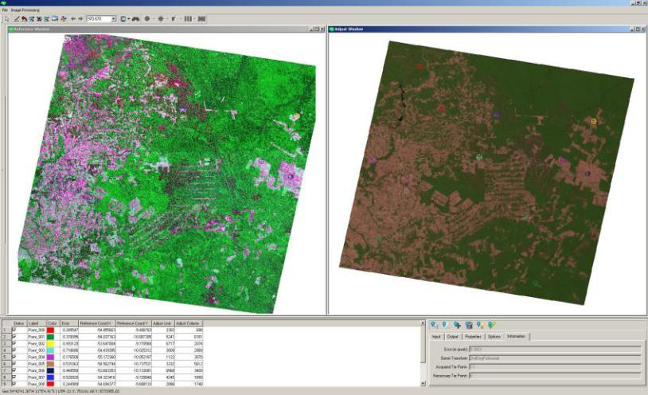

Figure a.3: An example of control points collection.

Contrast enhancement

Finally, the technique of contrast enhancement may be applied to improve the quality of the images under the subjective criteria of the human eye. The contrast between two objects may be defined as the ratio between their average gray levels.

The goal at this step is to increase the contrast to facilitate the visual discrimination of objects in the image.

Calculating deforestation rates based on deforestation increments

Deforestation rate calculations are elaborate, and have as a basis the information on deforestation increments. The simple sum of the mapped, observed deforestation polygons, is the deforestation increment.

Deforestation Increments | Deforestation Rates
Value measured by image interpretation | Value is estimated
Calculated for each pair of LANDSAT | Interpolated to a reference date (August
image | 1st)
Indicating the date of image acquisition | Takes into account the area covered by
 | clouds

69
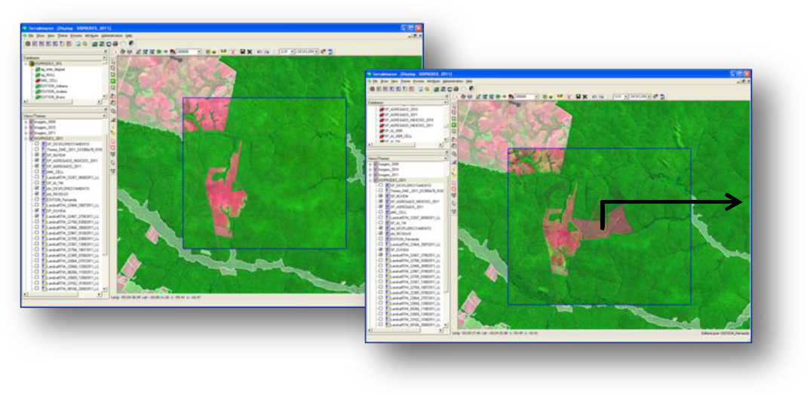

Deforestation Polygon

It should be noted that up to 2000, the Landsat TM scenes 222/61 and 222/62 were never considered by PRODES since they were persistently covered by clouds. In 2001, it was possible to observe these scenes. It was then verified that a large area was cleared in these scenes, leading to a high deforestation increment at that year (2001). This implies that there will be a substantial difference between increments and rates in years before 2001.

In early 2000s, there was a predilection for scenes without clouds, even when they were taken many days before the date of reference (August 1st). A limit to the number of days for the analysis of scenes was only later defined as a measure to avoid the discrepancy between deforestation rates and deforestation increment. In 2004, INPE decided to select only the images with dates as close as possible to the next reference date, so that after 2005/2006, the discrepancies between deforestation rates and deforestation increment became very small.

Comparing the emissions estimates: deforestation rates vs. adjusted increments

Deforestation rates were not the basis for the FREL calculations. The FREL was calculated based on adjusted deforestation increments and these are two different approaches. Brazil´s FREL is conservative because it uses only historical data and is dynamics through time (which is not required in any REDD+ decision).

PRODES maps up to 2001 were analogic and constrained the integration with the carbon map adopted in this FREL. As an exercise, the annual CO2 emissions per year were calculated taking as a basis the deforestation rates from PRODES and applying the average carbon stock per unit area (tC ha-1). This was done to assess the average difference in CO2 emissions using the annual rates of gross deforestation from PRODES and the emission estimates presented in this submission for years 1996 – 2005 based on the adjusted increments. The formula used was:

Deforestation rate (ha)/year * 151.6 tC/ha * 44/12

70

 | Deforestation | Deforestation | Emission PRODES (tCO2) | Emission FREL
 | (km2) | (ha) | (Mean = 151,6 tC/ha) | (tCO2)
1996 | 18.161 | 1.816.100 | 1.009.509.453 | 979.523.414
1997 | 13.227 | 1.322.700 | 735.244.840 | 979.523.414
1998 | 17.383 | 1.738.300 | 966.263.027 | 979.523.414
1999 | 17.259 | 1.725.900 | 959.370.280 | 979.523.414
2000 | 18.226 | 1.822.600 | 1.013.122.587 | 979.523.414
2001 | 18.165 | 1.816.500 | 1.009.731.800 | 908.964.140
2002 | 21.651 | 2.165.100 | 1.203.506.920 | 1.334.457.457
2003 | 25.396 | 2.539.600 | 1.411.678.987 | 1.375.223.215
2004 | 27.772 | 2.777.200 | 1.543.752.907 | 1.380.140.946
2005 | 19.014 | 1.901.400 | 1.056.924.880 | 1.163.873.340
Mean |  |  | 1.090.910.568 | 1.106.027.617
Difference |  |  |  | 1,39%

The average emissions from 1996 through 2005, using PRODES rates was 1,090,910,568 tCO2. The average emissions from 1996 through 2005 presented in the FREL was 1,106,027,617 tCO2. Since the FREL uses the average emissions of 10 years, these differences balance out at the end, being only 1.4 per cent.

- PPCDAm: Action Plan for the Prevention and Control of Deforestation in the Legal Amazonia

The process of deforestation in Legal Amazonia is not homogeneous, presenting distinct spatial and temporal features. It is estimated that by 1980, the accumulated gross deforestation reached approximately 300,000 km2, corresponding to approximately 6 per cent of the total forest area in Legal Amazonia. Deforestation during the 80’s and 90’s added about 280,000 km2 to this figure. In the early years of the past decade, the pace of deforestation changed, and the accumulated deforestation reached approximately 670,000 km2 in 2004, corresponding to approximately 16 per cent of the total forest area in Legal Amazonia.

This changed pace of deforestation led the Federal Government to establish, in 2003, a Permanent Interministerial Working Group (GPTI – Grupo Permanente de Trabalho Interministerial) through Decree s/n, July 3rd, to identify and promote coordinated actions aimed at reducing deforestation rates in Legal Amazonia. The GPTI was coordinated by the Chief of Staff of the Presidency until 2013 and is currently being coordinated by the Ministry of the Environment (MMA).

The GPTI was responsible for the development of the Action Plan for the Prevention and Control of Deforestation in the Legal Amazonia – PPCDAm, created in 2004, and which identified a number of measures, policies and actions to reverse the deforestation trend.

Since 2004, the Federal Government has been working in coordination with the various stakeholders, including state and municipal governments as well as the civil society, to promote a sustainable model of forest resource use and agricultural practices. PPCDAm is structured in three thematic axis that direct government actions towards reducing deforestation: i) Land Tenure and Territorial Planning; ii) Environmental Monitoring and Control, and iii) Fostering Sustainable Production Activities.

71
Since 2004, deforestation in Legal Amazonia has significantly decreased, reaching 6,418 km2 in the period 2010-2011. In 2012, gross deforestation reached its lowest historical value of 4,656 km2. In 2013, a pre-estimate based on a set of Landsat images indicates that deforestation has increased to 5,843 km2. Despite this increase, this value was the second lowest in the PRODES time-series.

The Brazilian government is developing and implementing a modular system (SMMARE, Modular System for Assessing and Monitoring GHG Emission Redutions - Sistema Modular de Monitoramento e Acompanhamento das Reduções das Emissões de Gases de Efeito Estufa) to monitor actions and GHG emission reductions to be achieved through the Brazilian Climate Change Mitigation Plan. This system also aims at supporting the analysis and management of the mitigation actions implemented by Brazil. It is presently under development by MMA.

During the period from 2004 until 2011, the decrease in gross deforestation has been mostly attributable to Environmental Monitoring and Control actions, due to the implementation of the Deforestation Detection at Almost Real Time (DETER – Detection in Real Time - Detecção em Tempo Real36) integrated with planning and supervision. Land Tenure and Territorial Planning were also key areas for achieving results during this period, through the establishment of Conservation Units and demarcation of Indigenous Lands.

The change in the pattern of deforestation (from large to small annual increments) increased the cost of the monitoring initiatives, limited by both human and budgetary resources. The occurrence of deforestation polygons of size smaller than 6,25 hectares increased the need for investments on Land Tenure and Territorial Planning and on the Development for Sustainable Production Activities. It is under this context that the Action Plan for the Prevention and Control of Deforestation in the Legal Amazonia (MMA, 2013), a key operational plan for the implementation of Brazil’s National REDD+ Strategy (2014-2020), initiated its third phase of implementation (2012-2015).

Relevant Links:

Brazil´s Action plan to reduce deforestation in the Legal Amazonia area (PPCDAm):
http://www.mma.gov.br/redd/index.php/en/legal-framework/national/ppcdam

http://www.mma.gov.br/images/arquivo/80120/PPCDAm/_FINAL_PPCDAM.PDF

- In 2004 INPE launched DETER, a quick monthly survey that maps both clear cut areas as well as areas undergoing forest degradation. DETER uses the MODIS sensor of the Terra / Aqua satellite and the WFI Sensor of the satellite CBERS, with spatial resolution of 250 m. It only detects deforestation in areas larger than 25 ha. DETER was designed as an early warning system to support surveillance and control of deforestation for the Legal Amazonia. To facilitate and streamline surveillance operations by different entities, the information is presented stratified by municipality, state, IBAMA’s operative basis and protected areas. This system can only be used as an indicator of trends in annual deforestation, not as a means for calculating annual deforestation rates. For more information see: http://www.obt.inpe.br/deter/

72

Annex II: Examples to support this FREL submission

All excel files mentioned in this example are available in its complete form through the

link: http://www.mma.gov.br/redd/index.php/en/forest-reference-emission-levels-frel/spatial-information. Parts of the example are also presented here as an illustration.

I. Example of the calculation of adjusted deforestation increment and associated CO2 emission for the year 2003

The file “calculo_def_increment_emission_2003” presents, for year 2003, the area of the deforestation polygons by forest type and RADAMBRASIL volume (activity data); and the carbon density associated with each polygon (emission factor) necessary for the calculation of the deforestation increment that precedes the calculation of the adjusted deforestation increment and the associated emissions (data in Table 1 of the submission). It results from data in tab “2003” in the file “calculo_def_increment_emission_2003” that presents individual information for each of the 402,175 deforestation polygons identified in Landsat satellite imagery at year 2003.

Lines 3 to 32 provide, for each forest type (line) and RADAMBRASIL volume (column) the total area of the deforestation polygons that fall under the corresponding line and column. For instance, the value 1,205.9 ha in row 5, column C, refers to the sum of the areas indicated in tab “2003” associated with forest type AA and RADAMBRASIL volume 3. The area deforested in each volume is presented in line 32 and columns B to X, respectively; and the total area (deforestation increment) presented in cell Y32 (2,781,345 hectares or 27,813 km2). Column Y, lines 5 to 30 provide the area deforested per forest types, and columns Z and AA provide the ratio and percent contribution of each forest type to the deforestation increment. In column AA, the cells shaded in yellow refer to the forest types in Table 4 (75.6 per cent); those in orange, to the forest types in Table 5 (23.8 per cent); and those in blue, to “new” forest types (refer to Box 1) (0.4 per cent). From column AA it can be observed that approximately 84 per cent of the deforestation polygons occurred in only four forest types (25 per cent in forest type As; 15 per cent in Db; 27 per cent in Ds; and 17 per cent in Fs).

BOX 2: Additional “forest types”

As a result of the technical assessment and disaggregation of the data by forest type and RADAMBRASIL volume, it was observed that few deforestation polygons fell over forest types that were not included in Tables 4 and 5, as follows: Lb (campinarana = 21.63 tC ha-1); Lg (campinarana gramíneo-lenhosa, depression = 25.31 tC ha-1); Rm (refúgio montano = 6.55 tC ha-1); Sg (savanna gramíneo-lenhosa, campo =16.30 tC ha-1) and Sp (cerrado parque; savanna parque = 24.10 tC ha-1).

The contribution of these forest types to the deforestation increment and associated emission is minor and highlighted in blue in column AA. For instance, for 2004 these forest types contributed 0.36 per cent to the deforestation increment and to 0.015 per cent of the total CO2 emissions; in 2005, the contribution to the deforestation increment was 0.29 per cent, and 0.011 per cent to the total emissions.

73

Lines 34 to 61 provide the carbon densities per forest type and RADAMBRASIL volume used to estimate the emissions associated with the deforestation polygons (as per Table 4, Table 5 and BOX 2 above).

Lines 64 to 91 provide, for each volume and forest type, the area of the deforestation polygons (as per data in lines 5 to 31); associated carbon densities (as per lines 36 to 61); and associated emission (in tC) (resulting from the product of the areas and carbon densities). For example, for volume 2:

- column A, lines 65 to 91 (A65 – A 91) reproduces the area of the deforestation polygons provided in B5 – B30 (activity data);

- B65 – B92 reproduces the carbon densities presented in B36 – B61 (emission factor);

- C65-C91 provides the product between the activity data in column A and the emission factor in column B.

Line 92 provides, for each RADAMBRASIL volume, the area of the deforestation polygons (highlighted in green) and the associated emissions (highlighted in yellow). The deforestation increment observed in 2003 was 2,781,345 ha (BS 92) or 27,813.45 km2 (BS 93); and the total emission was 411,592,418 tC (BS 95) or 1,509,172,201 tCO2 (BS 96). Note that the deforestation increment is the same as that obtained from the sum of the individual areas of the 402,176 deforestation polygons in file “Disaggregation 2003”, column G (in hectares).

The complete excel file, available through the link (http://www.mma.gov.br/redd/index.php/en/forest-reference-emission-levels-frel/spatial-information) also contains some interesting information.

Lines 94 to 118, column A, for instance, reproduce the areas presented in line 92 for all volumes (highlighted in green) and the deforestation increment in line 118 (2,781,345 ha); columns B and C for the corresponding lines present the ratio between the area deforested for each volume and the deforestation increment (total observed area deforested) and the corresponding percentage, respectively. It is to be noted that deforestation events do not occur evenly among the RADAMBRASIL volumes, but concentrate mainly (69.7 per cent) in volumes 4, 5, 16, 20, 22 and 26. From the figure provided in lines 96-118, columns F to M (corresponding to Figure 11 in the text of the submission) it can be seen that these volumes cover the area of the “Arc of Deforestation” in the Amazonia biome. The concentration of the deforestation polygons in these volumes is also observed for other years.

If the information on these volumes is individualized (see lines 120-150 for volume 4; lines 153-181 for volume 5; lines 184-212 for volume 16; lines 215-244 for volume 20; lines 247-276 for volume 22; and lines 279-307 for volume 26), then column F provides the forest types most affected by deforestation events in these relevant volumes. One notes that in all these volumes, the largest percentage of the deforestation polygons fell over at least 2 and at most 3 out of the 22 (+5) forest types. For volume 4, 99.0 per cent of the deforestation polygons fell over forest types AS and DS; for volume 5, 91.87 per cent over DB and DS; for volume 16, 96.86 per cent over forest types AS, DS and FS; for volume 22, 96.32 per cent over AS, FS and SD; and finally for volume 26, 84.85 over forest types AS and FS. Hence, none of the deforestation polygons fell over “new”

74
deforestation types (refer to Box 1 above) and most fell over forest types with data from RADAMBRASIL sample units (Table 4 – forest types AB, AS, DS, DB) and few over forest types with data from the literature (Table 5 – FS and SD).

The diagrams in columns H to AB, lines 120 – 308 show the range of the carbon densities associated with the corresponding forest type, from the lowest to the highest value. The arrows indicate the value of the carbon density used.

Note that the figure provided in BS 93 for the deforestation increment (in km2) is not the same as that presented in Table 1 for year 2003. The difference is explained by the fact that in 2002 some satellite images were cloud covered and the adjusted deforestation increment approach was applied (refer to Box 2 of the FREL´s main text).

The file “verification_2003_area_emissao” provides the data necessary to calculate the adjusted deforestation increment and associated CO2 emissions. It includes information over cloud-covered area and the distribution of areas among years, so as not to under or overestimate the total area deforested at any year (refer to Box 2 of the FREL´s main text).

Lines 6 to 68, columns A to J, provide information on the following: (i) satellite image of interest (i.e., the Path/Row information on the Landsat images for which adjustment will be applied to the associated deforestation increment); (ii) the area of the deforestation polygons observed in 2003 over areas that were cloud covered in 2002;

- the forest types associated with the deforestation polygons observed in 2003 over areas cloud covered in 2002; (iv) the associated RADAMBRASIL volume.

For instance, the value 28,068.05 ha in line 8 column I represents the sum of the areas of the deforestation polygons observed at year 2003 over areas that were cloud-covered at years 2002 and 2001 in Landsat Path/Row 225/59. This area concentrated in volume 6 of RADAMBRASIL and the deforestation polygons were associated with forest types AA, DA, DB, PA, PF, SA, SD, SG and SP, as indicated in lines 9 to 18. Tab “22559” in the file “verification_2003_area_emissao” gives the list of the deforestation polygons (a total of 3,441) stratified by forest type, and the associated areas (in column G, in hectares) and emissions (in column E, in tC) for this satellite scene. The emission associated with the deforestation polygons falling in forest type AA, for instance, are calculated using the carbon density for forest type AA in volume 6 in Table 4 (123,75 tC), totaling 3,295,357.34 tC (refer to BOX 3 below). Due to the fact that these polygons fell over an area in the satellite imagery that was cloud-covered in 2002 and 2001, the area of 28,068.05 ha and corresponding emission of 3.295.357,34 tC was evenly distributed among the deforestation increment for 2002 and 2001. This implied the division of these values by 3, resulting in a shared area of 9,356.02 ha and shared emission of 1,098,452.45 tC. So, the original area of 28,068.05 ha is subtracted from the 2003 deforestation increment (2,781,345.04 ha) and replaced by 9,356.02 ha. This value is added to the deforestation increment of 2002 and 2001.

BOX 3: Independent Verification

For the sake of verifiability, the original data for Landsat scene 225/59 have been reproduced in tab “22559” in file “verification_2003_area_emissao” for all forest types. Refer to lines 2-262 columns I to P for forest type AA (carbon density = 123.75 tC, Table 4); to lines 2-783 columns Q to X for forest type DA (carbon density =

75
131.82 tC, Table 4); to lines 2-600 columns Z to AG for forest type DB (carbon density

- 222.39 tC, Table 4); to lines 2-405 columns AI to AP for forest type PA (carbon density = 105.64 tC, Table 5); to lines 2-140 columns AR to AY for forest type PF (carbon density = 98.16 tC, Table 5); to lines 2-14 columns BA to BH for forest type SA (carbon density = 47.10 tC, Table 5); to lines 2-380 columns BJ - BQ for forest type SD (carbon density = 77.8 tC, Table 5); to lines 2-28 columns BS to BZ for forest type SG (carbon density = 16.3 tC, Box 1, Additional Forest Types); and to lines 2-447 columns CB to CI for forest type SP (carbon density = 24.10 tC, Box 1, Additional Forest Types). Note that the values highlighted in yellow (emissions) and green (area) in lines 263 (for AA); 784 (for DA); 601 (for DB); 406 (for PA); 141 (for PF); 15 (for SA); 381 (for SD); 29 (for SG); and 448 (for SP) correspond to the figures presented for Landsat scene 225/59 in columns F (for emissions) and G (for area) for forest types AA (line 9); DA (line 10); DB (line 11); PA (line 12); PF (line 13); SA (line 15); SD (line 16); SG (line 17); and SP (line 18). Note that the columns shaded in grey for each forest type (column P, X, AG, AP, AY, BH, BQ, BZ, and CI for forest types AA, DA, DB, PA, PF, SA, SD, SG, and SP, respectively is the verification column for the emissions. It results from the multiplication of the area (in hectares) by the carbon densities corresponding to the forest type in Table 4, Table 5 or Box 1 above (Additional Forest Types). Note that the original emissions (highlighted in yellow) and those reproduced independently (highlighted in grey) most likely due to the number of decimal places used for the carbon densities. The original data (area and emissions) originate from the database and has its own internal functions (decimal places, order of applying operations, etc.). However, the numbers have been closely reproduced.

The same procedure applies for Landsat scenes 224/60; 225/63; 226/58; 226/59; 226/60; 226/61; 226/62; 226/63; and 227/58 which, together, present and area of 368,979.57 ha of observed deforestation polygons at year 2003 that was cloud covered in the previous year or years, distributed as follows: scenes 224/60, 35.67 ha; 225/59, 28,068.05 ha; 225/63, 24,355.22 ha; 226/58, 5,248.91 ha; 226/59, 85.74 ha; 226/60, 6,483.50 ha; 226/61, 4,457.58 ha; 226/62, 218,283.72 ha; 226/63, 81,960.44 ha; and 227/58, 0.72 ha. These observed area in 2003 were cloud-covered in 2002 or 2002 and 2001, as follows: scenes 224/60, cloud-covered in 2002; 225/59, cloud-covered in 2001 and 2002; 225/63, cloud-covered in 2002; 226/58, cloud-covered in 2002; 226/59, cloud-covered in 2002; 226/60, cloud-covered in 2001 and 2002; 226/61, cloud-covered in 2002; 226/62, cloud-covered in 2001 and 2002; 226/63, cloud-covered in 2002; and 227/58, cloud-covered in 2002. Note that part of the area 368,979.57 ha is subtracted from the observed deforestation increment at year 2003 and is distributed among years 2001 and/or 2002, as applicable. Column J shows the portion of this area that is summed to the deforestation increment calculated for years 2001 and/or 2002 (corresponding to the area to be subtracted from the deforestation increment calculated for year 2003). Half of the area indicated in column J line 6 for scene 224/60 (17.84 ha) is added to the 2002 deforestation increment and half remains in the 2003 deforestation increment; one third of the area indicated in column J line 8 for scene 225/59 (9,356.02 ha) is added to the 2001 deforestation increment; one third is added to the 2002 deforestation increment and one third remains in the 2003 deforestation increment.

Table 1 shows the distribution of the area of the deforestation polygons observed in 2003 under cloud-cover areas in the satellite images in 2002 or 2001 and 2002.

76
 | 2003 | 2002 | 2001 | Total area
224/60 | 17.84 | 17.84 |  | 35,67
225/59 | 9,356.02 | 9,356.02 | 9,356.02 | 28.068,05
225/63 | 12,177.61 | 12,177.61 |  | 24.355,22
226/58 | 2,624.46 | 2,624.46 |  | 5.248,91
226/59 | 42.87 | 42.87 |  | 85,74
226/60 | 2,161.17 | 2,161.17 | 2,161.17 | 6.483,50
226/61 | 2,228.79 | 2,228.79 |  | 4.457,58
226/62 | 72,761.24 | 72,761.24 | 72,761.24 | 218.283,72
226/63 | 40,980.22 | 40,980.22 |  | 81.960,44
227/58 | 0.36 | 0.36 |  | 0,72
TOTAL | 142,350.57 | 142,350.57 | 84,278.43 | 368,979.57

The figures in Table 1 above show that out of the area of 368,979.57 ha associated to deforestation polygons observed in 2003 over areas that were cloud covered in years 2002 or 2001 and 2002, 142,350.57 ha was attributed to year 2003; 142,350.57 ha was attributed to year 2002; and 84,278.43 ha was attributed to year 2001, thus implying the addition of these quantities to the deforestation increment calculated for these years.

Relating these values to Equation 1 in the submission:

The value 368,979.57 ha corresponds to term ∑ ACC(t −Δ),(t ) Δ=1

The value 142,350.57 ha corresponds to term

.

Y | A |  | A |  | A |  | 116,144.29 |  | 252,835.28
∑ | CC(t −Δ),(t ) | = | CC(t −1),(t ) | + | CC(t −2),(t ) | = | 116,144.29 | + | 252,835.28
∑ | Δ +1 | = | 2 | + | 3 | = | 2 | + | 3
Δ=1 | Δ +1 |  | 2 |  | 3 |  | 2 |  | 3

- 58,072.14 +84,278.43 =142,350.57

The value 116,144.29 refers to term ACC(t −2),(t ) in Equation 1.

ACC(t −1),(t )

and the value 252,835.28 to term

The value 116,144.29 ha corresponds to the sum of the areas associated with Landsat scene 224/60 (35.67 ha); 225/63 (24,355.22 ha); 226/58 (5,248.91 ha); 226/59 (85.74 ha); 226/61 (4,457.58 ha); 226/63 (81,960.44 ha). The area 252,835.28 ha is associated to Landsat scenes 225/59 (28,068.05 ha); 226/60 (6,483.50 ha) and 226/62 (218,283.72 ha).

Y | A
The term ∑ | CC(t +Ω),(t ) | = 0 , since there were no cloud-covered areas in 2003 (thus, not
The term ∑ | Ω +1
Ω=1 | Ω +1

requiring distribution of area from 2004 to 2003).

77
Turning now to the distribution of the emissions associated with the areas transferred to years 2002 or 2001 and 2002.

Lines 2 – 81, columns Q to W provide the verification of the emissions reported in the information from lines 3 to 68, columns A to I. The emissions are estimated using the carbon densities per unit area (tC ha-1) provided in Tables 4 and 5 and Box 1 in the Annex, and hence it is to be expected that the numbers do not completely match due to the number of decimal places used and order of the functions performed.

The emissions associated with each satellite image are summarized in lines 1 to 23, columns L to O (the totals presented originate from the calculations performed in columns Q to W – values highlighted in yellow -individually or totals). The emissions associated with the deforestation polygons in 2003 over areas that were cloud covered in year 2002 or 2001 and 2002 totaled 74,179,069.36 tC. Column X indicates how this area will be distributed among years 2002 and 2001 (divide by 2 in case the area was cloud-covered in 2002; divide by 3 if the area was cloud-covered in years 2001 and 2002, and was observed in 2003). Column Y provides the individual values to be reallocated.

Table 2 shows the distribution of the emissions associated with the deforestation polygons observed in 2003 under cloud-cover areas in the satellite images in 2002 or 2001 and 2002.

 | 2003 | 2002 | 2001 | Total
 |  |  |  | emissions
224/60 | 3,302.22 | 3,302.22 |  | 6,604,44
225/59 | 1,097,478.97 | 1,097,478.97 | 1,097,478.97 | 3,292,436.91
225/63 | 2,329,889.95 | 2,329,889.95 |  | 4,659,779.9
226/58 | 574,005.21 | 574,005.21 |  | 1,148,010.42
226/59 | 9,467.20 | 9,467.20 |  | 18,934.40
226/60 | 325,830.63 | 325,830.63 | 325,830.63 | 977,491.89
226/61 | 409,717.70 | 409,717.70 |  | 819,435.40
226/62 | 16,286,514.94 | 16,286,514.94 | 16,286,514.94 | 48,859,544.82
226/63 | 7,198,338.73 | 7,198,338.73 |  | 14,396,677.46
227/58 | 76.88 | 76.88 |  | 153.76
TOTAL | 28,234,622.43 | 28,234,622.43 | 17,709,824.54 | 74,179,069.40

Columns AB and AC, rows 2 to 21 show a summary of the verification of the adjusted deforestation increment and corresponding emissions, where it can be observed that the differences were minor, given the different mode of calculation adopted in this example and that carried out for this submission.

78
Annex II, Part I

Example of the calculation of adjusted deforestation increment and associated CO2 emission for the year 2003

"calculo_def_increment_emission_2003"

 | A | B | C | D | E | F | G | H | I | J | K
1 | 2003
2
3 | Soma de area_ha | Rótulos de Coluna
 | Rótulos de Linha | Vol, 02 | Vol, 03 | Vol, 04 | Vol, 05 | Vol, 06 | Vol, 07 | Vol, 08 | Vol, 09 | Vol, 10 | Vol, 11
4
5 | AA |  | 1,205.90 |  |  | 2,517.63 |  |  |  | 13.14
 | AB | 54.21 | 4,831.47 |  |  |  |  |  |  | 5.09
6 | AB | 54.21 | 4,831.47 |  |  |  |  |  |  | 5.09
 | AS | 4,058.07 | 128.21 | 74,624.76 | 24,185.32 |  | 47,152.79 | 8,936.18 | 57.53 | 2,171.84 | 299.01
7
 | CB
8 | CB
 | CS |  | 30.84
9 | CS |  | 30.84
 | DA | 0.33 | 4,857.86 | 797.99 | 6,570.45 | 5,529.15 | 1,982.02 | 92.14 | 44.61 | 2,488.04
10
 | DB |  | 134,803.34 | 37.23 | 142,714.86 | 10,550.99 | 3,120.40 | 113.33 |  | 37,017.89
11 | DB |  |  |  |  |  |  |  |  | 37,017.89
 | DM |  |  |  |  |  |  | 211.43
12 | DM |  |  |  |  |  |  | 211.43
 | DS | 23,356.33 | 9,185.84 | 245,579.95 | 235,505.97 | 3,652.71 | 27,721.26 | 23,811.98 | 5,984.81 | 3,018.52 | 671.06
13
 | FA |  |  |  |  |  |  | 14.37 | 18.06
14 | FA |  |  |  |  |  |  | 14.37 | 18.06
 | FB
15 | FB
 | FS | 156.14 |  |  |  |  |  | 13,426.42
16 | FS | 156.14 |  |  |  |  |  | 13,426.42
 | LA |  |  |  | 135.12 |  |  | 326.10 |  |  | 16.16
17 | LA |  |  |  | 135.12 |  |  | 326.10 |  |  | 16.16
 | LB
18 | LB
 | LD |  |  |  |  |  |  | 529.41 |  | 12.46 | 354.00
19 | LD |  |  |  |  |  |  | 529.41 |  | 12.46 | 354.00
 | LG |  |  |  | 11.74 |  |  | 9.38 |  | 84.46
20 | LG |  |  |  | 11.74 |  |  | 9.38 |  | 84.46
 | PA | 16.51 | 1,646.41 |  | 499.79 | 7,096.23 | 17.14 |  |  | 100.93
21 | PA | 16.51 | 1,646.41 |  | 499.79 | 7,096.23 | 17.14 |  |  | 100.93
 | PF |  | 8,822.39 |  | 299.84 | 2,959.03
22 | PF |  | 8,822.39 |  | 299.84 | 2,959.03
 | PM |  | 19.53
23 | PM |  | 19.53
 | RIOS_LAGOS |  | 732.58 | 77.46 | 132.21 | 637.16 | 131.15 | 39.35 | 12.44 | 803.28 | 4.76
24 | RIOS_LAGOS
 | RM |  |  |  |  |  |  | 11.38
25 | RM |  |  |  |  |  |  | 11.38
 | SA | 34.07 | 365.46 | 521.81 | 168.04 | 233.04 | 291.48 | 939.98 | 170.32 | 48.13
26
 | SD | 8.98 |  | 1,394.42 | 1,479.55 | 3,385.98 | 1,152.62 |  |  | 436.03
27 | SD | 8.98 |  |  |  |  |  |  |  | 436.03
 | SG |  |  |  |  | 75.42 | 9.72 | 343.46 | 75.10
28 | SG
 | SP |  | 19.74 | 398.97 |  | 1,895.87 | 296.52 | 177.97 | 1,692.52 | 614.24
29 | SP |  | 19.74 | 398.97
 | TD |  |  |  |  |  |  | 108.80
30 | TD |  |  |  |  |  |  | 108.80
 | (vazio) |  | 37.48 | 4.09 |  |  |  |  |  |  | 0.16
31 | (vazio) |  | 37.48 | 4.09 |  |  |  |  |  |  | 0.16
32 | Total Geral | 27,684.64 | 166,687.03 | 323,436.68 | 411,702.90 | 38,533.20 | 81,875.11 | 49,091.68 | 8,055.39 | 46,814.05 | 1,345.16
33

Annex II, Part I

Example of the calculation of adjusted deforestation increment and associated CO2 emission for the year 2003

"calculo_def_increment_emission_2003"

 | A | L | M | N | O | P | Q | R | S | T | U | V
1 | 2003
2
3 | Soma de area_ha
 | Rótulos de Linha | Vol, 12 | Vol, 13 | Vol, 14 | Vol, 15 | Vol, 16 | Vol, 17 | Vol, 18 | Vol, 19 | Vol, 20 | Vol, 22 | Vol, 25
4
5 | AA | 22,184.60 | 1,142.83 | 292.51 | 3,108.47 | 873.59 | 2,217.79 | 191.73 | 392.88
 | AB | 68,567.42 | 3,061.13 | 4.02 | 4,129.93 | 27,811.58 | 2,276.12 | 3.21 | 36,086.64
6
 | AS | 5,537.63 |  |  |  | 193,353.69 | 936.42 | 2.74 | 11,159.16 | 145,892.68 | 139,662.63
7 | AS | 5,537.63
 | CB |  |  |  |  |  |  |  | 111.02
8 | CB |  |  |  |  |  |  |  | 111.02
 | CS |  |  |  |  |  |  |  |  | 4,510.49
9 | CS |  |  |  |  |  |  |  |  | 4,510.49
 | DA | 3,462.27 | 38.24 | 783.02 | 1,536.60 | 1,550.62 | 8,110.68 | 2,936.37 | 151.12 | 1,764.91 | 721.29
10
 | DB | 58,107.04 | 2,520.35 | 3,405.32 | 1,255.20 | 2,253.14 | 4,740.70 | 16,108.46
11
 | DM
12 | DM
 | DS | 12.14 |  | 199.91 |  | 23,936.37 | 4,569.16 | 1,271.95 | 392.96 | 151,976.40 | 55.39
13 | DS | 12.14 |  | 199.91
 | FA |  |  |  |  |  |  |  | 1,139.07 |  | 1,714.15 | 329.31
14 | FA |  |  |  |  |  |  |  | 1,139.07 |  | 1,714.15 | 329.31
 | FB |  |  |  |  |  |  |  | 18,475.89
15 | FB |  |  |  |  |  |  |  | 18,475.89
 | FS |  |  |  |  |  |  |  | 35,975.35 | 163,121.18 | 39,890.99 | 68,488.74
16 | FS
 | LA |  |  |  |  |  |  | 327.31 |  | 51.82
17 | LA |  |  |  |  |  |  | 327.31 |  | 51.82
 | LB | 301.82 |  | 7.92 |  |  |  | 2.45
18 | LB | 301.82 |  | 7.92 |  |  |  | 2.45
 | LD |  |  | 75.43 |  |  |  | 253.92 |  | 262.22
19 | LD |  |  | 75.43 |  |  |  | 253.92 |  | 262.22
 | LG |  |  |  |  |  |  | 46.99 |  | 50.55
20 | LG |  |  |  |  |  |  | 46.99 |  | 50.55
 | PA |  |  | 10.01 | 1.08 | 288.88 | 307.44 | 9.34 | 2,287.11 | 76.48 | 307.46 | 575.44
21 | PA
 | PF
22 | PF
 | PM
23 | PM
 | RIOS_LAGOS | 610.47 | 12.87 | 172.37 | 70.80 | 154.11 | 219.65 | 446.24 | 169.66 | 163.11 | 48.28 | 3.42
24
 | RM |  |  |  |  |  |  |  |  | 1,758.60
25 | RM |  |  |  |  |  |  |  |  | 1,758.60
 | SA |  |  |  |  | 467.07 | 13.93 |  | 1,438.64 | 9,310.28 | 4,447.83 | 1,787.83
26 | SA |  |  |  |  | 467.07 | 13.93
 | SD |  |  |  |  | 1,977.29 |  |  | 902.51 | 27,065.40 | 38,712.85 | 15,834.25
27 | SD |  |  |  |  | 1,977.29
 | SG |  |  |  |  | 4.09 | 29.48 |  |  |  | 123.95
28 | SG |  |  |  |  | 4.09 | 29.48 |  |  |  | 123.95
 | SP |  |  |  |  | 365.32 | 19.92 |  | 211.67 | 102.16 | 910.52 | 1,774.21
29 | SP |  |  |  |  | 365.32 | 19.92
 | TD
30 | TD
 | (vazio) | 0.09 |  |  |  |  |  |  |  | 0.37 | 0.95
31 | (vazio) | 0.09 |  |  |  |  |  |  |  | 0.37 | 0.95
32 | Total Geral | 158,783.47 | 6,775.43 | 4,950.51 | 10,102.08 | 253,035.75 | 23,441.28 | 21,600.70 | 108,893.67 | 506,106.64 | 226,596.30 | 88,793.20
33

Annex II, Part I

Example of the calculation of adjusted deforestation increment and associated CO2 emission for the year 2003

"calculo_def_increment_emission_2003"

 | A | W | X | Y | Z | AA | AB | AC | AD | AE | AF | AG
1 | 2003
2 |  |  |  |  |  |  | 2781345.04
3 | Soma de area_ha
 | Rótulos de Linha | Vol, 26 | Vol, 27 | Total Geral |  |  |  |  |  |  | %
4 |  |  |  |  |  |  |  |  |  |  | %
5 | AA |  |  | 34,141.07 | 0.01227502 | 1.227502 |  |  |  | table 4 | 75.56
6 | AB |  |  | 146,830.83 | 0.0527913 | 5.27913 |  |  |  | table 5 | 23.83
7 | AS | 38,077.53 |  | 696,236.18 | 0.25032356 | 25.03236 |  | AS |  | new types | 0.433
8 | CB | 567.01 |  | 678.02 | 0.00024378 | 0.024378 |  |  |  |  | 0.168
 | CS | 5,676.26 |  | 10,217.59 | 0.00367362 | 0.367362 |  |  |  |  | 0.002
9 | CS | 5,676.26 |  | 10,217.59 | 0.00367362 | 0.367362 |  |  |  |  | 0.002
10 | DA | 889.28 |  | 44,306.99 | 0.01593006 | 1.593006 |  |  |  |  | 100.00
 | DB |  |  | 416,748.24 | 0.14983694 | 14.98369 |  | DB
11 | DB |  |  | 416,748.24 | 0.14983694 | 14.98369 |  | DB
 | DM |  |  | 211.43 | 7.6017E-05 | 0.007602
12 | DM |  |  | 211.43 | 7.6017E-05 | 0.007602
 | DS |  |  | 760,902.73 | 0.27357365 | 27.35737 |  | DS
13 | DS |  |  | 760,902.73 | 0.27357365 | 27.35737 |  | DS
14 | FA | 868.57 |  | 4,083.53 | 0.00146818 | 0.146818
 | FB | 10,779.62 |  | 29,255.50 | 0.01051847 | 1.051847
15 | FB | 10,779.62 |  | 29,255.50 | 0.01051847 | 1.051847
 | FS | 145,958.83 |  | 467,017.64 | 0.16791072 | 16.79107 |  | FS
16 | FS | 145,958.83 |  | 467,017.64 | 0.16791072 | 16.79107 |  | FS
17 | LA |  |  | 856.50 | 0.00030795 | 0.030795 | 2781345.04
18 | LB |  |  | 312.18 | 0.00011224 | 0.011224
19 | LD |  |  | 1,487.44 | 0.00053479 | 0.053479
20 | LG |  |  | 203.13 | 7.3031E-05 | 0.007303
21 | PA | 854.00 |  | 14,094.26 | 0.00506742 | 0.506742
 | PF |  |  | 12,081.25 | 0.00434367 | 0.434367
22 | PF |  |  | 12,081.25 | 0.00434367 | 0.434367
 | PM |  |  | 19.53 | 7.0213E-06 | 0.000702
23 | PM |  |  | 19.53 | 7.0213E-06 | 0.000702
24 | RIOS_LAGOS | 32.55 |  | 4,673.92 | 0.00168045 | 0.168045 | River and Lakes
25 | RM |  |  | 1,769.98 | 0.00063637 | 0.063637
26 | SA | 5,542.32 | 78.54 | 25,858.75 | 0.00929721 | 0.929721
 | SD | 7,108.66 |  | 99,458.54 | 0.03575915 | 3.575915
27 | SD | 7,108.66 |  | 99,458.54 | 0.03575915 | 3.575915
28 | SG |  |  | 661.22 | 0.00023773 | 0.023773
 | SP | 535.53 | 69.66 | 9,084.81 | 0.00326634 | 0.326634
29
30 | TD |  |  | 108.80 | 3.9119E-05 | 0.003912
31 | (vazio) | 1.83 |  | 44.98 | 1.6171E-05 | 0.001617
 |  |  |  |  | 1 | 100
32 | Total Geral | 216,891.98 | 148.20 | 2,781,345.04 | 1 | 100
33
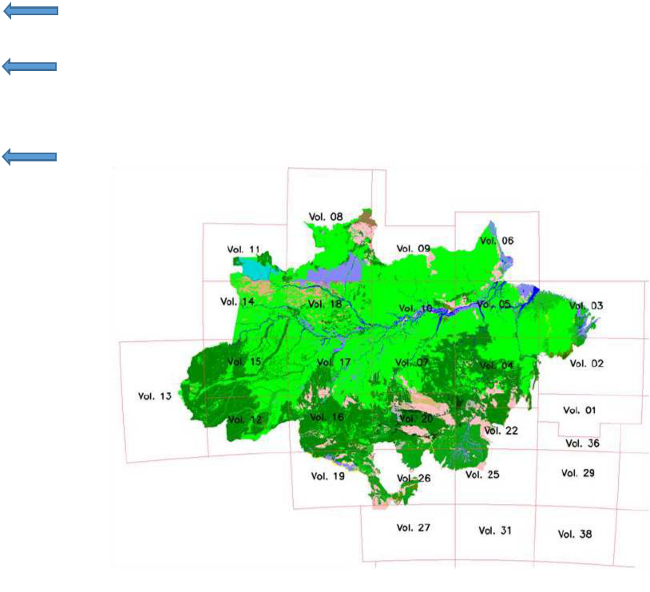
Annex II, Part I

Example of the calculation of adjusted deforestation increment and associated CO2 emission for the year 2003

"calculo_def_increment_emission_2003"

 | A | B | C | D | E | F | G | H | I | J | K | L
34 |  | Vol, 02 | Vol, 03 | Vol, 04 | Vol, 05 | Vol, 06 | Vol, 07 | Vol, 08 | Vol, 09 | Vol, 10 | Vol, 11 | Vol, 12
35 | CARBON STOCK IN THE DIFFERENT FOREST TYPES (tC/ha) - table 4 and table 5
 | AA | 98.24 | 98.24 | 94.88 | 108.33 | 123.75 | 159.51 | 146.97 | 127.61 | 141.81 | 154.71 | 144.32
36
 | AB | 154.55 | 154.55 | 154.55 | 154.55 | 154.55 | 160.29 | 197.91 | 213.37 | 169.49 | 197.91 | 150.69
37
 | AS | 110.06 | 129.28 | 129.28 | 146.82 | 133.99 | 180.66 | 73.64 | 112.13 | 146.45 | 158.2 | 116.14
38
 | CB | 116.27 | 116.27 | 116.27 | 116.27 | 116.27 | 116.27 | 116.27 | 116.27 | 116.27 | 116.27 | 116.27
39
 | CS | 116.27 | 116.27 | 116.27 | 116.27 | 116.27 | 116.27 | 116.27 | 116.27 | 116.27 | 116.27 | 116.27
40
 | DA | 182.98 | 137.85 | 119.67 | 213.85 | 131.82 | 142.58 | 270.89 | 262.68 | 174.03 | 166.72 | 164.35
41
 | DB | 176.1 | 161.01 | 154.59 | 185.15 | 222.39 | 153.42 | 163.92 | 157.38 | 149.54 | 168.13 | 157.42
42
 | DM | 139.03 | 139.03 | 139.03 | 109.69 | 109.69 | 139.03 | 149.5 | 109.69 | 147.77 | 83.74 | 139.03
43
 | DS | 169.35 | 275.37 | 148.3 | 230.13 | 213.55 | 175.71 | 138.56 | 184.64 | 171.21 | 144.81 | 161.84
44
 | FA | 140.09 | 140.09 | 140.09 | 140.09 | 140.09 | 140.09 | 140.09 | 140.09 | 140.09 | 140.09 | 140.09
45
 | FB | 140.09 | 140.09 | 140.09 | 140.09 | 140.09 | 140.09 | 140.09 | 140.09 | 140.09 | 140.09 | 140.09
46
 | FS | 140.09 | 140.09 | 140.09 | 140.09 | 140.09 | 140.09 | 140.09 | 140.09 | 140.09 | 140.09 | 140.09
47
 | LA | 183 | 183 | 183 | 183 | 183 | 262.99 | 183 | 262.99 | 262.99 | 114.31 | 183
48
49 | LB | 21.63 | 21.63 | 21.63 | 21.63 | 21.63 | 21.63 | 21.63 | 21.63 | 21.63 | 21.63 | 21.63
50 | LD |  |  |  |  |  |  | 183 |  | 262.99 | 114.31
51 | LG | 25.31 | 25.31 | 25.31 | 25.31 | 25.31 | 25.31 | 25.31 | 25.31 | 25.31 | 25.31 | 25.31
52 | PA | 105.64 | 105.64 | 105.64 | 105.64 | 105.64 | 105.64 | 105.64 | 105.64 | 105.64 | 105.64 | 105.64
 | PF | 98.16 | 98.16 | 98.16 | 98.16 | 98.16 | 98.16 | 98.16 | 98.16 | 98.16 | 98.16 | 98.16
53
54 | PM | 94.48 | 94.48 | 94.48 | 94.48 | 94.48 | 94.48 | 94.48 | 94.48 | 94.48 | 94.48 | 94.48
55 | RIOS_LAGOS
56 | RM | 6.55 | 6.55 | 6.55 | 6.55 | 6.55 | 6.55 | 6.55 | 6.55 | 6.55 | 6.55 | 6.55
57 | SA | 47.1 | 47.1 | 47.1 | 47.1 | 47.1 | 47.1 | 47.1 | 47.1 | 47.1 | 47.1 | 47.1
 | SD | 77.8 | 77.8 | 77.8 | 77.8 | 77.8 | 77.8 | 77.8 | 77.8 | 77.8 | 77.8 | 77.8
58
59 | SG | 16.30 | 16.30 | 16.30 | 16.30 | 16.30 | 16.30 | 16.30 | 16.30 | 16.30 | 16.30 | 16.30
 | SP | 24.10 | 24.10 | 24.10 | 24.10 | 24.10 | 24.10 | 24.10 | 24.10 | 24.10 | 24.10 | 24.10
60
61 | TD | 30.10 | 30.10 | 30.10 | 30.10 | 30.10 | 30.10 | 30.10 | 30.10 | 30.10 | 30.10 | 30.10

Annex II, Part I

Example of the calculation of adjusted deforestation increment and associated CO2 emission for the year 2003

"calculo_def_increment_emission_2003"

 | M | N | O | P | Q | R | S | T | U | V | W | X
34 | Vol, 13 | Vol, 14 | Vol, 15 | Vol, 16 | Vol, 17 | Vol, 18 | Vol, 19 | Vol, 20 | Vol, 22 | Vol, 25 | Vol, 26 | Vol, 27
35
 | 144.76 | 154.71 | 172.81 | 165.7 | 136.09 | 162.92 | 150.22 | 150.61 | 148.74 | 155.84 | 165.70
36
 | 144.62 | 177.28 | 164.36 | 136.14 | 159.17 | 213.37 | 147.92 | 151.80 | 154.55 | 154.55 | 136.14
37
 | 139.24 | 173.89 | 156.03 | 156.76 | 157.15 | 150.61 | 135.72 | 117.97 | 97.4 | 113.12 | 130.49
38
 | 116.27 | 116.27 | 116.27 | 116.27 | 116.27 | 116.27 | 116.27 | 116.27 | 116.27 | 116.27 | 116.27
39
 | 116.27 | 116.27 | 116.27 | 116.27 | 116.27 | 116.27 | 116.27 | 116.27 | 116.27 | 116.27 | 116.27
40
 | 168.64 | 157.86 | 171.77 | 175.73 | 175.64 | 174.79 | 170.56 | 169.39 | 137.67 | 172.77 | 175.73
41
 | 153.25 | 174.17 | 154.38 | 188.14 | 165.53 | 158.01 | 159.4 | 163.05 | 153.42 | 162.51 | 188.14
42
 | 104.05 | 104.05 | 104.05 | 139.03 | 104.05 | 139.03 | 139.03 | 139.03 | 139.03 | 139.03 | 139.03
43
 | 121.02 | 142.46 | 155.4 | 175.02 | 159.63 | 140.48 | 154.78 | 123.29 | 145.55 | 127.87 | 153.93
44
 | 140.09 | 140.09 | 140.09 | 140.09 | 140.09 | 140.09 | 140.09 | 140.09 | 140.09 | 140.09 | 140.09
45
 | 140.09 | 140.09 | 140.09 | 140.09 | 140.09 | 140.09 | 140.09 | 140.09 | 140.09 | 140.09 | 140.09
46
 | 140.09 | 140.09 | 140.09 | 140.09 | 140.09 | 140.09 | 140.09 | 140.09 | 140.09 | 140.09 | 140.09
47
 | 160.43 | 160.43 | 228.8 | 183 | 228.8 | 262.99 | 183 | 183 | 183 | 183 | 183
48
49 | 21.63 | 21.63 | 21.63 | 21.63 | 21.63 | 21.63 | 21.63 | 21.63 | 21.63 | 21.63 | 21.63 | 21.63
50 | 160.43 | 160.43 |  |  |  | 262.99 |  | 183
51 | 25.31 | 25.31 | 25.31 | 25.31 | 25.31 | 25.31 | 25.31 | 25.31 | 25.31 | 25.31 | 25.31 | 25.31
52 | 105.64 | 105.64 | 105.64 | 105.64 | 105.64 | 105.64 | 105.64 | 105.64 | 105.64 | 105.64 | 105.64
 | 98.16 | 98.16 | 98.16 | 98.16 | 98.16 | 98.16 | 98.16 | 98.16 | 98.16 | 98.16 | 98.16
53
 | 94.48 | 94.48 | 94.48 | 94.48 | 94.48 | 94.48 | 94.48 | 94.48 | 94.48 | 94.48 | 94.48
54
55
56 | 6.55 | 6.55 | 6.55 | 6.55 | 6.55 | 6.55 | 6.55 | 6.55 | 6.55 | 6.55 | 6.55 | 6.55
57 | 47.1 | 47.1 | 47.1 | 47.1 | 47.1 | 47.1 | 47.1 | 47.1 | 47.1 | 47.1 | 47.1 | 47.1
 | 77.8 | 77.8 | 77.8 | 77.8 | 77.8 | 77.8 | 77.8 | 77.8 | 77.8 | 77.8 | 77.8
58
59 | 16.30 | 16.30 | 16.30 | 16.30 | 16.30 | 16.30 | 16.30 | 16.30 | 16.65 | 16.30 | 16.30 | 16.30
 | 24.10 | 24.10 | 24.10 | 24.10 | 24.10 | 24.10 | 24.10 | 24.10 | 24.10 | 24.10 | 24.10 | 24.10
60
61 | 30.10 | 30.10 | 30.10 | 30.10 | 30.10 | 30.10 | 30.10 | 30.10 | 30.10 | 30.10 | 30.10

Annex II, Part I

Example of the calculation of adjusted deforestation increment and associated CO2 emission for the year 2003

"calculo_def_increment_emission_2003"

 | A | B | C | D | E | F | G | H | I | J | K | L
64 | Vol, 02 |  |  | Vol, 03 |  |  | Vol, 04 |  |  | Vol, 05
65 |  |  |  | 1,205.90 | 98.24 | 118467.4339
66 | 54.21 | 154.55 | 8378.90977 | 4,831.47 | 154.55 | 746703.0862
67 | 4,058.07 | 110.06 | 446630.646 | 128.21 | 129.28 | 16574.46572 | 74,624.76 | 129.28 | 9647488.33 | 24,185.32 | 146.82 | 3550888.86
68
69 |  |  |  | 30.84 | 116.27 | 3585.824563
70 | 0.33 | 182.98 | 60.4692656 | 4,857.86 | 137.85 | 669656.061 | 797.99 | 119.67 | 95495.9855 | 6,570.45 | 213.85 | 1405090.65
 |  |  |  | 134,803.34 | 161.01 | 21704685.87 | 37.23 | 154.59 | 5755.33189 | 142,714.86 | 185.15 | 26423655.9
71
72
73 | 23,356.33 | 169.35 | 3955395.27 | 9,185.84 | 275.37 | 2529503.524 | 245,579.95 | 148.3 | 36419507 | 235,505.97 | 230.13 | 54196988.7
74
75
76 | 156.14 | 140.09 | 21873.3406
77 |  |  |  |  |  |  |  |  |  | 135.12 | 183 | 24727.0399
78
79
80 |  |  |  |  |  |  |  |  |  | 11.74 | 25.31 | 297.182272
81 | 16.51 | 105.64 | 1744.30104 | 1,646.41 | 105.64 | 173926.3719 |  |  |  | 499.79 | 105.64 | 52798.2382
 |  |  |  | 8,822.39 | 98.16 | 866005.8274 |  |  |  | 299.84 | 98.16 | 29432.0847
82 |  |  |  | 8,822.39 | 98.16 | 866005.8274 |  |  |  | 299.84 | 98.16 | 29432.0847
 |  |  |  | 19.53 | 94.48 | 1845.074062
83 |  |  |  | 19.53 | 94.48 | 1845.074062
 |  |  |  | 732.58 |  |  | 77.46 |  |  | 132.21
84 |  |  |  | 732.58 |  |  | 77.46 |  |  | 132.21
85
86 | 34.07 | 47.1 | 1604.47453 | 365.46 | 47.1 | 17213.19073 | 521.81 | 47.1 | 24577.1102 | 168.04 | 47.1 | 7914.75809
 | 8.98 | 77.8 | 698.856576 |  |  |  | 1,394.42 | 77.8 | 108485.936 | 1,479.55 | 77.8 | 115108.925
87 | 8.98 | 77.8 | 698.856576
88
89 |  |  |  | 19.74 | 24.10 | 475.7697567 | 398.97 | 24.10 | 9615.18152
90
 |  |  |  | 37.48 |  |  | 4.09
91 |  |  |  | 37.48 |  |  | 4.09
92 | 27,684.64 |  | 4436386.27 | 166,687.03 |  | 26848642.50 | 323,436.68 |  | 46310924.9 | 411,702.90 |  | 85806902.4
93

Annex II, Part I

Example of the calculation of adjusted deforestation increment and associated CO2 emission for the year 2003

"calculo_def_increment_emission_2003"

 | M | N | O | P | Q | R | S | T | U | V | W | X
64 | Vol, 06 |  |  | Vol, 07 |  |  | Vol, 08 |  |  | Vol, 09
65 | 2,517.63 | 123.75 | 311556.64 |  |  |  |  | 146.97
 |  |  |  |  |  |  |  | 197.91
66 |  |  |  |  |  |  |  | 197.91
67 |  |  |  | 47,152.79 | 180.66 | 8518622.8 | 8,936.18 | 73.64 | 658060.415 | 57.53 | 112.13 | 6451.112
 |  |  |  |  |  |  |  | 116.27
68 |  |  |  |  |  |  |  | 116.27
 |  |  |  |  |  |  |  | 116.27
69 |  |  |  |  |  |  |  | 116.27
70 | 5,529.15 | 131.82 | 728852.4 | 1,982.02 | 142.58 | 282597.108 | 92.14 | 270.89 | 24959.9006 | 44.61 | 262.68 | 11719.01
 | 10,550.99 | 222.39 | 2346434.2 | 3,120.40 | 153.42 | 478732.344 | 113.33 | 163.92 | 18576.4924
71
 |  |  |  |  |  |  | 211.43 | 149.5 | 31608.6954
72 |  |  |  |  |  |  | 211.43 | 149.5 | 31608.6954
73 | 3,652.71 | 213.55 | 780035.17 | 27,721.26 | 175.71 | 4870902.91 | 23,811.98 | 138.56 | 3299387.82 | 5,984.81 | 184.64 | 1105035
 |  |  |  |  |  |  | 14.37 | 140.09 | 2012.82194 | 18.06 | 140.09 | 2529.685
74
 |  |  |  |  |  |  |  | 140.09
75 |  |  |  |  |  |  |  | 140.09
 |  |  |  |  |  |  | 13,426.42 | 140.09 | 1880906.74
76 |  |  |  |  |  |  | 13,426.42 | 140.09 | 1880906.74
77 |  |  |  |  |  |  | 326.10 | 183 | 59676.3555
 |  |  |  |  |  |  |  | 21.63
78 |  |  |  |  |  |  |  | 21.63
 |  |  |  |  |  |  | 529.41 | 183 | 96882.6145
79 |  |  |  |  |  |  | 529.41 | 183 | 96882.6145
80 |  |  |  |  |  |  | 9.38 | 25.31 | 237.532981
81 | 7,096.23 | 105.64 | 749646.26 | 17.14 | 105.64 | 1810.80364 |  | 105.64
 | 2,959.03 | 98.16 | 290458.03 |  |  |  |  | 98.16
82 | 2,959.03 | 98.16 | 290458.03 |  |  |  |  | 98.16
 |  |  |  |  |  |  |  | 94.48
83 |  |  |  |  |  |  |  | 94.48
84 | 637.16 |  |  | 131.15 |  |  | 39.35 |  |  | 12.44
85 |  |  |  |  |  |  | 11.38 | 6.55 | 74.5241768
86 | 233.04 | 47.1 | 10976.01 | 291.48 | 47.1 | 13728.4979 | 939.98 | 47.1 | 44273.276 | 170.32 | 47.1 | 8022.181
 | 3,385.98 | 77.8 | 263429.06 | 1,152.62 | 77.8 | 89674.0471 |  | 77.8
87 |  |  |  |  |  |  |  | 77.8
88 | 75.42 | 16.30 | 1229.2802 | 9.72 | 16.30 | 158.46088 | 343.46 | 16.30 | 5598.31733 | 75.10 | 16.30 | 1224.144
 | 1,895.87 | 24.10 | 45690.55 | 296.52 | 24.10 | 7146.21158 | 177.97 | 24.10 | 4288.99458 | 1,692.52 | 24.10 | 40789.76
89
 |  |  |  |  |  |  | 108.80 | 30.10 | 3274.99282
90 |  |  |  |  |  |  | 108.80 | 30.10 | 3274.99282
91
92 | 38,533.20 |  | 5528307.6 | 81,875.11 |  | 14263373.2 | 49,091.68 |  | 6129819.49 | 8,055.39 |  | 1175771
93

Annex II, Part I

Example of the calculation of adjusted deforestation increment and associated CO2 emission for the year 2003

"calculo_def_increment_emission_2003"

 | Y | Z | AA | AB | AC | AD | AE | AF | AG | AH | AI | AJ | AK
64 | Vol, 10 |  |  | Vol, 11 |  |  | Vol, 12 |  |  | Vol, 13 |  |  | Vol, 14
65 | 13.14 | 141.81 | 1862.701 |  |  |  | 22,184.60 | 144.32 | 3201681.454 | 1,142.83 | 144.76 | 165436.5 | 292.51
 | 5.09 | 169.49 | 863.2893 |  |  |  | 68,567.42 | 150.69 | 10332424.8 | 3,061.13 | 144.62 | 442701.3 | 4.02
66 | 5.09 | 169.49 | 863.2893
67 | 2,171.84 | 146.45 | 318066.3 | 299.01 | 197.91 | 59177.121 | 5,537.63 | 116.14 | 643140.1611
68
69
70 | 2,488.04 | 174.03 | 432993.4 |  |  |  | 3,462.27 | 164.35 | 569024.0799 | 38.24 | 168.64 | 6448.221 | 783.02
 | 37,017.89 | 149.54 | 5535655 |  |  |  | 58,107.04 | 157.42 | 9147209.556 | 2,520.35 | 153.25 | 386244.3 | 3,405.32
71 | 37,017.89 | 149.54 | 5535655
72
73 | 3,018.52 | 171.21 | 516801.5 | 671.06 | 83.74 | 56194.974 | 12.14 | 161.84 | 1965.246706 |  |  |  | 199.91
74
75
76
77 |  |  |  | 16.16 | 140.09 | 2263.2619
78 |  |  |  |  |  |  | 301.82 | 21.63 | 6528.322602 |  |  |  | 7.92
79 | 12.46 | 262.99 | 3278.135 | 354.00 | 21.63 | 7657.0952 |  |  |  |  |  |  | 75.43
80 | 84.46 | 25.31 | 2137.683
 | 100.93 | 105.64 | 10662.19 |  |  |  |  |  |  |  |  |  | 10.01
81 | 100.93 | 105.64 | 10662.19 |  |  |  |  |  |  |  |  |  | 10.01
82
83
84 | 803.28 |  |  | 4.76 | 94.48 | 449.59871 | 610.47 |  |  | 12.87 |  |  | 172.37
85
86 | 48.13 | 47.1 | 2266.741
 | 436.03 | 77.8 | 33923.34
87 | 436.03 | 77.8 | 33923.34
88
89 | 614.24 | 24.10 | 14803.15
90
91 |  |  |  | 0.16 | 30.10 | 4.9154129 | 0.09
92 | 46,814.05 |  | 6873313 | 1,345.16 |  | 125746.97 | 158,783.47 |  | 23901973.62 | 6,775.43 |  | 1000830 | 4,950.51
93

Annex II, Part I

Example of the calculation of adjusted deforestation increment and associated CO2 emission for the year 2003

"calculo_def_increment_emission_2003"

 | AL | AM | AN | AO | AP | AQ | AR | AS | AT | AU | AV | AW | AX | AY
64 |  |  | Vol, 15 |  |  | Vol, 16 |  |  | Vol, 17 |  |  | Vol, 18
65 | 154.71 | 45254.97 | 3,108.47 | 172.81 | 537174.875 | 873.59 | 165.7 | 144754.5171 | 2,217.79 | 136.09 | 301818.434 | 191.73 | 162.92 | 31236.0652
 | 177.28 | 713.4532 | 4,129.93 | 164.36 | 678795.16 | 27,811.58 | 136.14 | 3786268.583 | 2,276.12 | 159.17 | 362290.309 | 3.21 | 213.37 | 684.006412
66
 |  |  |  |  |  | 193,353.69 | 156.76 | 30310124.92 | 936.42 | 157.15 | 147158.267 | 2.74 | 150.61 | 413.023689
67
68
69
70 | 157.86 | 123606.8 | 1,536.60 | 171.77 | 263940.985 | 1,550.62 | 175.73 | 272490.8911 | 8,110.68 | 175.64 | 1424559.11 | 2,936.37 | 174.79 | 513247.819
 | 174.17 | 593104.2 | 1,255.20 | 154.38 | 193777.389 | 2,253.14 | 188.14 | 423905.1699 | 4,740.70 | 165.53 | 784727.864 | 16,108.46 | 158.01 | 2545298.03
71
72
73 | 142.46 | 28479.47 |  |  |  | 23,936.37 | 175.02 | 4189343.99 | 4,569.16 | 159.63 | 729374.797 | 1,271.95 | 140.48 | 178684.204
74
75
76
77 |  |  |  |  |  |  |  |  |  |  |  | 327.31 | 262.99 | 86079.0527
78 | 21.63 | 171.238 |  |  |  |  |  |  |  |  |  | 2.45 | 21.63 | 52.9641642
79 | 160.43 | 12100.95 |  |  |  |  |  |  |  |  |  | 253.92 | 262.99 | 66777.3359
80 |  |  |  |  |  |  |  |  |  |  |  | 46.99 | 25.31 | 1189.20358
81 | 105.64 | 1057.594 | 1.08 | 105.64 | 114.165459 | 288.88 | 105.64 | 30517.40564 | 307.44 | 105.64 | 32478.2271 | 9.34 | 105.64 | 986.18508
82
83
 |  |  | 70.80 |  |  | 154.11 |  |  | 219.65 |  |  | 446.24
84 |  |  | 70.80 |  |  | 154.11 |  |  | 219.65 |  |  | 446.24
85
86 |  |  |  |  |  | 467.07 | 47.1 | 21998.86056 | 13.93 | 47.1 | 656.077985
 |  |  |  |  |  | 1,977.29 | 77.8 | 153832.8437
87 |  |  |  |  |  | 1,977.29 | 77.8 | 153832.8437
88 |  |  |  |  |  | 4.09 | 16.30 | 66.60442964 | 29.48 | 16.30 | 480.593742
 |  |  |  |  |  | 365.32 | 24.10 | 8804.214909 | 19.92 | 24.10 | 479.953875
89
90
91
92 |  | 804488.7 | 10,102.08 |  | 1673802.57 | 253,035.75 |  | 39342108.00 | 23,441.28 |  | 3784023.63 | 21,600.70 |  | 3424647.89
93

Annex II, Part I

Example of the calculation of adjusted deforestation increment and associated CO2 emission for the year 2003

"calculo_def_increment_emission_2003"

 | AZ | BA | BB | BC | BD | BE | BF | BG | BH | BI | BJ | BK | BL
64 | Vol, 19 |  |  | Vol, 20 |  |  | Vol, 22 |  |  | Vol, 25 |  |  | Vol, 26
65 | 392.88 | 150.22 | 59018.27815
 | 36,086.64 | 147.92 | 5337935.422
66 | 36,086.64 | 147.92 | 5337935.422
67 | 11,159.16 | 135.72 | 1514521.752 | 145,892.68 | 117.97 | 17210958.96 | 139,662.63 | 97.4 | 13603140.01 |  |  |  | 38,077.53
 | 111.02 | 116.27 | 12907.9349 |  |  |  |  |  |  |  |  |  | 567.01
68 | 111.02 | 116.27 | 12907.9349 |  |  |  |  |  |  |  |  |  | 567.01
69 |  |  |  | 4,510.49 | 116.27 | 524435.1975 |  |  |  |  |  |  | 5,676.26
70 | 151.12 | 170.56 | 25775.46128 | 1,764.91 | 169.39 | 298957.4442 | 721.29 | 137.67 | 99300.00464 |  |  |  | 889.28
71
72
73 | 392.96 | 154.78 | 60822.60061 | 151,976.40 | 123.29 | 18737170.3 | 55.39 | 145.55 | 8061.921293
74 | 1,139.07 | 140.09 | 159571.9352 |  |  |  | 1,714.15 | 140.09 | 240135.4749 | 329.31 | 140.09 | 46133.68971 | 868.57
 | 18,475.89 | 140.09 | 2588287.055 |  |  |  |  |  |  |  |  |  | 10,779.62
75 | 18,475.89 | 140.09 | 2588287.055 |  |  |  |  |  |  |  |  |  | 10,779.62
76 | 35,975.35 | 140.09 | 5039786.419 | 163,121.18 | 140.09 | 22851646.7 | 39,890.99 | 140.09 | 5588328.836 | 68,488.74 | 140.09 | 9594587.189 | 145,958.83
77 |  |  |  | 51.82 | 183 | 9482.290024
78
79 |  |  |  | 262.22 | 183 | 47985.82343
 |  |  |  | 50.55 | 25.31 | 1279.497891
80 |  |  |  | 50.55 | 25.31 | 1279.497891
81 | 2,287.11 | 105.64 | 241610.2669 | 76.48 | 105.64 | 8078.913669 | 307.46 | 105.64 | 32480.27593 | 575.44 | 105.64 | 60789.76902 | 854.00
82
83
84 | 169.66 |  |  | 163.11 |  |  | 48.28 |  |  | 3.42 |  |  | 32.55
85 |  |  |  | 1,758.60 | 6.55 | 11518.83393
86 | 1,438.64 | 47.1 | 67759.76697 | 9,310.28 | 47.1 | 438514.1992 | 4,447.83 | 47.1 | 209492.8827 | 1,787.83 | 47.1 | 84206.83574 | 5,542.32
 | 902.51 | 77.8 | 70215.5273 | 27,065.40 | 77.8 | 2105687.754 | 38,712.85 | 77.8 | 3011859.536 | 15,834.25 | 77.8 | 1231904.447 | 7,108.66
87
88 |  |  |  |  |  |  | 123.95 | 16.65 | 2063.262541
89 | 211.67 | 24.10 | 5101.254016 | 102.16 | 24.10 | 2461.982724 | 910.52 | 24.10 | 21943.41469 | 1,774.21 | 24.10 | 42758.4145 | 535.53
90
 |  |  |  | 0.37 |  |  | 0.95 |  |  |  |  |  | 1.83
91 |  |  |  | 0.37 |  |  | 0.95 |  |  |  |  |  | 1.83
92 | 108,893.67 |  | 15183313.67 | 506,106.64 |  | 62248177.88 | 226,596.30 |  | 22816805.62 | 88,793.20 |  | 11060380.35 | 216,891.98
93

Annex II, Part I

Example of the calculation of adjusted deforestation increment and associated CO2 emission for the year 2003

"calculo_def_increment_emission_2003"

 | BM | BN | BO | BP | BQ
64 |  |  | Vol, 27
65
66
67 | 130.49 | 4968736.444
 | 116.27 | 65925.99214
68 | 116.27 | 65925.99214
 | 116.27 | 659978.6699
69 | 116.27 | 659978.6699
 | 175.73 | 156273.793
70 | 175.73 | 156273.793
71
72
73
74 | 140.09 | 121677.5236
 | 140.09 | 1510116.581
75 | 140.09 | 1510116.581
 | 140.09 | 20447372.37
76 | 140.09 | 20447372.37
77
78
79
80
81 | 105.64 | 90216.1971
82
83
84
85
86 | 47.1 | 261043.2607 | 78.54 | 47.1 | 3699.104938
 | 77.8 | 553054.0705
87 | 77.8 | 553054.0705
88
89 | 24.10 | 12906.24512 | 69.66 | 24.10 | 1678.80311
 | 30.10
90 | 30.10
91
92 |  | 28847301.14 | 148.2 |  | 5377.91
93

Annex II, Part I

Example of the calculation of adjusted deforestation increment and associated CO2 emission for the year 2003

"calculo_def_increment_emission_2003"

 | BS |  | BT | BU
65 | AA
 | AB
66 | AB
 | AS
67 | AS
 | CB
68 | CB
 | CS
69 | CS
 | DA
70 | DA
 | DB
71 | DB
 | DM
72 | DM
 | DS
73 | DS
 | FA
74 | FA
 | FB
75 | FB
 | FS
76 | FS
 | LA
77 | LA
78 | LB
79 | LD
80 | LG
81 | PA
 | PF
82 | PF
83 | PM
84 | RIOS_LAGOS
85 | RM
86 | SA
 | SD
87 | SD
88 | SG
 | SP
89 | SP
 | TD
90 | TD
91 | vazio
92 | 2,781,345.04 |  | deforestation increment | ha
93
94
95 |  | 411592418.6 emissions |  | tC
 |  | 1509172201 emissions |  | t CO2
96 |  |  |  | t CO2
97

Annex II, Part I

Example of the calculation of adjusted deforestation increment and associated CO2 emission for the year 2003

"calculo_def_increment_emission_2003"

 | A | B | C | D | E | F | G | H | I | J | K | L
94 | AREA | RATIO TO TOTAL | % | VOLUME
 | 27,684.64 | 0.009953688 | 0.99536877 | 2
95
 | 166687.03 | 0.059930367 | 5.99303671 | 3
96
97 | 323436.68 | 0.116287866 | 11.6287866 | 4
 | 411702.9 | 0.14802295 | 14.802295 | 5
98
99 | 38533.2 | 0.01385416 | 1.38541602 | 6
 | 81875.11 | 0.029437236 | 2.94372358 | 7
100
 | 49091.68 | 0.017650338 | 1.76503379 | 8
101
 | 8055.39 | 0.002896221 | 0.2896221 | 9
102
 | 46814.05 | 0.016831443 | 1.68314428 | 10
103
 | 1345.16 | 0.000483637 | 0.04836365 | 11
104
 | 158783.47 | 0.057088735 | 5.70887348 | 12
105
 | 6775.43 | 0.002436026 | 0.24360264 | 13
106
 | 4950.51 | 0.001779898 | 0.17798978 | 14
107
 | 10102.08 | 0.003632084 | 0.36320844 | 15
108
109 | 253035.75 | 0.090976037 | 9.09760369 | 16
110 | 23441.28 | 0.008428037 | 0.84280374 | 17
 | 21600.7 | 0.007766278 | 0.77662784 | 18
111
 | 108893.67 | 0.039151442 | 3.91514422 | 19
112
113 | 506106.64 | 0.181964708 | 18.1964708 | 20
 | 226596.3 | 0.081470043 | 8.14700427 | 22
114
115 | 88793.2 | 0.031924554 | 3.19245539 | 25
116 | 216891.98 | 0.077980968 | 7.79809682 | 26
117 | 148.2 | 5.32836E-05 | 0.00532836 | 27
118 | 2,781,345.05 | 1 |  | 69.6702572
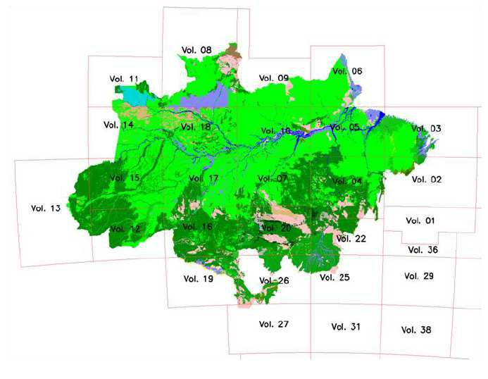
Annex II, Part I

Example of the calculation of adjusted deforestation increment and associated CO2 emission for the year 2003

"calculo_def_increment_emission_2003"

 | A | B | C | D | E | F | G
120 |  |  | VOLUME 4
121 | FOREST TYPE | AREA | t C/ha | t C
122 | AA
 | AB
123 | AB
124 | AS | 74,624.76 | 129.28 | 9647488.33 | 0.2307245 | 23.07244681
 | CB
125 | CB
 | CS
126 | CS
127 | DA | 797.99 | 119.67 | 95495.9855 | 0.0024672 | 0.246723524
 | DB | 37.23 | 154.59 | 5755.33189 | 0.0001151 | 0.011510646
128
 | DM
129 | DM
130 | DS | 245,579.95 | 148.3 | 36419507 | 0.7592829 | 75.92829477
 | FA
131 | FA
 | FB
132 | FB
 | FS
133 | FS
 | LA
134 | LA
135 | LB
136 | LD
137 | LG
138 | PA
 | PF
139 | PF
140 | PM
 | RIOS_LAGOS | 77.46 |  |  | 0.0002395 | 0.023948513
141 | RIOS_LAGOS | 77.46 |  |  | 0.0002395 | 0.023948513
 | RM
142 | RM
143 | SA | 521.81 | 47.1 | 24577.1102 | 0.0016133 | 0.161332047
 | SD | 1,394.42 | 77.8 | 108485.936 | 0.0043113 | 0.43112636
144
145 | SG
146 | SP | 398.97 | 24.10 | 9615.18152 | 0.0012335 | 0.123353416
 | TD
147 | TD
 | VAZIO | 4.09 |  |  | 1.264E-05 0.001263921
148 | VAZIO | 4.09
149 |  | 323,436.68 |  | 46310924.9 | 1 | 99.00074157
150 |  | AREA |  | EMISSIONS

Annex II, Part I

Example of the calculation of adjusted deforestation increment and associated CO2 emission for the year 2003

 |  |  |  |  |  |  |  |  |  |  |  | "calculo_def_increment_emission_2003"
 | H |  |  |  | I |  |  |  | J | K | L | M | N | O |  |  |  | P |  |  |  | Q | R | S | T | U
120
121
122
123 |  |  |  |  |  |  |  |  |  | As |  |  |  |  |  |  |  |  |  |  |  |  | Ds
124 |  |  |  |  |  |  |  |  |  | As |  |  |  |  |  |  |  |  |  |  |  |  | Ds
125 | 200 |  |  |  |  |  |  |  |  |  |  |  |  | 300
126 | 180
127 | 160 |  |  |  |  |  |  |  |  |  |  |  |  | 250
128 | 140 |  |  |  |  |  |  |  |  |  |  |  |  | 200
129 | 120 |  |  |  |  |  |  |  |  |  |  |  |  | 200
130 | 100 |  |  |  |  |  |  |  |  |  |  |  | As | 150 |  |  |  |  |  |  |  |  |  |  |  | Ds
131 | 80 |  |  |  |  |  |  |  |  |  |  |  | As |  |  |  |  |  |  |  |  |  |  |  |  | Ds
132 | 60 |  |  |  |  |  |  |  |  |  |  |  |  | 100
133 | 40 |  |  |  |  |  |  |  |  |  |  |  |  | 50
 | 20 |  |  |  |  |  |  |  |  |  |  |  |  | 50
134 | 20
135 | 0 |  |  |  |  |  |  |  |  |  |  |  |  | 0
136 | 2 | 3 | 4 | 5 | 6 | 7 | 8 | 9 | 10 11 12 13 14 15 16 17 18 19 20 22 25 26 |  |  |  |  | 2 | 3 | 4 | 5 | 6 | 7 | 8 | 9 | 10 11 12 13 14 15 16 17 18 19 20 22 25 26
137
138
139
140
141
142
143
144
145
146
147
148
149
150
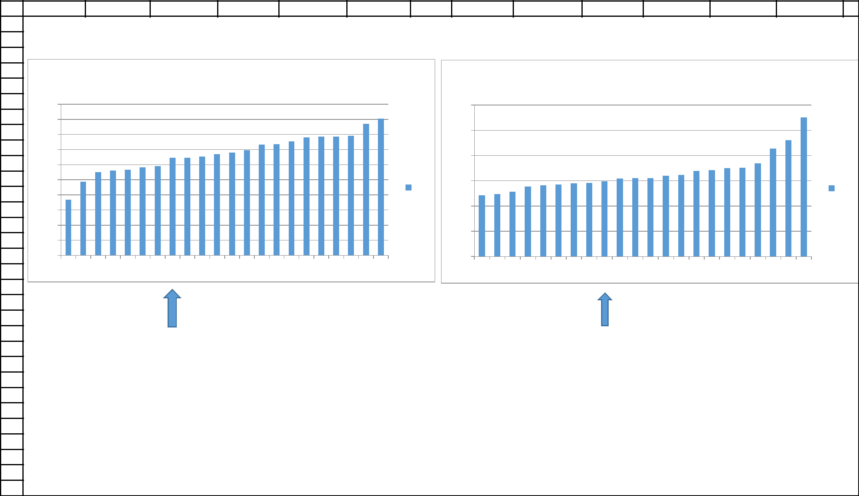
Annex II, Part I

Example of the calculation of adjusted deforestation increment and associated CO2 emission for the year 2003

"calculo_def_increment_emission_2003"

 | A | B | C | D | E | F | G
153 |  |  | VOLUME 5
154 |  | AREA | t C/ha | t C
155 | AA
 | AB
156 | AB
157 | AS | 24,185.32 | 146.82 | 3550888.856 | 0.0587446 | 5.8744598
 | CB
158 | CB
 | CS
159 | CS
160 | DA | 6,570.45 | 213.85 | 1405090.649 | 0.0159592 | 1.595920178
161 | DB | 142,714.86 | 185.15 | 26423655.94 | 0.3466453 | 34.66452603
 | DM
162 | DM
163 | DS | 235,505.97 | 230.13 | 54196988.71 | 0.5720289 | 57.20289338
 | FA
164 | FA
 | FB
165 | FB
 | FS
166 | FS
167 | LA | 135.12 | 183 | 24727.03994 | 0.0003282 | 0.03281989
168 | LB
169 | LD
170 | LG | 11.74 | 25.31 | 297.1822719 | 2.852E-05 | 0.002851982
171 | PA | 499.79 | 105.64 | 52798.23816 | 0.001214 | 0.121396765
 | PF | 299.84 | 98.16 | 29432.08473 | 0.0007283 | 0.072828699
172
173 | PM
 | RIOS_LAGOS | 132.21 |  |  | 0.0003211 | 0.032114027
174 | RIOS_LAGOS | 132.21 |  |  | 0.0003211 | 0.032114027
 | RM
175 | RM
176 | SA | 168.04 | 47.1 | 7914.758092 | 0.0004082 | 0.040816223
 | SD | 1,479.55 | 77.8 | 115108.9246 | 0.0035937 | 0.359373026
177
178 | SG
 | SP
179 | SP
 | TD
180 | TD
181 |  | 411,702.90 |  | 85,806,902.39 |  | 91.86741941

Annex II, Part I

Example of the calculation of adjusted deforestation increment and associated CO2 emission for the year 2003

"calculo_def_increment_emission_2003"

 | H |  | I | J | K | L | M | N | O | P | Q | R | S | T | U
153
154 |  |  |  |  | Db |  |  |  |  |  |  | Ds
155 |  |  |  |  | Db |  |  |  |  |  |  | Ds
 |  | 250 |  |  |  |  |  |  |  | 300
156 |  | 250 |  |  |  |  |  |  |  | 300
157 |  |  |  |  |  |  |  |  |  | 250
 |  | 200 |  |  |  |  |  |  |  | 250
158 |  | 200 |  |  |  |  |  |  |  | 250
159 |  |  |  |  |  |  |  |  |  | 200
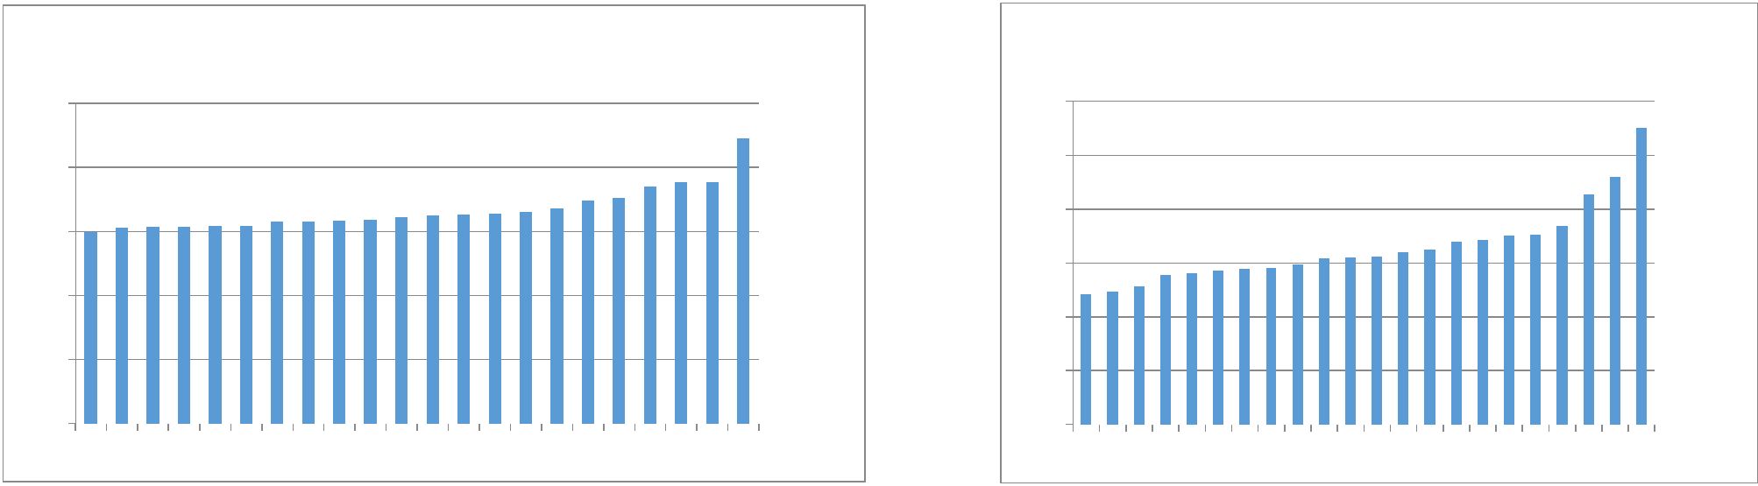
- 150
 |  |  |  |  |  |  |  |  |  |  |  |  |  | 150
161 | 100 |  |  |  |  |  |  |  |  |  |  |  | Db | 150 |  |  |  |  |  |  |  |  |  |  | Ds
162 | 100 |  |  |  |  |  |  |  |  |  |  |  |  | 100
163 | 50
 | 50 |  |  |  |  |  |  |  |  |  |  |  |  | 50
164 | 50 |  |  |  |  |  |  |  |  |  |  |  |  | 50
165 | 0 |  |  |  |  |  |  |  |  |  |  |  |  | 0
166 | 0 |  |  |  |  |  |  |  |  |  |  |  |  | 0
166 | 2 |  | 3 | 4 | 5 | 6 | 7 | 8 | 9 | 10 11 12 13 14 15 16 17 18 19 20 22 25 26 |  |  |  | 2 |  | 3 | 4 | 5 | 6 | 7 | 8 | 9 1011121314151617181920222526
167
168
169
170
171
172
173
174
175
176
177
178
179
180
181


Annex II, Part I

Example of the calculation of adjusted deforestation increment and associated CO2 emission for the year 2003

"calculo_def_increment_emission_2003"

 | A | B | C | D | E | F | G
184 |  |  | VOLUME 16
185 |  | AREA | t C/ha | t C
186 | AA | 873.59 | 165.7 | 144754.5171 | 0.0034525 | 0.345245266
187 | AB | 27,811.58 | 136.14 | 3786268.583 | 0.1099117 | 10.99116651
 | AS | 193,353.69 | 156.76 | 30310124.92 | 0.7641359 | 76.41358703
188
 | CB
189 | CB
 | CS
190 | CS
191 | DA | 1,550.62 | 175.73 | 272490.8911 | 0.0061281 | 0.612807675
 | DB | 2,253.14 | 188.14 | 423905.1699 | 0.0089044 | 0.890442108
192
 | DM
193 | DM
194 | DS | 23,936.37 | 175.02 | 4189343.99 | 0.0945968 | 9.459680275
 | FA
195 | FA
 | FB
196 | FB
 | FS
197 | FS
 | LA
198 | LA
199 | LB
200 | LD
201 | LG
202 | PA | 288.88 | 105.64 | 30517.40564 | 0.0011417 | 0.114166144
 | PF
203 | PF
204 | PM
 | RIOS_LAGOS | 154.11 |  |  | 0.000609 | 0.060904992
205 | RIOS_LAGOS | 154.11 |  |  | 0.000609 | 0.060904992
 | RM
206 | RM
207 | SA | 467.07 | 47.1 | 21998.86056 | 0.0018459 | 0.184585421
 | SD | 1,977.29 | 77.8 | 153832.8437 | 0.0078143 | 0.781425513
208
209 | SG | 4.09 | 16.30 | 66.60442964 | 1.615E-05 | 0.001614855
 | SP | 365.32 | 24.10 | 8804.214909 | 0.0014437 | 0.144374904
210
 | TD
211 | TD
212 |  | 253,035.75 |  | 39,342,108.00 |  | 96.86443381

Annex II, Part I

Example of the calculation of adjusted deforestation increment and associated CO2 emission for the year 2003

 |  |  |  |  |  |  |  |  |  |  | "calculo_def_increment_emission_2003"
 | H |  |  |  | I |  |  | J | K | L | M | N |  |  | O |  |  |  | P | Q | R | S | T
184
185 |  |  |  |  |  |  |  |  |  |  |  |  |  |  |  |  |  |  |  | As
186 |  |  |  |  |  |  |  |  | Ab |  |  |  |  |  |  |  |  |  |  | As
187 |  |  |  |  |  |  |  |  |  |  |  | 200
 | 250 |  |  |  |  |  |  |  |  |  |  | 200
188 | 250
189 | 200 |  |  |  |  |  |  |  |  |  |  | 150
190 | 200 |  |  |  |  |  |  |  |  |  |  | 150
191 | 150
192 |  |  |  |  |  |  |  |  |  |  |  | 100 |  |  |  |  |  |  |  |  |  |  | As
192 |  |  |  |  |  |  |  |  |  |  | Ab |  |  |  |  |  |  |  |  |  |  |  | As
 | 100 |  |  |  |  |  |  |  |  |  | Ab |  |  |  |  |  |  |  |  |  |  |  | As
193 | 100 |  |  |  |  |  |  |  |  |  | Ab
194 | 50 |  |  |  |  |  |  |  |  |  |  | 50
195 | 50
196 | 0 |  |  |  |  |  |  |  |  |  |  | 0
197 | 2 | 3 | 4 | 5 | 6 | 7 | 8 | 9 1011121314151617181920222526 |  |  |  | 2 | 3 | 4 | 5 | 6 | 7 | 8 | 9 | 10 11 12 13 14 15 16 17 18 19 20 22 25 26
198
199
200
201
202
203
204
205
206
207
208
209
210
211
212
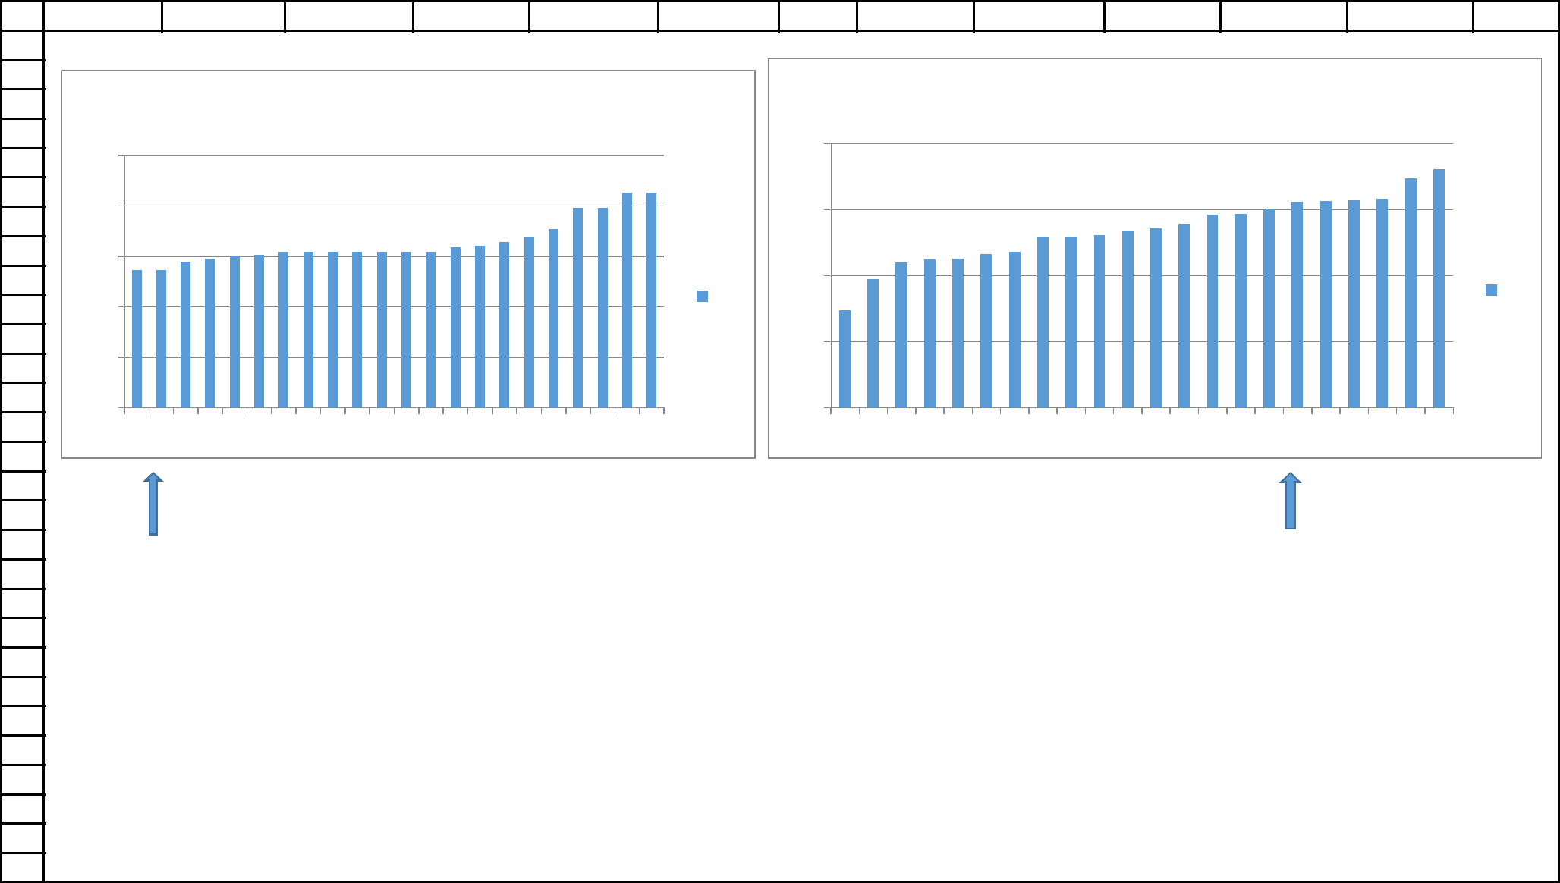
Annex II, Part I

Example of the calculation of adjusted deforestation increment and associated CO2 emission for the year 2003

 |  |  |  |  |  |  |  |  |  |  | "calculo_def_increment_emission_2003"
 | U |  | V |  |  |  |  | W | X | Y | Z | AA
184
185
186 |  |  |  |  |  |  |  |  | Ds
187 | 300
188
189 | 250
190 | 200
191
192 | 150 |  |  |  |  |  |  |  |  |  |  | Ds
193 | 100
194
195 | 50
196 | 0
197 | 2 | 3 | 4 | 5 | 6 | 7 | 8 | 9 | 10 11 12 13 14 15 16 17 18 19 20 22 25 26
198
199
200
201
202
203
204
205
206
207
208
209
210
211
212
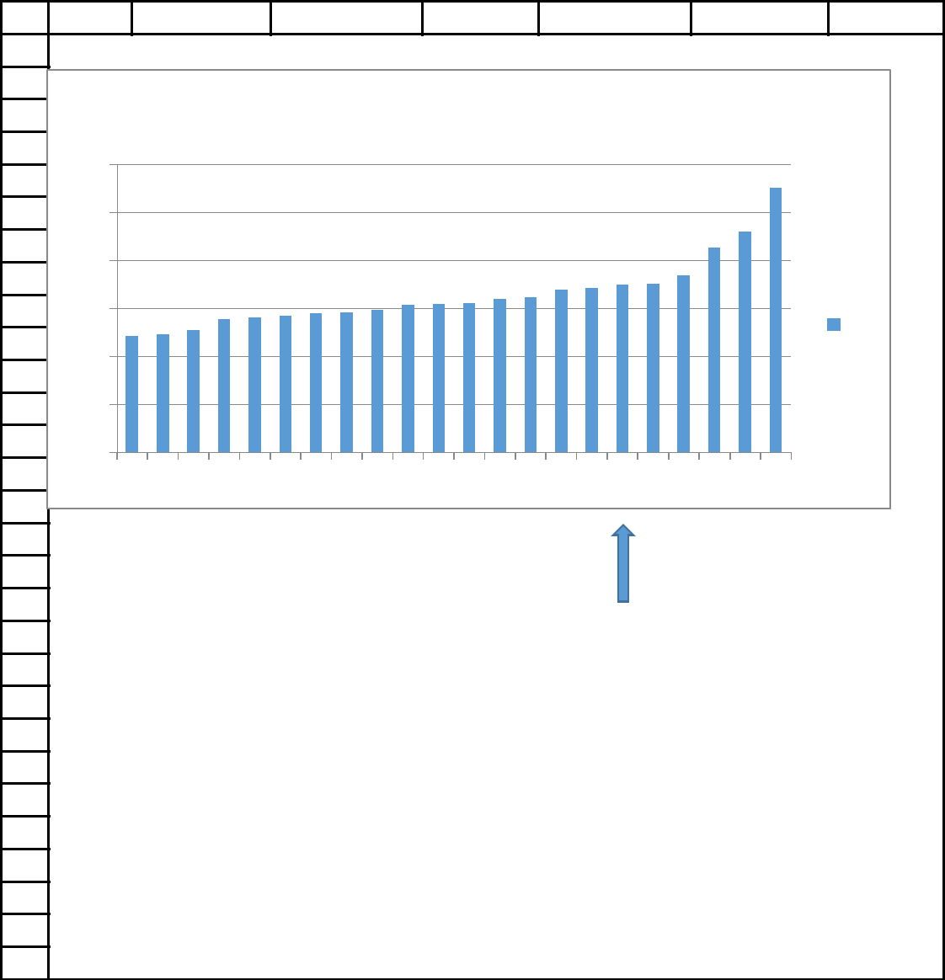
Annex II, Part I

Example of the calculation of adjusted deforestation increment and associated CO2 emission for the year 2003

"calculo_def_increment_emission_2003"

 | A | B | C | D | E | F | G
215 |  |  | VOLUME 20
216 |  | AREA | t C/ha | t C
217 | AA
 | AB
218 | AB
219 | AS | 145,892.68 | 117.97 | 17210958.96 | 0.2882647 | 28.8264693
 | CB
220 | CB
221 | CS | 4,510.49 | 116.27 | 524435.1975 | 0.0089121 | 0.891214251
 | DA | 1,764.91 | 169.39 | 298957.4442 | 0.0034872 | 0.348722177
222
 | DB
223 | DB
 | DM
224 | DM
225 | DS | 151,976.40 | 123.29 | 18737170.3 | 0.3002853 | 30.02853291
 | FA
226 | FA
 | FB
227 | FB
228 | FS | 163,121.18 | 140.09 | 22851646.7 | 0.322306 | 32.23059543
229 | LA | 51.82 | 183 | 9482.290024 | 0.0001024 | 0.010238117
230 | LB
231 | LD | 262.22 | 183 | 47985.82343 | 0.0005181 | 0.051810744
232 | LG | 50.55 | 25.31 | 1279.497891 | 9.989E-05 | 0.009988618
233 | PA | 76.48 | 105.64 | 8078.913669 | 0.0001511 | 0.015110629
 | PF
234 | PF
235 | PM
 | RIOS_LAGOS | 163.11 |  |  | 0.0003223 | 0.032229079
236 | RIOS_LAGOS | 163.11 |  |  | 0.0003223 | 0.032229079
237 | RM | 1,758.60 | 6.55 | 11518.83393 | 0.0034748 | 0.347476293
238 | SA | 9,310.28 | 47.1 | 438514.1992 | 0.0183959 | 1.83958863
 | SD | 27,065.40 | 77.8 | 2105687.754 | 0.0534777 | 5.347765285
239
240 | SG
241 | SP | 102.16 | 24.10 | 2461.982724 | 0.0002018 | 0.020184868
 | TD
242 | TD
243 |  | 0.37 |  |  | 7.367E-07 | 7.36697E-05
244 |  | 506,106.64 |  | 62248177.88 | 1 | 91.08559764
245

Annex II, Part I

Example of the calculation of adjusted deforestation increment and associated CO2 emission for the year 2003

"calculo_def_increment_emission_2003"

 | H |  | I | J | K | L | M |  |  | N | O | P | Q |  | R | S |  | T
215
216
217
218
219
220
221
222
 |  |  |  |  | As |  |  |  |  |  |  |  |  | Ds
223 |  |  |  |  | As
224 |  | 200 |  |  |  |  |  |  |  |  | 300
225 |  | 200 |  |  |  |  |  |  |  |  | 300
 |  |  |  |  |  |  |  |  |  |  | 250
226 |  | 150 |  |  |  |  |  |  |  |  | 250
227 |  | 150 |  |  |  |  |  |  |  |  | 200
228 |  |  |  |  |  |  |  |  |  |  | 200
 |  | 100 |  |  |  |  |  |  |  |  | 150
229 |  | 100 |  |  |  |  |  |  |  | As | 150 |  |  |  |  |  |  |  | Ds
230 |  |  |  |  |  |  |  |  |  | As | 100 |  |  |  |  |  |  |  | Ds
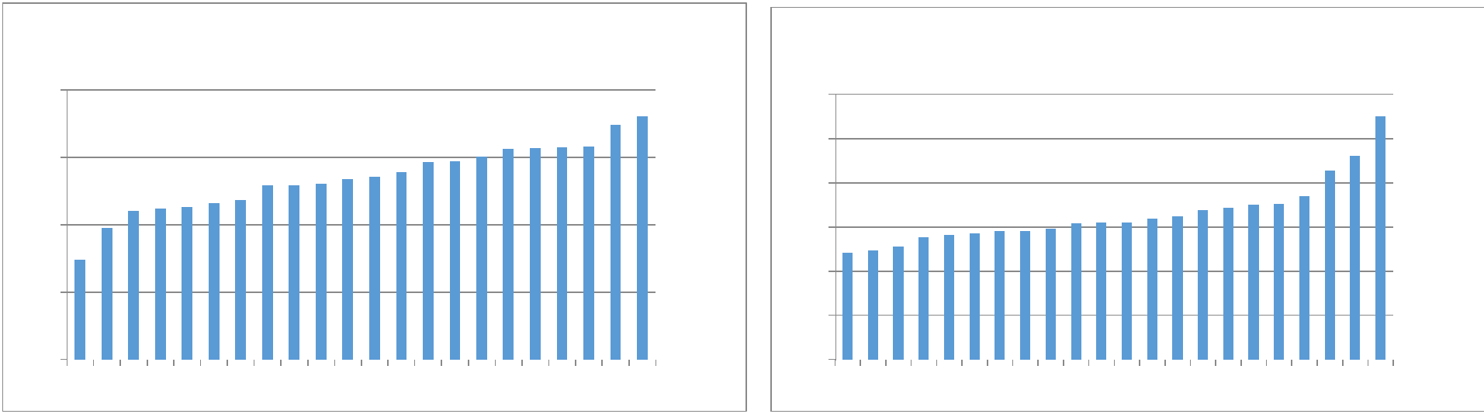
- 50
232 |  |  |  |  |  |  |  |  |  |  | 50
233 | 0 |  |  |  |  |  |  |  |  |  | 0
234 | 0 |  |  |  |  |  |  |  |  |  | 0
234 | 2 |  | 3 | 4 | 5 | 6 | 7 | 8 | 9 | 10 11 12 13 14 15 16 17 18 19 20 22 25 26 | 2 |  | 3 | 4 | 5 | 6 | 7 | 8 | 9 1011121314151617181920222526
235
236
237
238
239
240
241
242
243
244
245
Annex II, Part I

Example of the calculation of adjusted deforestation increment and associated CO2 emission for the year 2003

"calculo_def_increment_emission_2003"

 | A | B | C | D | E | F | G
247 |  |  | VOLUME 22
248 |  | AREA | t C/ha | t C
249 | AA
 | AB
250 | AB
251 | AS | 139,662.63 | 97.4 | 13603140.01 | 0.61635 | 61.63500033
 | CB
252 | CB
 | CS
253 | CS
254 | DA | 721.29 | 137.67 | 99300.00464 | 0.0031832 | 0.318315032
 | DB
255 | DB
 | DM
256 | DM
257 | DS | 55.39 | 145.55 | 8061.921293 | 0.0002444 | 0.024444071
 | FA | 1,714.15 | 140.09 | 240135.4749 | 0.0075648 | 0.756478133
258
 | FB
259 | FB
260 | FS | 39,890.99 | 140.09 | 5588328.836 | 0.1760443 | 17.60443169
 | LA
261 | LA
262 | LB
263 | LD
264 | LG
265 | PA | 307.46 | 105.64 | 32480.27593 | 0.0013569 | 0.135687084
 | PF
266 | PF
267 | PM
268 | RIOS_LAGOS | 48.28 |  |  | 0.0002131 | 0.021308185
269 | RM
270 | SA | 4,447.83 | 47.1 | 209492.8827 | 0.0196289 | 1.962888168
271 | SD | 38,712.85 | 77.8 | 3011859.536 | 0.170845 | 17.08450138
272 | SG | 123.95 | 16.65 | 2063.262541 | 0.000547 | 0.054702858
 | SP | 910.52 | 24.10 | 21943.41469 | 0.0040182 | 0.4018226
273
 | TD
274 | TD
275 |  | 0.95 |  |  | 4.205E-06 0.000420465
276 |  | 226,596.30 |  | 22816805.62 | 1 | 96.32393341
277

Annex II, Part I

Example of the calculation of adjusted deforestation increment and associated CO2 emission for the year 2003

"calculo_def_increment_emission_2003"

H | I | J | K | L | M | N
247

248

249

250

251

252

253

254

255

256

257

258
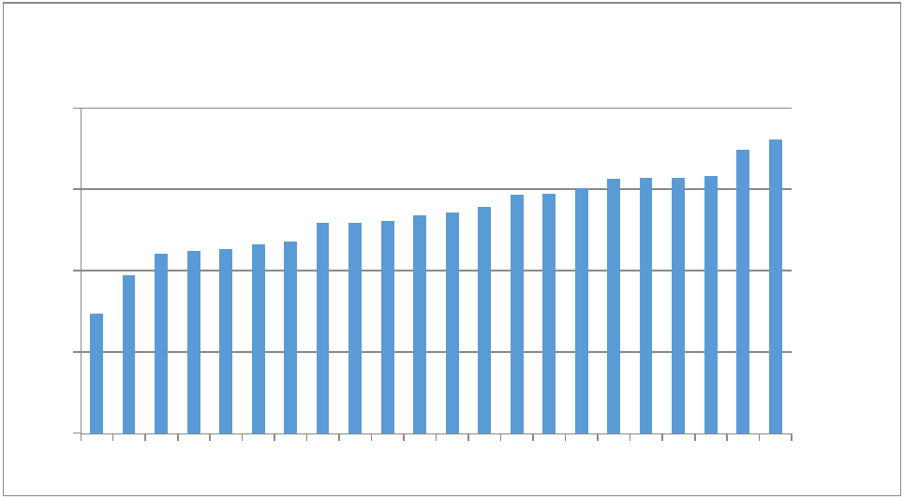
259 As
260

- 200

262
- 150

265
100

267
- 50
269
- 0
271 | 2 | 3 | 4 | 5 | 6 | 7 | 8 | 9 | 10 11 12 13 14 15 16 17 18 19 20 22 25 26
272
273
274
275
276
277

Annex II, Part I

Example of the calculation of adjusted deforestation increment and associated CO2 emission for the year 2003

"calculo_def_increment_emission_2003"

 | A | B | C | D | E | F | G
279 |  |  | VOLUME 26
280 |  | AREA | t C/ha | t C
281 | AA
 | AB
282 | AB
283 | AS | 38,077.53 | 130.49 | 4968736.444 | 0.1755599 | 17.55598671
284 | CB | 567.01 | 116.27 | 65925.99214 | 0.0026142 | 0.261424036
 | CS | 5,676.26 | 116.27 | 659978.6699 | 0.0261709 | 2.617090498
285
 | DA | 889.28 | 175.73 | 156273.793 | 0.0041001 | 0.41001218
286
 | DB
287 | DB
 | DM
288 | DM
 | DS
289 | DS
290 | FA | 868.57 | 140.09 | 121677.5236 | 0.0040046 | 0.400460551
 | FB | 10,779.62 | 140.09 | 1510116.581 | 0.0497004 | 4.970039659
291
292 | FS | 145,958.83 | 140.09 | 20447372.37 | 0.6729563 | 67.29563326
 | LA
293 | LA
294 | LB
295 | LD
296 | LG
297 | PA | 854.00 | 105.64 | 90216.1971 | 0.0039374 | 0.393742811
 | PF
298 | PF
299 | PM
 | RIOS_LAGOS | 32.55 |  |  | 0.0001501 | 0.01500604
300 | RIOS_LAGOS | 32.55 |  |  | 0.0001501 | 0.01500604
 | RM
301 | RM
302 | SA | 5,542.32 | 47.1 | 261043.2607 | 0.0255534 | 2.555336462
 | SD | 7,108.66 | 77.8 | 553054.0705 | 0.0327751 | 3.277513654
303
304 | SG
305 | SP | 535.53 | 24.10 | 12906.24512 | 0.0024691 | 0.246910398
 | TD
306 | TD
307 | vazio | 1.83 |  |  | 8.437E-06
308 |  | 216,891.98 |  | 28847301.14 | 1 | 84.85161997
309

Annex II, Part I

Example of the calculation of adjusted deforestation increment and associated CO2 emission for the year 2003

"calculo_def_increment_emission_2003"

 | H | I | J | K | L | M | N
279
280
281
282
283
284
285
286 |  |  |  | As
287 |  |  |  | As
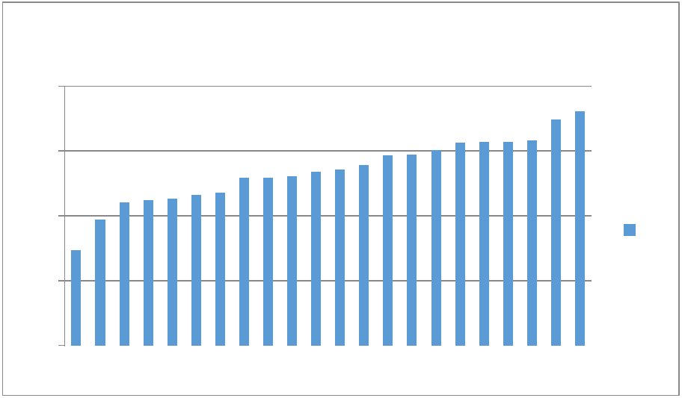

- 200

- 150

292
293 | 100
293 | As
294
- 50
296

- 0
- 2 3 4 5 6 7 8 9 1011121314151617181920222526

299

300

301

302

303

304

305

306

307

308

309
Annex II, PArt I

I. Example of the calculation of adjusted deforestation increment and associated CO2 emission for the year 2003

"verification_2003_area_emissao"

 | A | B | C | D | E | F | G | H | I | J | K
1 | 2003
2
3 |  | Column Labels
4 |  | Vol, 04 |  | Vol, 05 |  | Vol, 06 |  | Total Soma de emiss_am Total Soma de area_hectare |  | Area considered in 2003
5 | Row Labels | Soma de emiss_am | Soma de area_hectares | Soma de emiss_am | Soma de area_hectares | Soma de emiss_am | Soma de area_hectares
6 | 22460 |  |  | 6,607.62 | 35.67 |  |  | 6,607.62 | 35.67 | 17.84
7 | DB |  |  | 6,607.62 | 35.67 |  |  | 6,607.62 | 35.67
8 | 22559 |  |  |  |  | 3,295,357.34 | 28,068.05 | 3,295,357.34 | 28,068.05 | 9,356.02
9 | AA |  |  |  |  | 309,121.53 | 2,497.92 | 309,121.53 | 2,497.92
10 | DA |  |  |  |  | 681,384.90 | 5,151.94 | 681,384.90 | 5,151.94
11 | DB |  |  |  |  | 954,930.92 | 4,293.89 | 954,930.92 | 4,293.89
12 | PA |  |  |  |  | 741,756.96 | 7,019.30 | 741,756.96 | 7,019.30
13 | PF |  |  |  |  | 287,380.30 | 2,927.18 | 287,380.30 | 2,927.18
14 | RIOS_LAGOS |  |  |  |  |  | 607.46 |  | 607.46
15 | SA |  |  |  |  | 10,967.98 | 232.82 | 10,967.98 | 232.82
16 | SD |  |  |  |  | 263,181.20 | 3,378.21 | 263,181.20 | 3,378.21
17 | SG |  |  |  |  | 1,227.99 | 75.34 | 1,227.99 | 75.34
18 | SP |  |  |  |  | 45,405.56 | 1,884.00 | 45,405.56 | 1,884.00
19 | 22563 | 1,744,150.20 | 11,420.17 | 2,984,140.20 | 12,935.05 |  |  | 4,728,290.39 | 24,355.22 | 12,177.61
20 | AS |  |  | 10,130.38 | 69.00 |  |  | 10,130.38 | 69.00
21 | DA | 1,097.18 | 9.17 | 1,635.86 | 7.65 |  |  | 2,733.05 | 16.82
22 | DS | 1,743,053.01 | 11,408.96 | 2,972,373.96 | 12,840.43 |  |  | 4,715,426.97 | 24,249.39
23 | RIOS_LAGOS |  | 2.04 |  | 17.97 |  |  |  | 20.02
24 | 22658 |  |  |  |  | 1,159,913.35 | 5,248.91 | 1,159,913.35 | 5,248.91 | 2,624.46
25 | DA |  |  |  |  | 1,584.02 | 12.02 | 1,584.02 | 12.02
26 | DB |  |  |  |  | 853,241.92 | 3,836.64 | 853,241.92 | 3,836.64
27 | DS |  |  |  |  | 292,518.54 | 1,369.78 | 292,518.54 | 1,369.78
28 | RIOS_LAGOS |  |  |  |  |  | 19.50 |  | 19.50
29 | SD |  |  |  |  | 12,491.80 | 7.76 | 12,491.80 | 7.76
30 | SG |  |  |  |  | 1.29 | 0.08 | 1.29 | 0.08
31 | SP |  |  |  |  | 75.78 | 3.14 | 75.78 | 3.14
32 | 22659 |  |  |  |  | 18,934.65 | 85.74 | 18,934.65 | 85.74 | 42.87
33 | DB |  |  |  |  | 15,704.11 | 70.61 | 15,704.11 | 70.61
34 | DS |  |  |  |  | 3,230.54 | 15.13 | 3,230.54 | 15.13
35 | 22660 |  |  | 386,569.51 | 1,980.36 | 974,595.44 | 4,503.14 | 1,361,164.95 | 6,483.50 | 2,161.17
36 | AA |  |  |  |  | 2,439.00 | 19.71 | 2,439.00 | 19.71
37 | AS |  |  | 10,457.98 | 71.23 |  |  | 10,457.98 | 71.23
38 | DA |  |  | 1,345.87 | 6.29 | 63.63 | 0.48 | 1,409.50 | 6.78
39 | DB |  |  | 275,231.90 | 1,469.72 | 485,932.64 | 2,185.02 | 761,164.54 | 3,654.74
40 | DS |  |  | 99,474.44 | 432.25 | 482,136.34 | 2,257.70 | 581,610.79 | 2,689.95
41 | PA |  |  | 33.95 | 0.32 | 4,018.10 | 38.03 | 4,052.05 | 38.35
42 | RIOS_LAGOS |  |  |  |  |  | 1.97 |  | 1.97
43 | SA |  |  | 25.37 | 0.54 |  |  | 25.37 | 0.54
44 | SP |  |  |  |  | 5.73 | 0.24 | 5.73 | 0.24

Annex II, PArt I

I. Example of the calculation of adjusted deforestation increment and associated CO2 emission for the year 2003

"verification_2003_area_emissao"

 | A | B | C | D | E | F | G |  | H | I | J |  | K
45 | 22661 |  |  | 824,689.24 | 4,457.58 |  |  |  | 824,689.24 | 4,457.58 |  | 2,228.79
46 | AS |  |  | 24,583.41 | 167.43 |  |  |  | 24,583.41 | 167.43
47 | DB |  |  | 650,350.69 | 3,486.92 |  |  |  | 650,350.69 | 3,486.92
48 | DS |  |  | 116,625.56 | 506.78 |  |  |  | 116,625.56 | 506.78
49 | LA |  |  | 7,637.23 | 1.65 |  |  |  | 7,637.23 | 1.65
50 | PA |  |  | 20,964.23 | 198.40 |  |  |  | 20,964.23 | 198.40
51 | RIOS_LAGOS |  |  |  | 0.25 |  |  |  |  | 0.25
52 | SA |  |  | 4,528.13 | 96.14 |  |  |  | 4,528.13 | 96.14
53 | 22662 |  |  | 50,616,249.36 | 218,283.72 |  |  |  | 50,616,249.36 | 218,283.72 |  | 72,761.24
54 | AS |  |  | 2,114.66 | 14.15 |  |  |  | 2,114.66 | 14.15
55 | DA |  |  | 261,862.20 | 1,127.06 |  |  |  | 261,862.20 | 1,127.06
56 | DB |  |  | 6,230,606.63 | 29,553.58 |  |  |  | 6,230,606.63 | 29,553.58
57 | DS |  |  | 44,106,074.53 | 187,411.52 |  |  |  | 44,106,074.53 | 187,411.52
58 | PA |  |  | 15,591.34 | 147.56 |  |  |  | 15,591.34 | 147.56
59 | RIOS_LAGOS |  |  |  | 29.86 |  |  |  |  | 29.86
60 | 22663 | 1,066,432.53 | 8,042.56 | 13,547,680.17 | 73,917.88 |  |  |  | 14,614,112.69 | 81,960.44 |  | 40,980.22
61 | AS | 858,148.10 | 6,637.79 | 3,313,568.20 | 22,547.09 |  |  |  | 4,171,716.30 | 29,184.89
62 | DA |  |  | 11,155.51 | 52.17 |  |  |  | 11,155.51 | 52.17
63 | DB |  |  | 7,399,536.86 | 39,940.40 |  |  |  | 7,399,536.86 | 39,940.40
64 | DS | 208,284.43 | 1,404.45 | 2,823,419.59 | 11,357.83 |  |  |  | 3,031,704.02 | 12,762.29
65 | RIOS_LAGOS |  | 0.31 |  | 20.39 |  |  |  |  | 20.70
66 | 22758 |  |  |  |  | 153.52 |  | 0.72 | 153.52 | 0.72 |  | 0.36
67 | DS |  |  |  |  | 153.52 |  | 0.72 | 153.52 | 0.72
68 | Grand Total | 2,810,582.72 | 19,462.73 | 68,365,936.10 | 311,610.26 | 5,448,954.29 |  | 37,906.57 | 76,625,473.11 | 368,979.57 |  | 142,350.21 | Area in hectares

Annex II, PArt I

I. Example of the calculation of adjusted deforestation increment and associated CO2 emission for the year 2003

"verification_2003_area_emissao"

 | Q | R | S | T | U | V | W | X | Y
1
 |  | vol 5
2 | 22460 | vol 5
3 | DB | 35.67 | 185.15 | 6604.433762 |  |  |  | DIVIDE BY 2 | 3302.216881
4
5
 |  | vol 6
6 | 22559 | vol 6
7
8 | AA | 2,497.92 | 123.75 | 309117.6736 |  |  |  |  | 103039.2245
 | DA | 5,151.94 | 131.82 | 679128.1022 |  |  |  |  | 226376.0341
9 |  |  |  |  |  |  |  |  | 226376.0341
 | DB | 4,293.89 | 222.39 | 954917.2233 |  |  |  |  | 318305.7411
10 |  |  |  |  |  |  |  |  | 318305.7411
 | PA | 7,019.30 | 105.64 | 741518.5205 |  |  |  |  | 247172.8402
11 |  |  |  |  |  |  |  |  | 247172.8402
 | PF | 2,927.18 | 98.16 | 287331.8944 |  |  |  |  | 95777.29814
12 |  |  |  |  |  |  |  |  | 95777.29814
 | RIOS_LAG | 607.46
13 | RIOS_LAG | 607.46
14 | SA | 232.82 | 47.1 | 10965.9374 |  |  |  |  | 3655.312467
 | SD | 3,378.21 | 77.8 | 262825.0934 |  |  |  |  | 87608.36446
15 |  |  |  |  |  |  |  |  | 87608.36446
 | SG | 75.34 | 16.3 | 1227.98999 |  |  |  |  | 409.3299967
16 |  |  |  |  |  |  |  |  | 409.3299967
 | SP | 1,884.00 | 24.1 | 45404.46137 |  |  |  |  | 15134.82046
17 |  |  |  |  |  |  |  |  | 15134.82046
18 |  | 28,068.05 |  | 3292436.896 |  |  |  | DIVIDE BY 3 | 1097478.965
19
 |  | vol 4 |  |  | vol 5
20 | 22563 | vol 4 |  |  | vol 5
21 | AS |  |  |  | 69.00 | 146.82 | 10130.05
22 | DA | 9.17 | 119.67 | 1097.229823 | 7.65 | 213.85 | 1635.8676
 | DS | 11,408.96 | 148.3 | 1691948.723 | 12,840.43 | 230.13 | 2954968
23
24 |  | 11,418.13 |  | 1693045.953 | 12,917.08 |  | 2966733.9 | DIVIDE BY 2 | 2329889.95
25 |  |  |  |  |  | TOTAL | 4659779.9
 |  | vol 6
26 | 22658 | vol 6
27 | DA | 12.02 | 131.82 | 1584.002593
 | DB | 3,836.64 | 222.39 | 853229.6806
28
 | DS | 1,369.78 | 213.55 | 292515.7059
29
 | RIOS_LAG | 19.50
30 | RIOS_LAG | 19.50
31 | SD | 7.76 | 77.8 | 603.9680483
 | SG | 0.08 | 16.3 | 1.290188904
32
 | SP | 3.14 | 24.1 | 75.7792093
33
34 |  | 5,248.91 |  | 1148010.427 |  |  |  | DIVIDE BY 2 | 574005.2133
35 | 22659 | vol 6
36 | DB | 70.61 | 222.39 | 15703.88505
 | DS | 15.13 | 213.55 | 3230.506277
37
38 |  | 85.74 |  | 18934.39133 |  |  |  | DIVIDE BY 2 | 9467.195665
39 | 22660 | vol 5 |  |  | vol 6
40 | AA |  |  |  | 19.71 | 123.75 | 2438.9658
41 | AS | 71.23 | 146.82 | 218.05
42 | DA | 6.29 | 213.85 | 220.14 | 0.48 | 131.82 | 63.627835
 | DB | 1,469.72 | 185.15 | 1,654.87 | 2,185.02 | 222.39 | 485925.67
43
 | DS | 432.25 | 230.13 | 662.38 | 2,257.70 | 213.55 | 482131.67
44
 | PA | 0.32 | 105.64 | 105.96 | 38.03 | 105.64 | 4017.1871
45
 | RIOS_LAGOS |  |  |  | 1.97
46 |  |  |  |  | 1.97
47 | SA | 0.54 | 47.1 | 47.64
48 | SP | 1,980.36 |  | 2,909.05 | 0.24 | 24.1 | 5.7315529 | DIVIDE BY 3 | 325830.6347
49 |  |  |  |  | 4,503.14 |  | 974582.86
50 |  |  |  |  |  | TOTAL | 977,491.90

Annex II, PArt I

I. Example of the calculation of adjusted deforestation increment and associated CO2 emission for the year 2003

"verification_2003_area_emissao"

 | Q | R | S | T | U | V | W | X | Y
51
 |  | vol 5
52 | 22662 | vol 5
53 | AS | 14.15 | 146.82 | 2076.895105
 | DA | 1,127.06 | 213.85 | 241021.3146
54
 | DB | 29,553.58 | 185.15 | 5471845.51
55
 | DS | 187,411.52 | 230.13 | 43129013.29
56
 | PA | 147.56 | 105.64 | 15587.79629
57
58 |  | 218,253.86 |  | 48859544.81 |  |  |  | DIVIDE BY 3 | 16286514.94
59
60
 |  | vol 4 |  |  | vol 5
61 | 22663 | vol 4 |  |  | vol 5
62 | AS | 6,637.79 | 129.28 | 858133.797 | 22,547.09 | 146.82 | 3310364.3
 | DA |  |  |  | 52.17 | 213.85 | 11155.562
63 | DA |  |  |  | 52.17 | 213.85 | 11155.562
 | DB |  |  |  | 39,940.40 | 185.15 | 7394964.8
64 | DB |  |  |  | 39,940.40 | 185.15 | 7394964.8
65 | DS | 1,404.45 | 148.3 | 208280.5562 | 11,357.83 | 230.13 | 2613778.5
66 |  | 8,042.25 |  | 1066414.353 | 73,897.49 |  | 13330263 | DIVIDE BY 2 | 7198338.732
67 |  |  |  |  |  | TOTAL | 14396677
 |  | vol 6
68 | 22758 | vol 6
69 | DS | 0.72 | 213.55 | 153.756 |  |  |  | DIVIDE BY 2 | 76.878
70
71
 |  | VOL 5
72 | 22661 | VOL 5
73 | AS | 167.43 | 146.82 | 24582.61109
 | DB | 3,486.92 | 185.15 | 645603.3772
74
 | DS | 506.78 | 230.13 | 116625.1621
75
 | LA | 1.65 | 183 | 301.6112877
76
 | PA | 198.40 | 140.09 | 27794.50246
77
 | RIOS_LAG | 0.25
78 | RIOS_LAG | 0.25
79 | SA | 96.14 | 47.1 | 4528.134784
80 |  | 4,457.58 |  | 819435.3989 |  |  |  | DIVIDE BY 2 | 409717.6995

Annex II, PArt I

I. Example of the calculation of adjusted deforestation increment and associated CO2 emission for the year 2003

 |  |  |  | "verification_2003_area_emissao"
 | L | M |  | N | O
1 | VERIFICATION | VOLUME | VOLUME |  | EMISSION TOTAL
2 | SCENE | EMISSION | EMISSION |  | VERIFICATION
3
 |  | 6,604.43 |  |  | 6,604.43
4 | 22460 | 6,604.43 |  |  | 6,604.43
5
 |  | 3,292,436.90 |  |  | 3,292,436.90
6 | 22559 | 3,292,436.90 |  |  | 3,292,436.90
7
 |  | 1,693,045.93 |  | 2,966,733.95 | 4,659,779.88
8 | 22563 | 1,693,045.93 |  | 2,966,733.95 | 4,659,779.88
9
 |  | 1,148,010.43 |  |  | 1,148,010.43
10 | 22658 | 1,148,010.43 |  |  | 1,148,010.43
11
 |  | 18,934.39 |  |  | 18,934.39
12 | 22659 | 18,934.39 |  |  | 18,934.39
13
 |  | 2,909.05 |  | 974,582.86 | 977,491.91
14 | 22660 | 2,909.05 |  | 974,582.86 | 977,491.91
15
 |  | 48,859,544.81 |  |  | 48,859,544.81
16 | 22662 | 48,859,544.81 |  |  | 48,859,544.81
17
 |  | 1,066,414.35 |  | 13,330,263.10 | 14,396,677.45
18 | 22663 | 1,066,414.35 |  | 13,330,263.10 | 14,396,677.45
19
 |  | 153.76 |  |  | 153.76
20 | 22758 | 153.76 |  |  | 153.76
21
 |  | 819,435.40 |  |  | 819,435.40
22 | 22661 | 819,435.40 |  |  | 819,435.40
23 | TOTAL EMISSIONS |  |  |  | 74,179,069.36

Annex II, PArt I

I. Example of the calculation of adjusted deforestation increment and associated CO2 emission for the year 2003

"verification_2003_area_emissao"

 | AB | AC
1
2 | DEFORESTATION INCREMENT | 2,781,345.04
 | AREA TO BE DISTRIBUTED | -368,979.57
3 | AREA TO BE DISTRIBUTED | -368,979.57
 | AREA TO REMAIN | 142,350.57
4 | AREA TO REMAIN | 142,350.57
 | ADJ DEF INCREM (ha) | 2,554,716.04
5 | ADJ DEF INCREM (ha) | 2,554,716.04
 | ADJ DEF INCREM (ha) SUBMISSION | 2,558,846.30
6 | ADJ DEF INCREM (ha) SUBMISSION | 2,558,846.30
7
 | DIFFERENCE OF AREA (ha) | 4,130.26
8 | DIFFERENCE OF AREA (ha) | 4,130.26
 |  | 0.00161411
9 |  | 0.00161411
 | PERCENT DIFFERENCE (%) | 0.161411023
10 | PERCENT DIFFERENCE (%) | 0.161411023
11
12
13 | TOTAL EMISSIONS (tC) | 411,592,418.00
 | EMISSIONS IN 2003 TO BE SHARED (tC) | -74,179,069.38
14 | EMISSIONS IN 2003 TO BE SHARED (tC) | -74,179,069.38
 | EMISSIONS THAT REMAIN IN 2003 | 28,234,545.54
15 | EMISSIONS THAT REMAIN IN 2003 | 28,234,545.54
 | ADJUSTED EMISSIONS (tC) | 365,647,894.16
16 | ADJUSTED EMISSIONS (tC) | 365,647,894.16
 | ADJUSTED EMISSIONS (t CO2) | 1,340,708,945
17 | ADJUSTED EMISSIONS (t CO2) | 1,340,708,945
 | EMISSIONS IN SUBMISSION (t CO2) | 1,375,223,215
18 | EMISSIONS IN SUBMISSION (t CO2) | 1,375,223,215
 | DIFFERENCE (t CO2) | 34,514,270
19 | DIFFERENCE (t CO2) | 34,514,270
 |  | 0.025097213
20 |  | 0.025097213
 | PERCENT DIFFERENCE (%) | 2.509721282
21 | PERCENT DIFFERENCE (%) | 2.509721282

- Example of the calculation of the carbon density associated with a forest type

This example aims at facilitating the understanding of the application of Equations 5, 6 and 9 in the main text of the submission. The original RADAMBRASIL data will be applied, i.e., the values of the circumference at breast height (CBH) collected on the sample units to the allometric equation by Higuchi et al., 1998. The objective in this example is to reproduce the carbon density per unit area presented for forest type Ab in RADAMBRASIL volume 18 (refer to Table 4 of the submission).

File “equations_569_volume18_Ab”

contains the data necessary to reproduce the carbon density for forest type Ab in volume 18, equal to 213.37 tC (Table 4).

Column A – Circumference at Breast Height (CBH)
For sample unit 1 : lines 4 to 73

For sample unit 2 : lines 77 to 113
For sample unitt 3: lines 117 – 201
For sample unit 4 : lines 206 – 263

Column B – Conversion of CBH to Diameter at Breast Height (DBH) (by multiplying by 3,1416 (refer to footnote 21 in the submission) or multiplying by 113/355:

Columns C, D, E and F refer to the data necessary to apply the allometric equation (Equation 5) reproduced below.

ln P = -0.151 + 2.170 × ln DBH Equation 5

Column C – Natural logarithm of the DBH values (ln DBH)
Column D – Product of column C by 2.170
Column E – Value in column D - 0.151
Column F – Transforming natural logarithm of P (ln P) into P

Column G – Applying Equation 6, reproduced below, multiplying data in column F by 0,2859

C(CBH > 100 cm) = 0.2859 × P Equation 6

Column H – Transforming the data provided in kg of fresh biomass in column G to tonnes, by multiplying by 1,000.

Column H, line 74 – Total carbon stock in sample unit 1, necessary for application of Equation 9, reproduced below. It is the sum of the carbon stock of all trees in the sampling plot.

Ctotal, SU = 1.9384 × AC(CBH > 100 cm) Equation 9

where:

111
Ctotal, SU = total carbon stock in living biomass (above and below-ground) for all trees, palms and vines in the sample unit; tC ha-1;

AC(CBH > 100 cm) = total carbon stock in a sample unit from trees with CBH > 100 cm; tC ha-1

Column H, line 75 – Product of the value in column H, line 76 by 1,9384 to obtain the total carbon stock in living biomass (above and below-ground) for all trees, lianas and palms in sample unit 1.

Repetition of the steps above for the three other sample units: the total carbon stock in living biomass (above and below-ground, including vines and palms) for all trees in sample units 2, 3 and 4 are provided in Column H, lines 115, 203 and 265, respectively.

Since there were four sample units in Volume 18 for forest type Ab, Rule 1 in Step 5 (Step 5: Application of extrapolation rules to estimate the carbon density associated with forest types in each volume of RADAMBRASIL) can be used to generate the average carbon stock for forest type Ab in that volume.

Following Rule 1, the simple average of the values in column I lines 75, 115, 203, and 265 is presented in Column B, line 276.

This example is presented below and is available at: http://www.mma.gov.br/redd/index.php/en/forest-reference-emission-levels-frel/spatial-information

112
Annex II, Part II

Example of the calculation of the carbon density associated with a forest type

"equations_569_volume18_Ab"

 | A |  | B | C | D | E | F | G | H | I
1
2 |  |  | EQUAÇÃO 5 |  |  |  |  | EQUAÇÃO 6 | EQUAÇÃO 6 | EQUATION 9
 | CBH |  | DBH = CBH*113/355 | ln(DBH) | ln (DBH)*2,17 | ln P = -0,151 + D | P = exp(E) | C = 0,2859 * P (kg C) | C in tonnes of C
3 | CBH
4 |  | 130 | 41.38028169014080 | 3.7228044796925 | 8.078485720933 | 7.927485720933 | 2772.4473277363800 | 792.6426909998300 | 0.7926426909998 | refer to line 75
5 |  | 230 | 73.21126760563380 | 4.2933493381601 | 9.316568063807 | 9.165568063807 | 9562.1517943347800 | 2733.8191980003100 | 2.7338191980003
6 |  | 430 | 136.87323943662000 | 4.9190552379245 | 10.674349866296 | 10.523349866296 | 37173.4422130707000 | 10627.8871287169000 | 10.6278871287169
7 |  | 100 | 31.83098591549300 | 3.4604402152250 | 7.509155267038 | 7.358155267038 | 1568.9396171068900 | 448.5598365308590 | 0.4485598365309
8 |  | 110 | 35.01408450704230 | 3.5557503950293 | 7.715978357214 | 7.564978357214 | 1929.4270204275500 | 551.6231851402350 | 0.5516231851402
9 |  | 450 | 143.23943661971800 | 4.9645176120013 | 10.773003218043 | 10.622003218043 | 41027.7201331912000 | 11729.8251860794000 | 11.7298251860794
10 |  | 100 | 31.83098591549300 | 3.4604402152250 | 7.509155267038 | 7.358155267038 | 1568.9396171068900 | 448.5598365308590 | 0.4485598365309
11 |  | 110 | 35.01408450704230 | 3.5557503950293 | 7.715978357214 | 7.564978357214 | 1929.4270204275500 | 551.6231851402350 | 0.5516231851402
12 |  | 180 | 57.29577464788730 | 4.0482268801271 | 8.784652329876 | 8.633652329876 | 5617.5580055731000 | 1606.0598337933500 | 1.6060598337934
13 |  | 280 | 89.12676056338030 | 4.4900596324062 | 9.743429402321 | 9.592429402321 | 14653.4253927782000 | 4189.4143197952800 | 4.1894143197953
14 |  | 290 | 92.30985915492960 | 4.5251509522174 | 9.819577566312 | 9.668577566312 | 15812.8403019756000 | 4520.8910423348200 | 4.5208910423348
15 |  | 300 | 95.49295774647890 | 4.5590525038931 | 9.893143933448 | 9.742143933448 | 17019.9920230805000 | 4866.0157193987100 | 4.8660157193987
16 |  | 300 | 95.49295774647890 | 4.5590525038931 | 9.893143933448 | 9.742143933448 | 17019.9920230805000 | 4866.0157193987100 | 4.8660157193987
17 |  | 350 | 111.40845070422500 | 4.7132031837204 | 10.227650908673 | 10.076650908673 | 23781.2065904388000 | 6799.0469642064500 | 6.7990469642065
18 |  | 360 | 114.59154929577500 | 4.7413740606871 | 10.288781711691 | 10.137781711691 | 25280.3251896062000 | 7227.6449717084200 | 7.2276449717084
19 |  | 380 | 120.95774647887300 | 4.7954412819574 | 10.406107581848 | 10.255107581848 | 28427.3668558112000 | 8127.3841840764300 | 8.1273841840764
20 |  | 380 | 120.95774647887300 | 4.7954412819574 | 10.406107581848 | 10.255107581848 | 28427.3668558112000 | 8127.3841840764300 | 8.1273841840764
21 |  | 390 | 124.14084507042300 | 4.8214167683606 | 10.462474387343 | 10.311474387343 | 30075.7472677607000 | 8598.6561438527900 | 8.5986561438528
22 |  | 430 | 136.87323943662000 | 4.9190552379245 | 10.674349866296 | 10.523349866296 | 37173.4422130707000 | 10627.8871287169000 | 10.6278871287169
23 |  | 460 | 146.42253521126800 | 4.9864965187201 | 10.820697445623 | 10.669697445623 | 43031.9200323947000 | 12302.8259372616000 | 12.3028259372616
24 |  | 540 | 171.88732394366200 | 5.1468391687953 | 11.168640996286 | 11.017640996286 | 60939.7528123814000 | 17422.6753290599000 | 17.4226753290599
25 |  | 140 | 44.56338028169010 | 3.7969124518462 | 8.239300020506 | 8.088300020506 | 3256.1474785978100 | 930.9325641311140 | 0.9309325641311
26 |  | 150 | 47.74647887323940 | 3.8659053233332 | 8.389014551633 | 8.238014551633 | 3782.0238358071300 | 1081.2806146572600 | 1.0812806146573
27 |  | 320 | 101.85915492957700 | 4.6235910250307 | 10.033192524317 | 9.882192524317 | 19578.6021990810000 | 5597.5223687172700 | 5.5975223687173
28 |  | 340 | 108.22535211267600 | 4.6842156468471 | 10.164747953658 | 10.013747953658 | 22331.3757674208000 | 6384.5403319056100 | 6.3845403319056
29 |  | 100 | 31.83098591549300 | 3.4604402152250 | 7.509155267038 | 7.358155267038 | 1568.9396171068900 | 448.5598365308590 | 0.4485598365309
30 |  | 120 | 38.19718309859160 | 3.6427617720190 | 7.904793045281 | 7.753793045281 | 2330.3949654930400 | 666.2599206344590 | 0.6662599206345
31 |  | 120 | 38.19718309859160 | 3.6427617720190 | 7.904793045281 | 7.753793045281 | 2330.3949654930400 | 666.2599206344590 | 0.6662599206345
32 |  | 100 | 31.83098591549300 | 3.4604402152250 | 7.509155267038 | 7.358155267038 | 1568.9396171068900 | 448.5598365308590 | 0.4485598365309
33 |  | 120 | 38.19718309859160 | 3.6427617720190 | 7.904793045281 | 7.753793045281 | 2330.3949654930400 | 666.2599206344590 | 0.6662599206345
34 |  | 180 | 57.29577464788730 | 4.0482268801271 | 8.784652329876 | 8.633652329876 | 5617.5580055731000 | 1606.0598337933500 | 1.6060598337934
35 |  | 200 | 63.66197183098590 | 4.1535873957850 | 9.013284648853 | 8.862284648853 | 7060.5953127620600 | 2018.6241999186700 | 2.0186241999187
36 |  | 250 | 79.57746478873240 | 4.3767309470992 | 9.497506155205 | 9.346506155205 | 11458.7184418349000 | 3276.0476025205900 | 3.2760476025206
37 |  | 120 | 38.19718309859160 | 3.6427617720190 | 7.904793045281 | 7.753793045281 | 2330.3949654930400 | 666.2599206344590 | 0.6662599206345
38 |  | 150 | 47.74647887323940 | 3.8659053233332 | 8.389014551633 | 8.238014551633 | 3782.0238358071300 | 1081.2806146572600 | 1.0812806146573

Annex II, Part II

Example of the calculation of the carbon density associated with a forest type

"equations_569_volume18_Ab"

 | A |  | B | C | D | E | F | G | H | I
2 |  |  | EQUAÇÃO 5 |  |  |  |  | EQUAÇÃO 6 | EQUAÇÃO 6 | EQUATION 9
 | CBH |  | DBH = CBH*113/355 | ln(DBH) | ln (DBH)*2,17 | ln P = -0,151 + D | P = exp(E) | C = 0,2859 * P (kg C) | C in tonnes of C
3 | CBH
39 |  | 110 | 35.01408450704230 | 3.5557503950293 | 7.715978357214 | 7.564978357214 | 1929.4270204275500 | 551.6231851402350 | 0.5516231851402
40 |  | 140 | 44.56338028169010 | 3.7969124518462 | 8.239300020506 | 8.088300020506 | 3256.1474785978100 | 930.9325641311140 | 0.9309325641311
41 |  | 210 | 66.84507042253520 | 4.2023775599544 | 9.119159305101 | 8.968159305101 | 7849.1404275128500 | 2244.0692482259200 | 2.2440692482259
42 |  | 170 | 54.11267605633800 | 3.9910684662872 | 8.660618571843 | 8.509618571843 | 4962.2699778131200 | 1418.7129866567700 | 1.4187129866568
43 |  | 140 | 44.56338028169010 | 3.7969124518462 | 8.239300020506 | 8.088300020506 | 3256.1474785978100 | 930.9325641311140 | 0.9309325641311
44 |  | 130 | 41.38028169014080 | 3.7228044796925 | 8.078485720933 | 7.927485720933 | 2772.4473277363800 | 792.6426909998300 | 0.7926426909998
45 |  | 140 | 44.56338028169010 | 3.7969124518462 | 8.239300020506 | 8.088300020506 | 3256.1474785978100 | 930.9325641311140 | 0.9309325641311
46 |  | 160 | 50.92957746478870 | 3.9304438444708 | 8.529063142502 | 8.378063142502 | 4350.5743180312300 | 1243.8291975251300 | 1.2438291975251
47 |  | 230 | 73.21126760563380 | 4.2933493381601 | 9.316568063807 | 9.165568063807 | 9562.1517943347800 | 2733.8191980003100 | 2.7338191980003
48 |  | 120 | 38.19718309859160 | 3.6427617720190 | 7.904793045281 | 7.753793045281 | 2330.3949654930400 | 666.2599206344590 | 0.6662599206345
49 |  | 210 | 66.84507042253520 | 4.2023775599544 | 9.119159305101 | 8.968159305101 | 7849.1404275128500 | 2244.0692482259200 | 2.2440692482259
50 |  | 300 | 95.49295774647890 | 4.5590525038931 | 9.893143933448 | 9.742143933448 | 17019.9920230805000 | 4866.0157193987100 | 4.8660157193987
51 |  | 160 | 50.92957746478870 | 3.9304438444708 | 8.529063142502 | 8.378063142502 | 4350.5743180312300 | 1243.8291975251300 | 1.2438291975251
52 |  | 140 | 44.56338028169010 | 3.7969124518462 | 8.239300020506 | 8.088300020506 | 3256.1474785978100 | 930.9325641311140 | 0.9309325641311
53 |  | 290 | 92.30985915492960 | 4.5251509522174 | 9.819577566312 | 9.668577566312 | 15812.8403019756000 | 4520.8910423348200 | 4.5208910423348
54 |  | 120 | 38.19718309859160 | 3.6427617720190 | 7.904793045281 | 7.753793045281 | 2330.3949654930400 | 666.2599206344590 | 0.6662599206345
55 |  | 120 | 38.19718309859160 | 3.6427617720190 | 7.904793045281 | 7.753793045281 | 2330.3949654930400 | 666.2599206344590 | 0.6662599206345
56 |  | 210 | 66.84507042253520 | 4.2023775599544 | 9.119159305101 | 8.968159305101 | 7849.1404275128500 | 2244.0692482259200 | 2.2440692482259
57 |  | 250 | 79.57746478873240 | 4.3767309470992 | 9.497506155205 | 9.346506155205 | 11458.7184418349000 | 3276.0476025205900 | 3.2760476025206
58 |  | 120 | 38.19718309859160 | 3.6427617720190 | 7.904793045281 | 7.753793045281 | 2330.3949654930400 | 666.2599206344590 | 0.6662599206345
59 |  | 160 | 50.92957746478870 | 3.9304438444708 | 8.529063142502 | 8.378063142502 | 4350.5743180312300 | 1243.8291975251300 | 1.2438291975251
60 |  | 130 | 41.38028169014080 | 3.7228044796925 | 8.078485720933 | 7.927485720933 | 2772.4473277363800 | 792.6426909998300 | 0.7926426909998
61 |  | 140 | 44.56338028169010 | 3.7969124518462 | 8.239300020506 | 8.088300020506 | 3256.1474785978100 | 930.9325641311140 | 0.9309325641311
62 |  | 140 | 44.56338028169010 | 3.7969124518462 | 8.239300020506 | 8.088300020506 | 3256.1474785978100 | 930.9325641311140 | 0.9309325641311
63 |  | 160 | 50.92957746478870 | 3.9304438444708 | 8.529063142502 | 8.378063142502 | 4350.5743180312300 | 1243.8291975251300 | 1.2438291975251
64 |  | 180 | 57.29577464788730 | 4.0482268801271 | 8.784652329876 | 8.633652329876 | 5617.5580055731000 | 1606.0598337933500 | 1.6060598337934
65 |  | 410 | 130.50704225352100 | 4.8714271889353 | 10.570996999990 | 10.419996999990 | 33523.3335753428000 | 9584.3210691905100 | 9.5843210691905
66 |  | 530 | 168.70422535211300 | 5.1281470357831 | 11.128079067649 | 10.977079067649 | 58517.3790950847000 | 16730.1186832847000 | 16.7301186832847
67 |  | 150 | 47.74647887323940 | 3.8659053233332 | 8.389014551633 | 8.238014551633 | 3782.0238358071300 | 1081.2806146572600 | 1.0812806146573
68 |  | 230 | 73.21126760563380 | 4.2933493381601 | 9.316568063807 | 9.165568063807 | 9562.1517943347800 | 2733.8191980003100 | 2.7338191980003
69 |  | 240 | 76.39436619718310 | 4.3359089525789 | 9.408922427096 | 9.257922427096 | 10487.3225144161000 | 2998.3255068715600 | 2.9983255068716
70 |  | 160 | 50.92957746478870 | 3.9304438444708 | 8.529063142502 | 8.378063142502 | 4350.5743180312300 | 1243.8291975251300 | 1.2438291975251
71 |  | 150 | 47.74647887323940 | 3.8659053233332 | 8.389014551633 | 8.238014551633 | 3782.0238358071300 | 1081.2806146572600 | 1.0812806146573
72 |  | 220 | 70.02816901408450 | 4.2488975755893 | 9.220107739029 | 9.069107739029 | 8682.8729596794200 | 2482.4333791723500 | 2.4824333791724
73 |  | 300 | 95.49295774647890 | 4.5590525038931 | 9.893143933448 | 9.742143933448 | 17019.9920230805000 | 4866.0157193987100 | 4.8660157193987
74 |  |  |  |  |  |  |  |  | 236.0229277454240
75 |  |  |  |  |  |  |  |  | 457.5068431417300 | sample unit 1468
76

Annex II, Part II

Example of the calculation of the carbon density associated with a forest type

"equations_569_volume18_Ab"

 | A |  | B | C | D | E | F | G | H | I
2 |  |  | EQUAÇÃO 5 |  |  |  |  | EQUAÇÃO 6 | EQUAÇÃO 6 | EQUATION 9
 | CBH |  | DBH = CBH*113/355 | ln(DBH) | ln (DBH)*2,17 | ln P = -0,151 + D | P = exp(E) | C = 0,2859 * P (kg C) | C in tonnes of C
3 | CBH
77 |  | 155 | 49.33802816901410 | 3.8986951461562 | 8.460168467159 | 8.309168467159 | 4060.9347787219500 | 1161.0212532366100 | 1.1610212532366 | refer to line 115
78 |  | 160 | 50.92957746478870 | 3.9304438444708 | 8.529063142502 | 8.378063142502 | 4350.5743180312300 | 1243.8291975251300 | 1.2438291975251
79 |  | 110 | 35.01408450704230 | 3.5557503950293 | 7.715978357214 | 7.564978357214 | 1929.4270204275500 | 551.6231851402350 | 0.5516231851402
80 |  | 110 | 35.01408450704230 | 3.5557503950293 | 7.715978357214 | 7.564978357214 | 1929.4270204275500 | 551.6231851402350 | 0.5516231851402
81 |  | 115 | 36.60563380281690 | 3.6002021576002 | 7.812438681992 | 7.661438681992 | 2124.8121596495600 | 607.4837964438100 | 0.6074837964438
82 |  | 120 | 38.19718309859160 | 3.6427617720190 | 7.904793045281 | 7.753793045281 | 2330.3949654930400 | 666.2599206344590 | 0.6662599206345
83 |  | 330 | 105.04225352112700 | 4.6543626836975 | 10.099967023624 | 9.948967023623 | 20930.5904056061000 | 5984.0557969627900 | 5.9840557969628
84 |  | 150 | 47.74647887323940 | 3.8659053233332 | 8.389014551633 | 8.238014551633 | 3782.0238358071300 | 1081.2806146572600 | 1.0812806146573
85 |  | 340 | 108.22535211267600 | 4.6842156468471 | 10.164747953658 | 10.013747953658 | 22331.3757674208000 | 6384.5403319056100 | 6.3845403319056
86 |  | 120 | 38.19718309859160 | 3.6427617720190 | 7.904793045281 | 7.753793045281 | 2330.3949654930400 | 666.2599206344590 | 0.6662599206345
87 |  | 125 | 39.78873239436620 | 3.6835837665392 | 7.993376773390 | 7.842376773390 | 2546.2495056433300 | 727.9727336634280 | 0.7279727336634
88 |  | 160 | 50.92957746478870 | 3.9304438444708 | 8.529063142502 | 8.378063142502 | 4350.5743180312300 | 1243.8291975251300 | 1.2438291975251
89 |  | 105 | 33.42253521126760 | 3.5092303793945 | 7.615029923286 | 7.464029923286 | 1744.1627556108600 | 498.6561318291440 | 0.4986561318291
90 |  | 130 | 41.38028169014080 | 3.7228044796925 | 8.078485720933 | 7.927485720933 | 2772.4473277363800 | 792.6426909998300 | 0.7926426909998
91 |  | 130 | 41.38028169014080 | 3.7228044796925 | 8.078485720933 | 7.927485720933 | 2772.4473277363800 | 792.6426909998300 | 0.7926426909998
92 |  | 110 | 35.01408450704230 | 3.5557503950293 | 7.715978357214 | 7.564978357214 | 1929.4270204275500 | 551.6231851402350 | 0.5516231851402
93 |  | 260 | 82.76056338028170 | 4.4159516602525 | 9.582615102748 | 9.431615102748 | 12476.6615576905000 | 3567.0775393437200 | 3.5670775393437
94 |  | 100 | 31.83098591549300 | 3.4604402152250 | 7.509155267038 | 7.358155267038 | 1568.9396171068900 | 448.5598365308590 | 0.4485598365309
95 |  | 120 | 38.19718309859160 | 3.6427617720190 | 7.904793045281 | 7.753793045281 | 2330.3949654930400 | 666.2599206344590 | 0.6662599206345
96 |  | 140 | 44.56338028169010 | 3.7969124518462 | 8.239300020506 | 8.088300020506 | 3256.1474785978100 | 930.9325641311140 | 0.9309325641311
97 |  | 160 | 50.92957746478870 | 3.9304438444708 | 8.529063142502 | 8.378063142502 | 4350.5743180312300 | 1243.8291975251300 | 1.2438291975251
98 |  | 160 | 50.92957746478870 | 3.9304438444708 | 8.529063142502 | 8.378063142502 | 4350.5743180312300 | 1243.8291975251300 | 1.2438291975251
99 |  | 300 | 95.49295774647890 | 4.5590525038931 | 9.893143933448 | 9.742143933448 | 17019.9920230805000 | 4866.0157193987100 | 4.8660157193987
100 |  | 170 | 54.11267605633800 | 3.9910684662872 | 8.660618571843 | 8.509618571843 | 4962.2699778131200 | 1418.7129866567700 | 1.4187129866568
101 |  | 130 | 41.38028169014080 | 3.7228044796925 | 8.078485720933 | 7.927485720933 | 2772.4473277363800 | 792.6426909998300 | 0.7926426909998
102 |  | 125 | 39.78873239436620 | 3.6835837665392 | 7.993376773390 | 7.842376773390 | 2546.2495056433300 | 727.9727336634280 | 0.7279727336634
103 |  | 160 | 50.92957746478870 | 3.9304438444708 | 8.529063142502 | 8.378063142502 | 4350.5743180312300 | 1243.8291975251300 | 1.2438291975251
104 |  | 150 | 47.74647887323940 | 3.8659053233332 | 8.389014551633 | 8.238014551633 | 3782.0238358071300 | 1081.2806146572600 | 1.0812806146573
105 |  | 140 | 44.56338028169010 | 3.7969124518462 | 8.239300020506 | 8.088300020506 | 3256.1474785978100 | 930.9325641311140 | 0.9309325641311
106 |  | 170 | 54.11267605633800 | 3.9910684662872 | 8.660618571843 | 8.509618571843 | 4962.2699778131200 | 1418.7129866567700 | 1.4187129866568
107 |  | 180 | 57.29577464788730 | 4.0482268801271 | 8.784652329876 | 8.633652329876 | 5617.5580055731000 | 1606.0598337933500 | 1.6060598337934
108 |  | 150 | 47.74647887323940 | 3.8659053233332 | 8.389014551633 | 8.238014551633 | 3782.0238358071300 | 1081.2806146572600 | 1.0812806146573
109 |  | 150 | 47.74647887323940 | 3.8659053233332 | 8.389014551633 | 8.238014551633 | 3782.0238358071300 | 1081.2806146572600 | 1.0812806146573
110 |  | 110 | 35.01408450704230 | 3.5557503950293 | 7.715978357214 | 7.564978357214 | 1929.4270204275500 | 551.6231851402350 | 0.5516231851402
111 |  | 100 | 31.83098591549300 | 3.4604402152250 | 7.509155267038 | 7.358155267038 | 1568.9396171068900 | 448.5598365308590 | 0.4485598365309
112 |  | 200 | 63.66197183098590 | 4.1535873957850 | 9.013284648853 | 8.862284648853 | 7060.5953127620600 | 2018.6241999186700 | 2.0186241999187
113 |  | 120 | 38.19718309859160 | 3.6427617720190 | 7.904793045281 | 7.753793045281 | 2330.3949654930400 | 666.2599206344590 | 0.6662599206345
114 |  |  |  |  |  |  |  |  | 51.5396197871497
115 |  |  |  |  |  |  |  |  | 99.9043989954110 | sample 1470

Annex II, Part II

Example of the calculation of the carbon density associated with a forest type

"equations_569_volume18_Ab"

 | A |  | B | C | D | E | F | G | H | I
2 |  |  | EQUAÇÃO 5 |  |  |  |  | EQUAÇÃO 6 | EQUAÇÃO 6 | EQUATION 9
 | CBH |  | DBH = CBH*113/355 | ln(DBH) | ln (DBH)*2,17 | ln P = -0,151 + D | P = exp(E) | C = 0,2859 * P (kg C) | C in tonnes of C
3 | CBH
116
117 |  | 150 | 47.74647887323940 | 3.8659053233332 | 8.389014551633 | 8.238014551633 | 3782.0238358071300 | 1081.2806146572600 | 1.0812806146573 | refer to line 203
118 |  | 150 | 47.74647887323940 | 3.8659053233332 | 8.389014551633 | 8.238014551633 | 3782.0238358071300 | 1081.2806146572600 | 1.0812806146573
119 |  | 170 | 54.11267605633800 | 3.9910684662872 | 8.660618571843 | 8.509618571843 | 4962.2699778131200 | 1418.7129866567700 | 1.4187129866568
120 |  | 110 | 35.01408450704230 | 3.5557503950293 | 7.715978357214 | 7.564978357214 | 1929.4270204275500 | 551.6231851402350 | 0.5516231851402
121 |  | 120 | 38.19718309859160 | 3.6427617720190 | 7.904793045281 | 7.753793045281 | 2330.3949654930400 | 666.2599206344590 | 0.6662599206345
122 |  | 120 | 38.19718309859160 | 3.6427617720190 | 7.904793045281 | 7.753793045281 | 2330.3949654930400 | 666.2599206344590 | 0.6662599206345
123 |  | 130 | 41.38028169014080 | 3.7228044796925 | 8.078485720933 | 7.927485720933 | 2772.4473277363800 | 792.6426909998300 | 0.7926426909998
124 |  | 140 | 44.56338028169010 | 3.7969124518462 | 8.239300020506 | 8.088300020506 | 3256.1474785978100 | 930.9325641311140 | 0.9309325641311
125 |  | 150 | 47.74647887323940 | 3.8659053233332 | 8.389014551633 | 8.238014551633 | 3782.0238358071300 | 1081.2806146572600 | 1.0812806146573
126 |  | 180 | 57.29577464788730 | 4.0482268801271 | 8.784652329876 | 8.633652329876 | 5617.5580055731000 | 1606.0598337933500 | 1.6060598337934
127 |  | 110 | 35.01408450704230 | 3.5557503950293 | 7.715978357214 | 7.564978357214 | 1929.4270204275500 | 551.6231851402350 | 0.5516231851402
128 |  | 130 | 41.38028169014080 | 3.7228044796925 | 8.078485720933 | 7.927485720933 | 2772.4473277363800 | 792.6426909998300 | 0.7926426909998
129 |  | 190 | 60.47887323943660 | 4.1022941013974 | 8.901978200032 | 8.750978200032 | 6316.8642436562300 | 1805.9914872613200 | 1.8059914872613
130 |  | 120 | 38.19718309859160 | 3.6427617720190 | 7.904793045281 | 7.753793045281 | 2330.3949654930400 | 666.2599206344590 | 0.6662599206345
131 |  | 115 | 36.60563380281690 | 3.6002021576002 | 7.812438681992 | 7.661438681992 | 2124.8121596495600 | 607.4837964438100 | 0.6074837964438
132 |  | 110 | 35.01408450704230 | 3.5557503950293 | 7.715978357214 | 7.564978357214 | 1929.4270204275500 | 551.6231851402350 | 0.5516231851402
133 |  | 120 | 38.19718309859160 | 3.6427617720190 | 7.904793045281 | 7.753793045281 | 2330.3949654930400 | 666.2599206344590 | 0.6662599206345
134 |  | 130 | 41.38028169014080 | 3.7228044796925 | 8.078485720933 | 7.927485720933 | 2772.4473277363800 | 792.6426909998300 | 0.7926426909998
135 |  | 270 | 85.94366197183100 | 4.4536919882353 | 9.664511614471 | 9.513511614471 | 13541.4633198463000 | 3871.5043631440500 | 3.8715043631441
136 |  | 130 | 41.38028169014080 | 3.7228044796925 | 8.078485720933 | 7.927485720933 | 2772.4473277363800 | 792.6426909998300 | 0.7926426909998
137 |  | 100 | 31.83098591549300 | 3.4604402152250 | 7.509155267038 | 7.358155267038 | 1568.9396171068900 | 448.5598365308590 | 0.4485598365309
138 |  | 150 | 47.74647887323940 | 3.8659053233332 | 8.389014551633 | 8.238014551633 | 3782.0238358071300 | 1081.2806146572600 | 1.0812806146573
139 |  | 195 | 62.07042253521130 | 4.1282695878007 | 8.958345005527 | 8.807345005527 | 6683.1519598911400 | 1910.7131453328800 | 1.9107131453329
140 |  | 210 | 66.84507042253520 | 4.2023775599544 | 9.119159305101 | 8.968159305101 | 7849.1404275128500 | 2244.0692482259200 | 2.2440692482259
141 |  | 240 | 76.39436619718310 | 4.3359089525789 | 9.408922427096 | 9.257922427096 | 10487.3225144161000 | 2998.3255068715600 | 2.9983255068716
142 |  | 150 | 47.74647887323940 | 3.8659053233332 | 8.389014551633 | 8.238014551633 | 3782.0238358071300 | 1081.2806146572600 | 1.0812806146573
143 |  | 170 | 54.11267605633800 | 3.9910684662872 | 8.660618571843 | 8.509618571843 | 4962.2699778131200 | 1418.7129866567700 | 1.4187129866568
144 |  | 110 | 35.01408450704230 | 3.5557503950293 | 7.715978357214 | 7.564978357214 | 1929.4270204275500 | 551.6231851402350 | 0.5516231851402
145 |  | 150 | 47.74647887323940 | 3.8659053233332 | 8.389014551633 | 8.238014551633 | 3782.0238358071300 | 1081.2806146572600 | 1.0812806146573
146 |  | 170 | 54.11267605633800 | 3.9910684662872 | 8.660618571843 | 8.509618571843 | 4962.2699778131200 | 1418.7129866567700 | 1.4187129866568
147 |  | 100 | 31.83098591549300 | 3.4604402152250 | 7.509155267038 | 7.358155267038 | 1568.9396171068900 | 448.5598365308590 | 0.4485598365309
148 |  | 110 | 35.01408450704230 | 3.5557503950293 | 7.715978357214 | 7.564978357214 | 1929.4270204275500 | 551.6231851402350 | 0.5516231851402
149 |  | 120 | 38.19718309859160 | 3.6427617720190 | 7.904793045281 | 7.753793045281 | 2330.3949654930400 | 666.2599206344590 | 0.6662599206345
150 |  | 120 | 38.19718309859160 | 3.6427617720190 | 7.904793045281 | 7.753793045281 | 2330.3949654930400 | 666.2599206344590 | 0.6662599206345
151 |  | 120 | 38.19718309859160 | 3.6427617720190 | 7.904793045281 | 7.753793045281 | 2330.3949654930400 | 666.2599206344590 | 0.6662599206345
152 |  | 140 | 44.56338028169010 | 3.7969124518462 | 8.239300020506 | 8.088300020506 | 3256.1474785978100 | 930.9325641311140 | 0.9309325641311
153 |  | 120 | 38.19718309859160 | 3.6427617720190 | 7.904793045281 | 7.753793045281 | 2330.3949654930400 | 666.2599206344590 | 0.6662599206345
154 |  | 130 | 41.38028169014080 | 3.7228044796925 | 8.078485720933 | 7.927485720933 | 2772.4473277363800 | 792.6426909998300 | 0.7926426909998

Annex II, Part II

Example of the calculation of the carbon density associated with a forest type

"equations_569_volume18_Ab"

 | A |  | B | C | D | E | F | G | H | I
2 |  |  | EQUAÇÃO 5 |  |  |  |  | EQUAÇÃO 6 | EQUAÇÃO 6 | EQUATION 9
 | CBH |  | DBH = CBH*113/355 | ln(DBH) | ln (DBH)*2,17 | ln P = -0,151 + D | P = exp(E) | C = 0,2859 * P (kg C) | C in tonnes of C
3 | CBH
155 |  | 140 | 44.56338028169010 | 3.7969124518462 | 8.239300020506 | 8.088300020506 | 3256.1474785978100 | 930.9325641311140 | 0.9309325641311
156 |  | 160 | 50.92957746478870 | 3.9304438444708 | 8.529063142502 | 8.378063142502 | 4350.5743180312300 | 1243.8291975251300 | 1.2438291975251
157 |  | 190 | 60.47887323943660 | 4.1022941013974 | 8.901978200032 | 8.750978200032 | 6316.8642436562300 | 1805.9914872613200 | 1.8059914872613
158 |  | 100 | 31.83098591549300 | 3.4604402152250 | 7.509155267038 | 7.358155267038 | 1568.9396171068900 | 448.5598365308590 | 0.4485598365309
159 |  | 100 | 31.83098591549300 | 3.4604402152250 | 7.509155267038 | 7.358155267038 | 1568.9396171068900 | 448.5598365308590 | 0.4485598365309
160 |  | 100 | 31.83098591549300 | 3.4604402152250 | 7.509155267038 | 7.358155267038 | 1568.9396171068900 | 448.5598365308590 | 0.4485598365309
161 |  | 120 | 38.19718309859160 | 3.6427617720190 | 7.904793045281 | 7.753793045281 | 2330.3949654930400 | 666.2599206344590 | 0.6662599206345
162 |  | 130 | 41.38028169014080 | 3.7228044796925 | 8.078485720933 | 7.927485720933 | 2772.4473277363800 | 792.6426909998300 | 0.7926426909998
163 |  | 150 | 47.74647887323940 | 3.8659053233332 | 8.389014551633 | 8.238014551633 | 3782.0238358071300 | 1081.2806146572600 | 1.0812806146573
164 |  | 170 | 54.11267605633800 | 3.9910684662872 | 8.660618571843 | 8.509618571843 | 4962.2699778131200 | 1418.7129866567700 | 1.4187129866568
165 |  | 100 | 31.83098591549300 | 3.4604402152250 | 7.509155267038 | 7.358155267038 | 1568.9396171068900 | 448.5598365308590 | 0.4485598365309
166 |  | 110 | 35.01408450704230 | 3.5557503950293 | 7.715978357214 | 7.564978357214 | 1929.4270204275500 | 551.6231851402350 | 0.5516231851402
167 |  | 115 | 36.60563380281690 | 3.6002021576002 | 7.812438681992 | 7.661438681992 | 2124.8121596495600 | 607.4837964438100 | 0.6074837964438
168 |  | 120 | 38.19718309859160 | 3.6427617720190 | 7.904793045281 | 7.753793045281 | 2330.3949654930400 | 666.2599206344590 | 0.6662599206345
169 |  | 130 | 41.38028169014080 | 3.7228044796925 | 8.078485720933 | 7.927485720933 | 2772.4473277363800 | 792.6426909998300 | 0.7926426909998
170 |  | 100 | 31.83098591549300 | 3.4604402152250 | 7.509155267038 | 7.358155267038 | 1568.9396171068900 | 448.5598365308590 | 0.4485598365309
171 |  | 100 | 31.83098591549300 | 3.4604402152250 | 7.509155267038 | 7.358155267038 | 1568.9396171068900 | 448.5598365308590 | 0.4485598365309
172 |  | 110 | 35.01408450704230 | 3.5557503950293 | 7.715978357214 | 7.564978357214 | 1929.4270204275500 | 551.6231851402350 | 0.5516231851402
173 |  | 120 | 38.19718309859160 | 3.6427617720190 | 7.904793045281 | 7.753793045281 | 2330.3949654930400 | 666.2599206344590 | 0.6662599206345
174 |  | 150 | 47.74647887323940 | 3.8659053233332 | 8.389014551633 | 8.238014551633 | 3782.0238358071300 | 1081.2806146572600 | 1.0812806146573
175 |  | 170 | 54.11267605633800 | 3.9910684662872 | 8.660618571843 | 8.509618571843 | 4962.2699778131200 | 1418.7129866567700 | 1.4187129866568
176 |  | 115 | 36.60563380281690 | 3.6002021576002 | 7.812438681992 | 7.661438681992 | 2124.8121596495600 | 607.4837964438100 | 0.6074837964438
177 |  | 120 | 38.19718309859160 | 3.6427617720190 | 7.904793045281 | 7.753793045281 | 2330.3949654930400 | 666.2599206344590 | 0.6662599206345
178 |  | 130 | 41.38028169014080 | 3.7228044796925 | 8.078485720933 | 7.927485720933 | 2772.4473277363800 | 792.6426909998300 | 0.7926426909998
179 |  | 140 | 44.56338028169010 | 3.7969124518462 | 8.239300020506 | 8.088300020506 | 3256.1474785978100 | 930.9325641311140 | 0.9309325641311
180 |  | 170 | 54.11267605633800 | 3.9910684662872 | 8.660618571843 | 8.509618571843 | 4962.2699778131200 | 1418.7129866567700 | 1.4187129866568
181 |  | 100 | 31.83098591549300 | 3.4604402152250 | 7.509155267038 | 7.358155267038 | 1568.9396171068900 | 448.5598365308590 | 0.4485598365309
182 |  | 110 | 35.01408450704230 | 3.5557503950293 | 7.715978357214 | 7.564978357214 | 1929.4270204275500 | 551.6231851402350 | 0.5516231851402
183 |  | 110 | 35.01408450704230 | 3.5557503950293 | 7.715978357214 | 7.564978357214 | 1929.4270204275500 | 551.6231851402350 | 0.5516231851402
184 |  | 135 | 42.97183098591550 | 3.7605448076754 | 8.160382232656 | 8.009382232656 | 3009.0576410327300 | 860.2895795712590 | 0.8602895795713
185 |  | 120 | 38.19718309859160 | 3.6427617720190 | 7.904793045281 | 7.753793045281 | 2330.3949654930400 | 666.2599206344590 | 0.6662599206345
186 |  | 120 | 38.19718309859160 | 3.6427617720190 | 7.904793045281 | 7.753793045281 | 2330.3949654930400 | 666.2599206344590 | 0.6662599206345
187 |  | 160 | 50.92957746478870 | 3.9304438444708 | 8.529063142502 | 8.378063142502 | 4350.5743180312300 | 1243.8291975251300 | 1.2438291975251
188 |  | 270 | 85.94366197183100 | 4.4536919882353 | 9.664511614471 | 9.513511614471 | 13541.4633198463000 | 3871.5043631440500 | 3.8715043631441
189 |  | 140 | 44.56338028169010 | 3.7969124518462 | 8.239300020506 | 8.088300020506 | 3256.1474785978100 | 930.9325641311140 | 0.9309325641311
190 |  | 130 | 41.38028169014080 | 3.7228044796925 | 8.078485720933 | 7.927485720933 | 2772.4473277363800 | 792.6426909998300 | 0.7926426909998
191 |  | 220 | 70.02816901408450 | 4.2488975755893 | 9.220107739029 | 9.069107739029 | 8682.8729596794200 | 2482.4333791723500 | 2.4824333791724

Annex II, Part II

Example of the calculation of the carbon density associated with a forest type

"equations_569_volume18_Ab"

 | A |  | B | C | D | E | F | G | H | I
2 |  |  | EQUAÇÃO 5 |  |  |  |  | EQUAÇÃO 6 | EQUAÇÃO 6 | EQUATION 9
 | CBH |  | DBH = CBH*113/355 | ln(DBH) | ln (DBH)*2,17 | ln P = -0,151 + D | P = exp(E) | C = 0,2859 * P (kg C) | C in tonnes of C
3 | CBH
192 |  | 190 | 60.47887323943660 | 4.1022941013974 | 8.901978200032 | 8.750978200032 | 6316.8642436562300 | 1805.9914872613200 | 1.8059914872613
193 |  | 260 | 82.76056338028170 | 4.4159516602525 | 9.582615102748 | 9.431615102748 | 12476.6615576905000 | 3567.0775393437200 | 3.5670775393437
194 |  | 110 | 35.01408450704230 | 3.5557503950293 | 7.715978357214 | 7.564978357214 | 1929.4270204275500 | 551.6231851402350 | 0.5516231851402
195 |  | 190 | 60.47887323943660 | 4.1022941013974 | 8.901978200032 | 8.750978200032 | 6316.8642436562300 | 1805.9914872613200 | 1.8059914872613
196 |  | 130 | 41.38028169014080 | 3.7228044796925 | 8.078485720933 | 7.927485720933 | 2772.4473277363800 | 792.6426909998300 | 0.7926426909998
197 |  | 160 | 50.92957746478870 | 3.9304438444708 | 8.529063142502 | 8.378063142502 | 4350.5743180312300 | 1243.8291975251300 | 1.2438291975251
198 |  | 120 | 38.19718309859160 | 3.6427617720190 | 7.904793045281 | 7.753793045281 | 2330.3949654930400 | 666.2599206344590 | 0.6662599206345
199 |  | 120 | 38.19718309859160 | 3.6427617720190 | 7.904793045281 | 7.753793045281 | 2330.3949654930400 | 666.2599206344590 | 0.6662599206345
200 |  | 100 | 31.83098591549300 | 3.4604402152250 | 7.509155267038 | 7.358155267038 | 1568.9396171068900 | 448.5598365308590 | 0.4485598365309
201 |  | 120 | 38.19718309859160 | 3.6427617720190 | 7.904793045281 | 7.753793045281 | 2330.3949654930400 | 666.2599206344590 | 0.6662599206345
202 |  |  |  |  |  |  |  |  | 87.2617433249005
203 |  |  |  |  |  |  |  |  | 169.1481632609870 | sample 1471
204
205
206 |  | 130 | 41.38028169014080 | 3.7228044796925 | 8.078485720933 | 7.927485720933 | 2772.4473277363800 | 792.6426909998300 | 0.7926426909998 | refer to line 265
207 |  | 130 | 41.38028169014080 | 3.7228044796925 | 8.078485720933 | 7.927485720933 | 2772.4473277363800 | 792.6426909998300 | 0.7926426909998
208 |  | 115 | 36.60563380281690 | 3.6002021576002 | 7.812438681992 | 7.661438681992 | 2124.8121596495600 | 607.4837964438100 | 0.6074837964438
209 |  | 120 | 38.19718309859160 | 3.6427617720190 | 7.904793045281 | 7.753793045281 | 2330.3949654930400 | 666.2599206344590 | 0.6662599206345
210 |  | 130 | 41.38028169014080 | 3.7228044796925 | 8.078485720933 | 7.927485720933 | 2772.4473277363800 | 792.6426909998300 | 0.7926426909998
211 |  | 170 | 54.11267605633800 | 3.9910684662872 | 8.660618571843 | 8.509618571843 | 4962.2699778131200 | 1418.7129866567700 | 1.4187129866568
212 |  | 100 | 31.83098591549300 | 3.4604402152250 | 7.509155267038 | 7.358155267038 | 1568.9396171068900 | 448.5598365308590 | 0.4485598365309
213 |  | 160 | 50.92957746478870 | 3.9304438444708 | 8.529063142502 | 8.378063142502 | 4350.5743180312300 | 1243.8291975251300 | 1.2438291975251
214 |  | 120 | 38.19718309859160 | 3.6427617720190 | 7.904793045281 | 7.753793045281 | 2330.3949654930400 | 666.2599206344590 | 0.6662599206345
215 |  | 150 | 47.74647887323940 | 3.8659053233332 | 8.389014551633 | 8.238014551633 | 3782.0238358071300 | 1081.2806146572600 | 1.0812806146573
216 |  | 140 | 44.56338028169010 | 3.7969124518462 | 8.239300020506 | 8.088300020506 | 3256.1474785978100 | 930.9325641311140 | 0.9309325641311
217 |  | 140 | 44.56338028169010 | 3.7969124518462 | 8.239300020506 | 8.088300020506 | 3256.1474785978100 | 930.9325641311140 | 0.9309325641311
218 |  | 110 | 35.01408450704230 | 3.5557503950293 | 7.715978357214 | 7.564978357214 | 1929.4270204275500 | 551.6231851402350 | 0.5516231851402
219 |  | 145 | 46.15492957746480 | 3.8320037716575 | 8.315448184497 | 8.164448184497 | 3513.7818427166900 | 1004.5902288327000 | 1.0045902288327
220 |  | 105 | 33.42253521126760 | 3.5092303793945 | 7.615029923286 | 7.464029923286 | 1744.1627556108600 | 498.6561318291440 | 0.4986561318291
221 |  | 110 | 35.01408450704230 | 3.5557503950293 | 7.715978357214 | 7.564978357214 | 1929.4270204275500 | 551.6231851402350 | 0.5516231851402
222 |  | 110 | 35.01408450704230 | 3.5557503950293 | 7.715978357214 | 7.564978357214 | 1929.4270204275500 | 551.6231851402350 | 0.5516231851402
223 |  | 115 | 36.60563380281690 | 3.6002021576002 | 7.812438681992 | 7.661438681992 | 2124.8121596495600 | 607.4837964438100 | 0.6074837964438
224 |  | 115 | 36.60563380281690 | 3.6002021576002 | 7.812438681992 | 7.661438681992 | 2124.8121596495600 | 607.4837964438100 | 0.6074837964438
225 |  | 140 | 44.56338028169010 | 3.7969124518462 | 8.239300020506 | 8.088300020506 | 3256.1474785978100 | 930.9325641311140 | 0.9309325641311
226 |  | 110 | 35.01408450704230 | 3.5557503950293 | 7.715978357214 | 7.564978357214 | 1929.4270204275500 | 551.6231851402350 | 0.5516231851402
227 |  | 110 | 35.01408450704230 | 3.5557503950293 | 7.715978357214 | 7.564978357214 | 1929.4270204275500 | 551.6231851402350 | 0.5516231851402
228 |  | 130 | 41.38028169014080 | 3.7228044796925 | 8.078485720933 | 7.927485720933 | 2772.4473277363800 | 792.6426909998300 | 0.7926426909998
229 |  | 130 | 41.38028169014080 | 3.7228044796925 | 8.078485720933 | 7.927485720933 | 2772.4473277363800 | 792.6426909998300 | 0.7926426909998

Annex II, Part II

Example of the calculation of the carbon density associated with a forest type

"equations_569_volume18_Ab"

 | A |  | B | C | D | E | F | G | H | I
2 |  |  | EQUAÇÃO 5 |  |  |  |  | EQUAÇÃO 6 | EQUAÇÃO 6 | EQUATION 9
 | CBH |  | DBH = CBH*113/355 | ln(DBH) | ln (DBH)*2,17 | ln P = -0,151 + D | P = exp(E) | C = 0,2859 * P (kg C) | C in tonnes of C
3 | CBH
230 |  | 200 | 63.66197183098590 | 4.1535873957850 | 9.013284648853 | 8.862284648853 | 7060.5953127620600 | 2018.6241999186700 | 2.0186241999187
231 |  | 110 | 35.01408450704230 | 3.5557503950293 | 7.715978357214 | 7.564978357214 | 1929.4270204275500 | 551.6231851402350 | 0.5516231851402
232 |  | 150 | 47.74647887323940 | 3.8659053233332 | 8.389014551633 | 8.238014551633 | 3782.0238358071300 | 1081.2806146572600 | 1.0812806146573
233 |  | 110 | 35.01408450704230 | 3.5557503950293 | 7.715978357214 | 7.564978357214 | 1929.4270204275500 | 551.6231851402350 | 0.5516231851402
234 |  | 100 | 31.83098591549300 | 3.4604402152250 | 7.509155267038 | 7.358155267038 | 1568.9396171068900 | 448.5598365308590 | 0.4485598365309
235 |  | 150 | 47.74647887323940 | 3.8659053233332 | 8.389014551633 | 8.238014551633 | 3782.0238358071300 | 1081.2806146572600 | 1.0812806146573
236 |  | 120 | 38.19718309859160 | 3.6427617720190 | 7.904793045281 | 7.753793045281 | 2330.3949654930400 | 666.2599206344590 | 0.6662599206345
237 |  | 120 | 38.19718309859160 | 3.6427617720190 | 7.904793045281 | 7.753793045281 | 2330.3949654930400 | 666.2599206344590 | 0.6662599206345
238 |  | 220 | 70.02816901408450 | 4.2488975755893 | 9.220107739029 | 9.069107739029 | 8682.8729596794200 | 2482.4333791723500 | 2.4824333791724
239 |  | 110 | 35.01408450704230 | 3.5557503950293 | 7.715978357214 | 7.564978357214 | 1929.4270204275500 | 551.6231851402350 | 0.5516231851402
240 |  | 150 | 47.74647887323940 | 3.8659053233332 | 8.389014551633 | 8.238014551633 | 3782.0238358071300 | 1081.2806146572600 | 1.0812806146573
241 |  | 175 | 55.70422535211270 | 4.0200560031604 | 8.723521526858 | 8.572521526858 | 5284.4378568054400 | 1510.8207832606700 | 1.5108207832607
242 |  | 150 | 47.74647887323940 | 3.8659053233332 | 8.389014551633 | 8.238014551633 | 3782.0238358071300 | 1081.2806146572600 | 1.0812806146573
243 |  | 170 | 54.11267605633800 | 3.9910684662872 | 8.660618571843 | 8.509618571843 | 4962.2699778131200 | 1418.7129866567700 | 1.4187129866568
244 |  | 170 | 54.11267605633800 | 3.9910684662872 | 8.660618571843 | 8.509618571843 | 4962.2699778131200 | 1418.7129866567700 | 1.4187129866568
245 |  | 175 | 55.70422535211270 | 4.0200560031604 | 8.723521526858 | 8.572521526858 | 5284.4378568054400 | 1510.8207832606700 | 1.5108207832607
246 |  | 155 | 49.33802816901410 | 3.8986951461562 | 8.460168467159 | 8.309168467159 | 4060.9347787219500 | 1161.0212532366100 | 1.1610212532366
247 |  | 220 | 70.02816901408450 | 4.2488975755893 | 9.220107739029 | 9.069107739029 | 8682.8729596794200 | 2482.4333791723500 | 2.4824333791724
248 |  | 240 | 76.39436619718310 | 4.3359089525789 | 9.408922427096 | 9.257922427096 | 10487.3225144161000 | 2998.3255068715600 | 2.9983255068716
249 |  | 280 | 89.12676056338030 | 4.4900596324062 | 9.743429402321 | 9.592429402321 | 14653.4253927782000 | 4189.4143197952800 | 4.1894143197953
250 |  | 290 | 92.30985915492960 | 4.5251509522174 | 9.819577566312 | 9.668577566312 | 15812.8403019756000 | 4520.8910423348200 | 4.5208910423348
251 |  | 150 | 47.74647887323940 | 3.8659053233332 | 8.389014551633 | 8.238014551633 | 3782.0238358071300 | 1081.2806146572600 | 1.0812806146573
252 |  | 125 | 39.78873239436620 | 3.6835837665392 | 7.993376773390 | 7.842376773390 | 2546.2495056433300 | 727.9727336634280 | 0.7279727336634
253 |  | 150 | 47.74647887323940 | 3.8659053233332 | 8.389014551633 | 8.238014551633 | 3782.0238358071300 | 1081.2806146572600 | 1.0812806146573
254 |  | 165 | 52.52112676056340 | 3.9612155031375 | 8.595837641808 | 8.444837641808 | 4651.0005236295600 | 1329.7210497056900 | 1.3297210497057
255 |  | 150 | 47.74647887323940 | 3.8659053233332 | 8.389014551633 | 8.238014551633 | 3782.0238358071300 | 1081.2806146572600 | 1.0812806146573
256 |  | 170 | 54.11267605633800 | 3.9910684662872 | 8.660618571843 | 8.509618571843 | 4962.2699778131200 | 1418.7129866567700 | 1.4187129866568
257 |  | 120 | 38.19718309859160 | 3.6427617720190 | 7.904793045281 | 7.753793045281 | 2330.3949654930400 | 666.2599206344590 | 0.6662599206345
258 |  | 130 | 41.38028169014080 | 3.7228044796925 | 8.078485720933 | 7.927485720933 | 2772.4473277363800 | 792.6426909998300 | 0.7926426909998
259 |  | 100 | 31.83098591549300 | 3.4604402152250 | 7.509155267038 | 7.358155267038 | 1568.9396171068900 | 448.5598365308590 | 0.4485598365309
260 |  | 120 | 38.19718309859160 | 3.6427617720190 | 7.904793045281 | 7.753793045281 | 2330.3949654930400 | 666.2599206344590 | 0.6662599206345
261 |  | 220 | 70.02816901408450 | 4.2488975755893 | 9.220107739029 | 9.069107739029 | 8682.8729596794200 | 2482.4333791723500 | 2.4824333791724
262 |  | 140 | 44.56338028169010 | 3.7969124518462 | 8.239300020506 | 8.088300020506 | 3256.1474785978100 | 930.9325641311140 | 0.9309325641311
263 |  | 140 | 44.56338028169010 | 3.7969124518462 | 8.239300020506 | 8.088300020506 | 3256.1474785978100 | 930.9325641311140 | 0.9309325641311
264 |  |  |  |  |  |  |  |  | 65.4762791021438
265 |  |  |  |  |  |  |  |  | 126.9192194115950 | sample 1472

Annex II, Part II

Example of the calculation of the carbon density associated with a forest type

"equations_569_volume18_Ab"

 | A | B | C |  | D |  | E | F | G | H | I
268 | AVERAGE OF VALUES FOR SAMPLING UNITS 1468, 1470, 1471, 1472
269
270 | SAMPLE | TONNES CARBON
271 | 1468 | 457.5068
 | 1470 | 99.9044
272 | 1470 | 99.9044
 | 1471 | 169.1482
273 | 1471 | 169.1482
 | 1472 | 126.9192
274 | 1472 | 126.9192
 |  | 853.4786
275 |  | 853.4786
276 |  | 213.36965 | AVERAGE OF THE FOUR SAMPLE UNITS , RULE 1

Annex III: The development of FRELs for other REDD+ activities in the Amazonia biome

- Degradation in the Amazon biome: available historical data and forest monitoring systems

INPE has developed a system, referred to as DEGRAD, to map the occurrence and monitor the fate of degraded areas in the Legal Amazonia using satellite imagery (Landsat-class, up to 30 meters spatial resolution). INPE plans to maintain this system as part of the Amazonia Program to create a long enough time series to allow the dynamics and fate of degraded forests to be better understood.

DEGRAD maps mostly forest fire scars that occur predominantly in previously logged sites and areas under logging activities characterized by widespread damage to the forest canopy. The identification of degraded forest areas is carried out through visual interpretation of color composites of Landsat-class data (multispectral with resolution up to 30 m) where the conspicuous damage to the forest canopy by forest fire and rampant traditional forest exploitation is clear. Part of the selectively logged areas are abandoned and left to regenerate37.

For DEGRAD, a time series with annual data for the period 2007 to 2013 is available (Figure b.1.), based on the same set of images used for PRODES for these years. DEGRAD is performed independently each year, without taking into account the record of degraded forests from previous years, identifying only the updates of the deforested areas recorded by PRODES.

The maps generated by DEGRAD, with evidence of forest degradation, are also publicly available as part of INPE´s policy of open data distribution (http://www.obt.inpe.br/degrad/).

- FUNCATE provided the figures of their assessment of selective logging areas in Legal Amazonia, as follows: 2011 = 9 000 km2; 2012 = 7.200 km2 and 2013 = 6 000 km2. These figures summarize the total area identified using Landsat satellite images over Legal Amazonia, and may include logging that occurred in previous years. The figures show a systematic decrease in the selectively logged area from 2011 to 2013, and this may be related to the conversion of previously mapped areas to deforestation (captured by PRODES), degradation (captured by DEGRAD) or regenerated (leaving no degradation scar in the image) -see also dos Santos et al. (2001) for the fate of selectively logged areas from 1988 – 1998 (Multitemporal TM-Landsat data applied to the Study of the Dynamics of Selective Logging in Amazonia - Dados multitemporais TM/Landsat aplicados ao estudo da dinâmica de exploração madeireira na Amazônia. Anais X SBSR, 21 a 26 de abril 2001, p. 1751-1755.

121
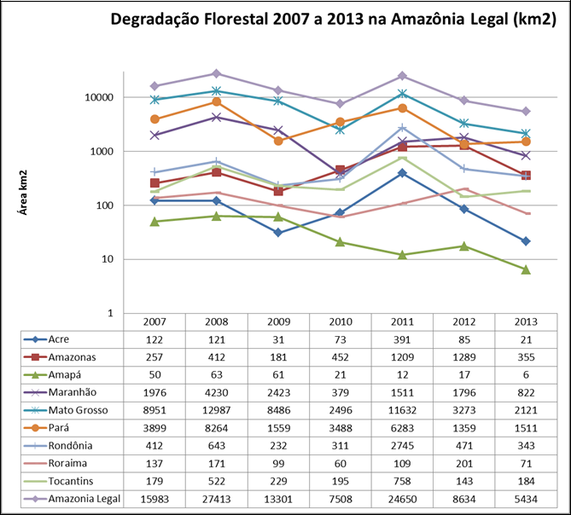

Figure b.1: Forest degradation in Legal Amazonia from 2007 to 2013. Distribution of the area under

forest degradation in Legal Amazonia (in km2). Source: INPE, DEGRAD, 2014.

It has been noted that there is a close relationship between the increase of the degraded forest area and the increase of fire occurrences in years impacted by drought, due to the vulnerability of forest areas to fire due to the presence of dry, easily combustible material (dry litter).

DEGRAD clearly indicates that the forest degradation process is closely associated to climatic conditions in a given year, such as unusually hot years (e.g., 2007 and 2010). A lagged effect of extreme events on forest degradation has also been observed (e.g., an extremely dry year leading to increased fire occurrences in subsequent year or years).

122
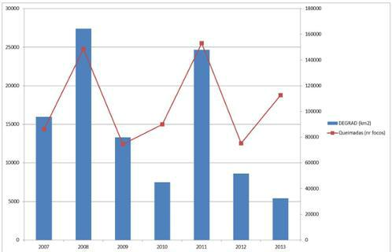

Figure b.2. Relationship between fire occurrences and degradation in the Legal
Amazonia from 2007 to 2013. Source: INPE, 2014.

The causal relationship between the reduction in deforestation in some areas and the increase in forest degradation in others is difficult to be established, if not impossible.

INPE has monitored, through PRODES, the areas mapped by DEGRAD to assess the extent to which the areas affected by forest degradation in one year are converted to clear cut in subsequent years. Table b.1 presents data for DEGRAD and for PRODES from 2007 to 2013.

Table b.1. Percentage of the areas identified as degraded by DEGRAD and subsequently converted to clear cut (deforestation) and included in PRODES, from 2007 to 2012.


% conversion of the area |  |  |  | PRODES (year)
degraded (DEGRAD) to
 |  | 2008 | 2009 | 2010 | 2011 | 2012 | 2013
clear cut (PRODES)
(year) | 2007 | 12 | 2 | 2 | 2 | 1 | 2
(year) | 2008 |  | 1 | 2 | 1 | 1 | 1
DEGRAD | 2009 |  |  | 2 | 2 | 2 | 2
DEGRAD | 2010 |  |  |  | 3 | 1 | 2
 | 2011 |  |  |  |  | 2 | 4
 | 2012 |  |  |  |  |  | 4

The major challenge of monitoring and addressing forest degradation adequately (in particular in relation to the anthropogenic contribution to the associated emissions) lies in the ability to accurately assess the changes of carbon stock in the areas affected by degradation, particularly aboveground biomass. Degradation may have different intensities, from very low (where few trees are removed) to very high (where, most likely, the land will be deforested at some point in time).

DEGRAD time series is not long enough to allow a good understanding of the degradation process and hence, for Brazil to include the REDD+ activity “Reducing Emissions from Forest Degradation” in this submission. It is expected that this understanding improves with time, as new data become available. Forest degradation

123
has not been included in the construction of this FREL, to ensure a conservative approach for REDD+ results-based payments.

The data indicates that, on average, the emissions associated with forest degradation in the Amazonia biome, from 2007 to 2010 inclusive, are approximately 59.0 per cent of those from deforestation. It is to be noted that the pattern of emissions from deforestation and forest degradation show some correspondence in the time series from 2007 to 2010 (a decrease in one is followed by a decrease in the other, and vice versa), as can be seen from Figure b.3.

In the calculation of the percentage indicated above (see IMPORTANT REMARK below), it was assumed that the average loss of carbon in the areas affected by degradation was 33 per cent (consistent with the value in the Second National GHG Inventory). This percentage was assumed for the loss of carbon from selective logging and may not represent the average loss for forests impacted by degradation events in general.
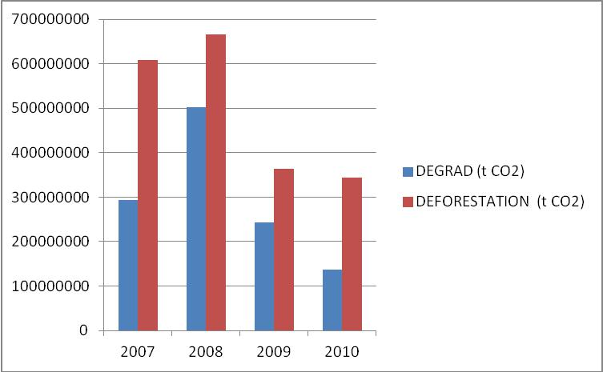

Figure b.3. Emissions (in tCO2) from deforestation and from forest degradation in the Amazonia biome for years 2007 to 2010, inclusive.

IMPORTANT REMARK 1: The emissions from forest degradation have been estimated using the area of forest degradation identified in DEGRAD (refer to Figure b.1); the mean carbon density in forest types in the Amazonia biome (151.6 tC ha-1 - refer to section b.2 in the main text of this submission); and an estimate of the average carbon loss from forest degradation of 33 per cent, after Asner et al., 2005 and consistent with the Second National GHG Inventory. An expert judgement from the SFB indicated a similar estimate for selectively logged areas. For information on this issue in the Second National Inventory, refer to BRASIL (2010); Chapter 3, page 228.

124

IMPORTANT REMARK 2: The data and information on forest degradation already available for Amazonia is indicative of the complexities ahead to include emissions from forest degradation in a future FREL submission. Part of these complexities will arise from limited understanding of the dynamics of forest degradation processes. Unlike deforestation which is an activity normally associated with conversion of forest to other land uses, forest degradation may result from natural extreme events (such as droughts that intensify the vulnerability of forests to fire, for instance) that may result in emissions which will be balanced by the subsequent uptake of CO2 from the atmosphere when the agent of degradation is eliminated. Forest degradation identified in a specific year in satellite imagery may not be identifiable in subsequent years. Other areas of forest degradation may be subject to continuous degradation pressure (intensification of selective logging activities, for instance), culminating to deforestation (clear cut). Under this situation, it will be important not to double count emissions from deforestation and from forest degradation, if both activities are included in the FREL. For the present submission, the use of the same carbon density per unit area for areas deforested, regardless of the underlying process of deforestation, does not pose a concern. However, addressing this issue if emissions from forest degradation are included in the FREL may be a challenge. Another challenge is related to the estimation of the fraction of carbon lost from degradation processes, which may require intensive ground data information. Finally, additional complexities may arise depending on the own definition of forest degradation applied in the country.

125

Annex IV: The development of FRELs for other biomes

I. From subnational to national (all biomes)

As an interim measure, Brazil considered in this submission a FREL for Reducing Emissions from Deforestation in the Amazonia biome. This is due to the fact that Brazil has a historical time-series for deforestation that is consistent, credible, accurate, transparent, and verifiable for the Legal Amazonia area (and hence, the Amazonia biome).

Brazil is concentrating efforts to develop as good a time series for forest degradation for the Amazonia biome so as to have reliable and consistent data and information that will support the decision on how emissions from forest degradation should be addressed in future REDD+ submission. Meanwhile, INPE continuously monitors forest degradation to assess if the reduction of deforestation is not leading to an increase in forest degradation activities (displacement of emissions) – refer to Annex III.

Investments have already started in Brazil to expand the forest monitoring system developed for Legal Amazonia to other biomes by assessing deforestation in all biomes for years 2009, 2010 and 2011. It is expected that by 2015 Brazil will have a national monitoring system to monitor deforestation in all biomes, on an annual basis.

The idea is to develop FRELs for the remaining biomes in order of emissions importance, the Cerrado biome being the second in this respect (refer to section II of this Annex). Table c.1 presents the relative importance of the Brazilian biomes to the average annual CO2 emissions from deforestation, estimated from the Second National Inventory.

Table c.1: Average annual gross CO2 emissions from forest (managed + unmanaged) converted to other

land uses. Source: Adapted from Tables 3.98, 3.100, 3.102, 3.104, 3.106, 3.108, Second National Inventory, BRASIL (2010).

Biomes | Annual Average Gross CO2 | Relative Importance (%)
 | Emissions from Deforestation
 | (Gg) (1994-2002)
Amazonia | 1,021,875.28 | 70.21
Cerrado | 287,728.50 | 19.77
Caatinga | 42,193.09 | 2.90
Mata Atlantica | 87,337.30 | 6.00
Pantanal | 16,363.03 | 1.12
Pampa | 41.94 | 0.00
TOTAL | 1,455,539.14 | 100

126
II. Deforestation and degradation in the Cerrado biome

The Cerrado biome is the richest savanna in the world in terms of biodiversity. This biome provides fundamental local and global environmental services, and since the 1970s faces high pressure from deforestation due to mechanized agriculture, livestock and charcoal production to meet the demand of the steel industry. Cerrado is a strategic biome for both economic and environmental reasons and also for food security.

The Cerrado landscape is a mosaic of different vegetation types, ranging from grasslands to forestlands, corresponding to a gradient of woody cover (Eiten (1972), Castro & Kauffman (1998)). The structural diversity of vegetation types in the Cerrado involves a wide spectrum of total biomass (Miranda et al., 2014). Available data highlight the importance of woodland savannas as carbon sinks, particularly the belowground pool (soil and root system) (Miranda et al. (2014); Abdala (1993)).

a. Available historical data, forest monitoring systems and related uncertainties

Only recently forest monitoring systems other than that developed for Legal Amazonia have started to be developed in Brazil. In 2002, the project Monitoring Deforestation in Brazilian Biomes by Satellite was created and had as a starting point the vegetation map generated for the PROBIO/MMA project (“time zero map”) containing the historical natural vegetation changes that occurred in the Cerrado biome up to 2002, based on the analysis of remotely sensed data. New changes from 2002 to 2008 were also identified through visual interpretation of satellites images (CBERS and Landsat).

The presently available data for deforestation in the Cerrado biome consist of the deforestation mapped from 2002 and 2008, followed by and annual assessments of the rate of deforestation for 2009 and 2010. The analysis of these data indicates a downward trend in the loss of natural vegetation in this biome. The determination of the accuracy of these estimates is still under way.

The mapping of deforestation from 2002 to 2008 was contracted, and presented some distortions that were not readily identified. For years 2008, 2009 and 2010, the analysis of satellite imagery to identify new deforestation was carried out by the technical team at IBAMA, which was, to a great extent, able to correct the distortions. For example, some deforestation that occurred prior to 2008 was mapped in either one of years 2008, 2009 or 2010, thus overestimating the deforestation associated with these years.

Recognizing this problem, the Brazilian government is now working to rebuild the time series for this biome, having as a reference the methods used for PRODES for the Legal Amazonia. One of the initiatives to produce environmental information for the Cerrado biome is funded by the Forest Investment Program, FIP.38

- The Brazil Investment Plan comprises coordinated actions by three Ministries (Environment; Science, Technology & Innovation; and Agriculture and Livestock and Food Supply) focused on building synergies in order to maximize the impact of a larger set of policies aimed at reducing deforestation in the Cerrado biome through (1) improving environmental management in areas previously impacted by Human actions; and (2) producing and disseminating environmental information at the biome scale.

127
The analysis of the data available so far does not indicate an increase in deforestation in the Cerrado biome as a result of the significant reduction of deforestation in the Amazonia biome. This risk is mitigated by policies in place to tackle deforestation in the Cerrado biome (see BOX 4 below).

BOX 4. Action Plan for Prevention and Control of Deforestation in the Cerrado and Burning – PPCerrado

The overall goal of PPCerrado is to promote the continuous reduction of deforestation and forest degradation, as well as the incidence of unwanted forest fires in the Cerrado biome, through joint actions and partnerships between federal, state and municipal governments, civil society, business sector and universities. PPCerrado actions include the promotion of sustainable activities and the monitoring of private rural properties through the Rural Environmental Registry - CAR, considered one of the main instruments for environmental management of the Forest Code.

In the Cerrado, deforestation drivers are related to agriculture, cattle ranching and the demand for charcoal, mainly for the steel industry. Reconciling the binomial production/environmental protection is the great challenge for the Cerrado biome, considering its legal constraints (e.g., legal reserve of 20 per cent, as defined by the Forest Code) and the high demand for the occupation of lands, particularly for agriculture production.

The positive results already achieved for reducing deforestation in the Cerrado biome are viewed with caution by the Federal Government, since there is no systematic monitoring of deforestation in the biome as there is for the Amazonia. In order to bridge this gap in deforestation data for the Cerrado, a system for annual monitoring and for early warnings is being developed under the PPCerrado.

For more information see: http://www.mma.gov.br/redd/index.php/en/legal-framework/national/ppcerrado

The loss of natural vegetation of the Cerrado biome is often associated with the use of fire. According to the National Information System about Fires (Sisfogo)39, about 90 per cent of the fires are human related. In 2010 alone, 74,120 hot spots were detected, of which 70 per cent were located in areas of native vegetation40. Data on degradation in Cerrado has a high degree of variability and uncertainty41.

- Sisfogo is an online automated tool available for the management of early warnings and records of forest fires and controlled biomass burning. It is powered by various institutions working in the control of

fires, prevention and combating forest fires. Available for public access on: http://siscom.ibama.gov.br/sisfogo/

- INPE has an operational program to Monitor Fires and Biomass Burning using satellite data, that also provides for the estimation of the risk of fire. Data for Central and South America, Africa and Europe, are updated every three hours, every day of the year. Access to this information is free for users, available online on: http://www.inpe.br/queimadas/.

- More information about actions in other Brazilian biomes is presented in Annex II.

128
Despite its relevance to the profile of emissions in Brazil, estimation of degradation by fire still depends on the development of land cover monitoring tools. Historical data series of burned areas in the Cerrado biome are not yet available.

Initiatives in coordination between INPE and the MMA seek to provide the means for the development of automated tools so that these data become regularly available. Brazil is also working on the historical time series of burned areas between 2000 and 2013, which will allow for the development of the FREL for degradation by fire for the Cerrado biome.

Another source of uncertainty for estimating emissions in this biome relates to the estimation of biomass for different regions and vegetation types. The Second National GHG Inventory used distinct biomass for different types of Cerrado vegetation as available from the national scientific literature. For example, for estimating the biomass of forest type Savanna Woodland, eleven different sources were consulted. To obtain the total biomass, expansion factors were applied to consider dead organic matter and belowground biomass (root-to-shoot ratio), having as a basis default data in the GPG-LULUCF (IPCC, 2003). Despite the existence of national data for carbon pools, as in Miranda (2012), there is great variability in the literature depending on the methods used and the areas under investigation.

Brazil is continuously working to improve its database and aims to provide FRELs for deforestation for the Cerrado biome in the next submission. For now, information is provided here only to demonstrate the ongoing efforts by Brazil to expand its coverage of REDD+ to the national level.

- Enhancement of forest carbon stocks in the Atlantic Forest biome

The Atlantic Forest is the most threatened biome in Brazil: there are only 7.9 per cent of remaining forests fragments over 100 hectares. In case all the small fragments of natural forest over 3 acres are included, this reaches 13.32%42. Data from 2005 to 2008 show that the level of deforestation for that period was a total of 1,030 km2, an average of 340 km2 per year. In the period between 2008 and 2010, about 208 km2 of native forest were cleared, representing a drop in deforestation from the previous period (SOS/INPE, 2010). Although deforestation has dropped in recent years, it is still of concern for this biome.

After habitat loss, the second major threat to Atlantic Forest is its high degree of fragmentation. This leads to high vulnerability to disturbance (by fire, edge effects, etc.) and high degree of isolation of natural populations of the biome.

This has motivated investments from governmental and non-governmental entities in initiatives to promote the restoration of this biome.

The estimation of CO2 removals from restoration is of paramount importance to monitor mitigation efforts that occur in this biome. However, unlike what is observed with clear-

- For more information see: http://www.inpe.br/noticias/noticia.php?Cod_Noticia=2923, last accessed on May 23rd, 2014.

129
cut logging (or even forest degradation), the identification of growing stocks through remotely sensed data is still questionable and lies as a research theme.

Brazil is investing on the development of monitoring tools and protocols in the field of restoration, which so far occurs only at the project level.

130

